Main tabs

1. Introduction

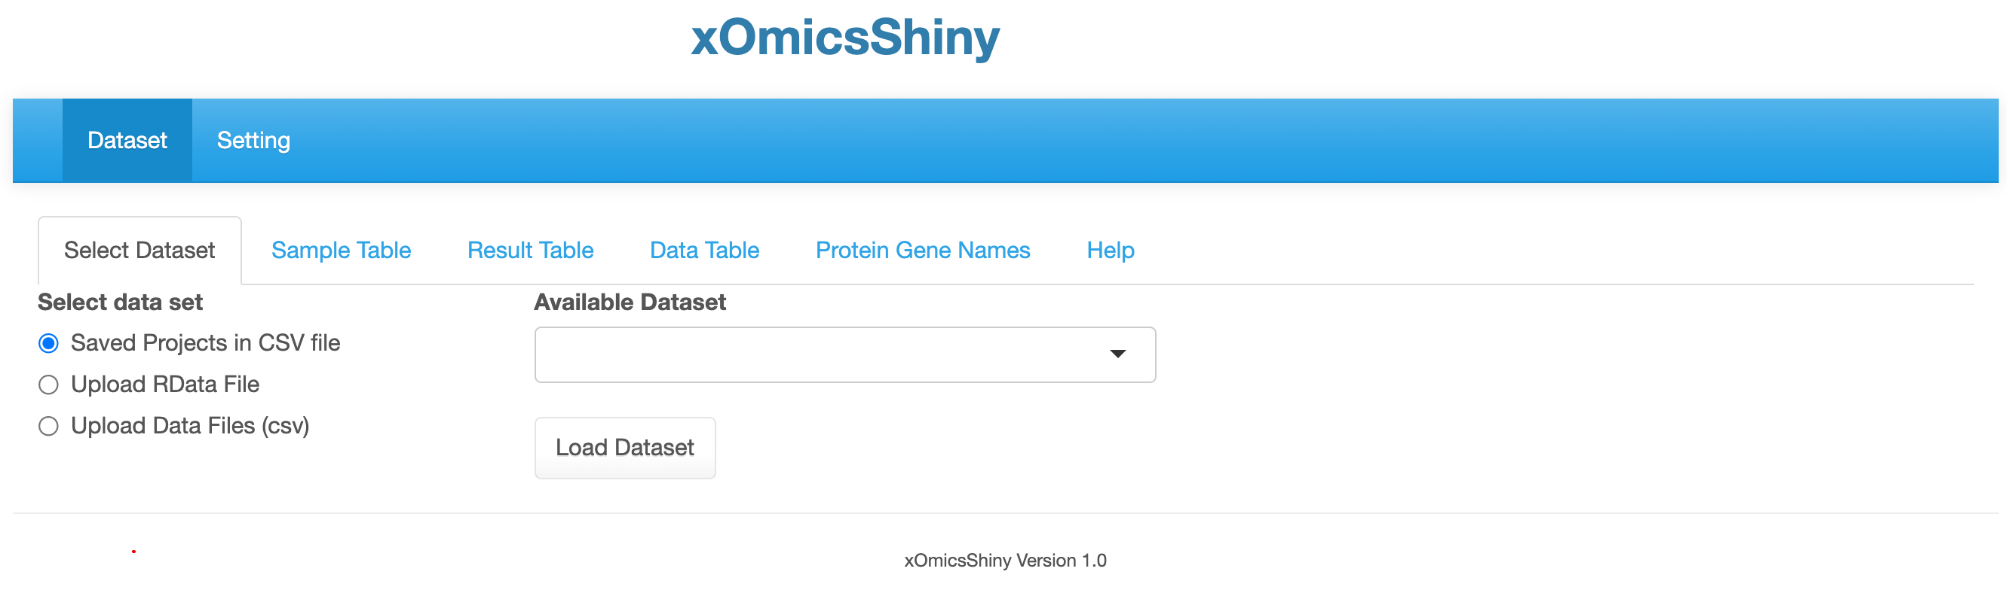

Sub tabs for different functionalities.

Main tabs

* 1. 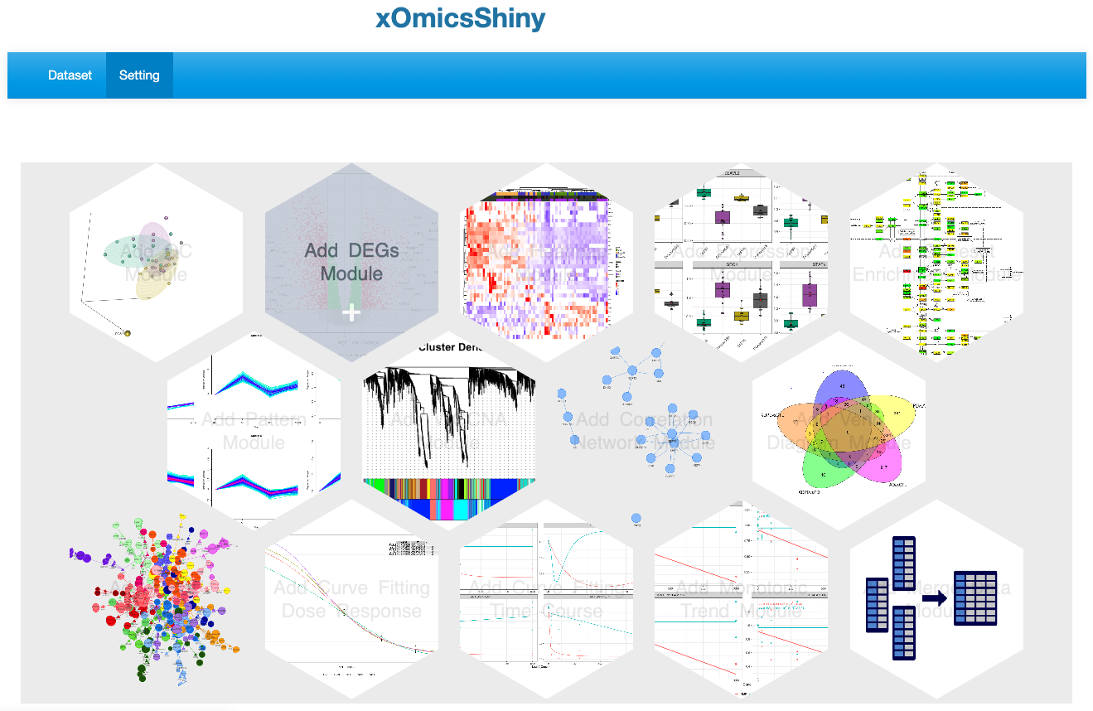
  2. 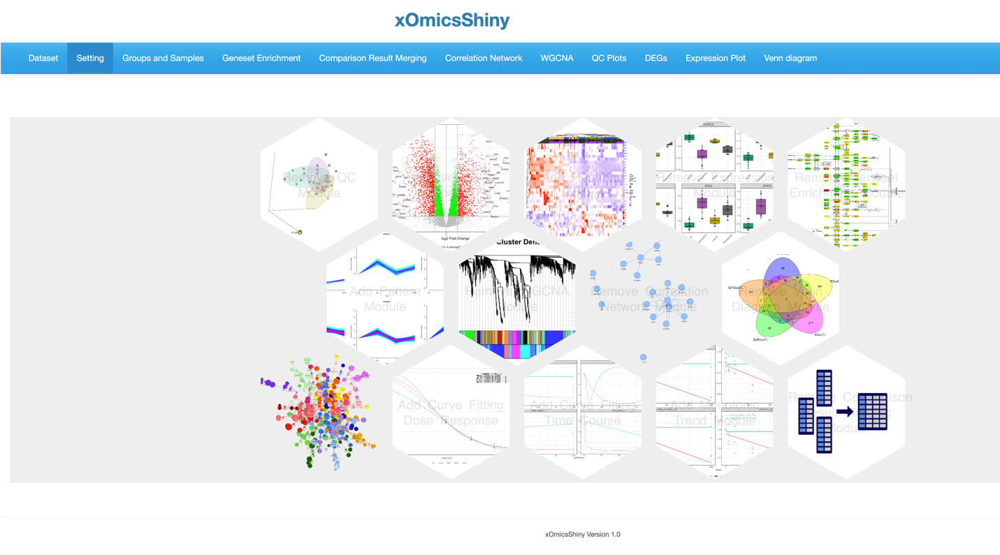

1. Installation
2. Dataset Module
   1. 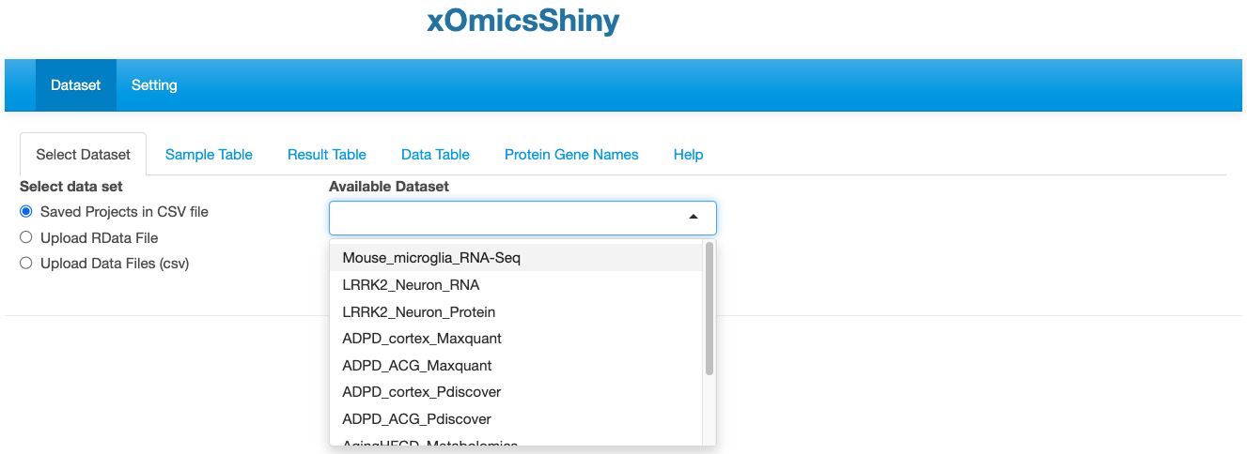

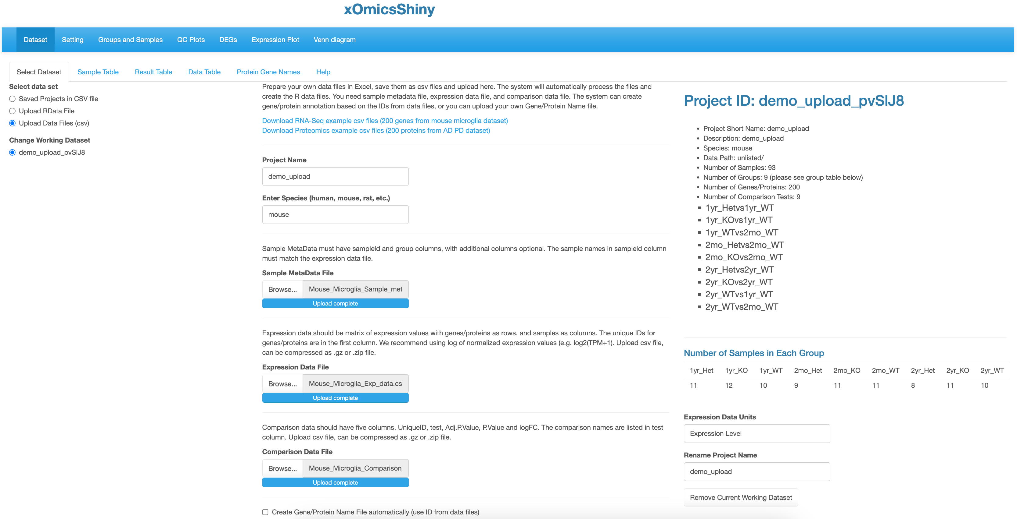

* 1. 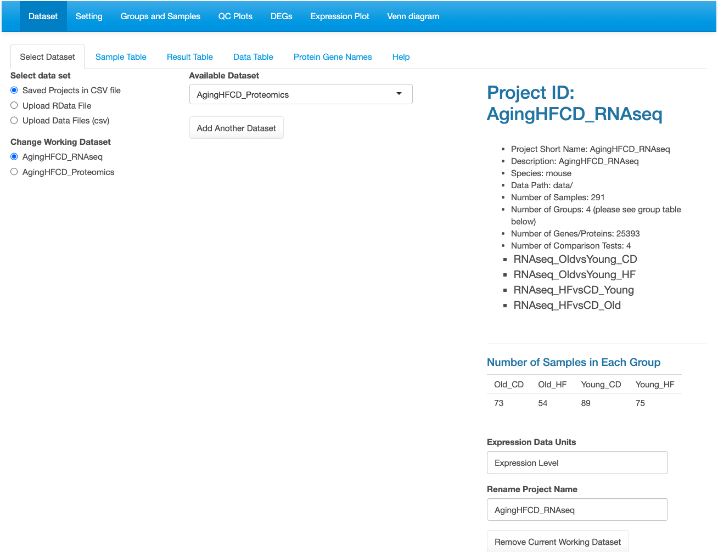

Click to remove current dataset.

Details about the dataset and listing the comparisons as defined during data upload.

Loaded datasets are listed here.

Multiple datasets can be loaded.

* 1. 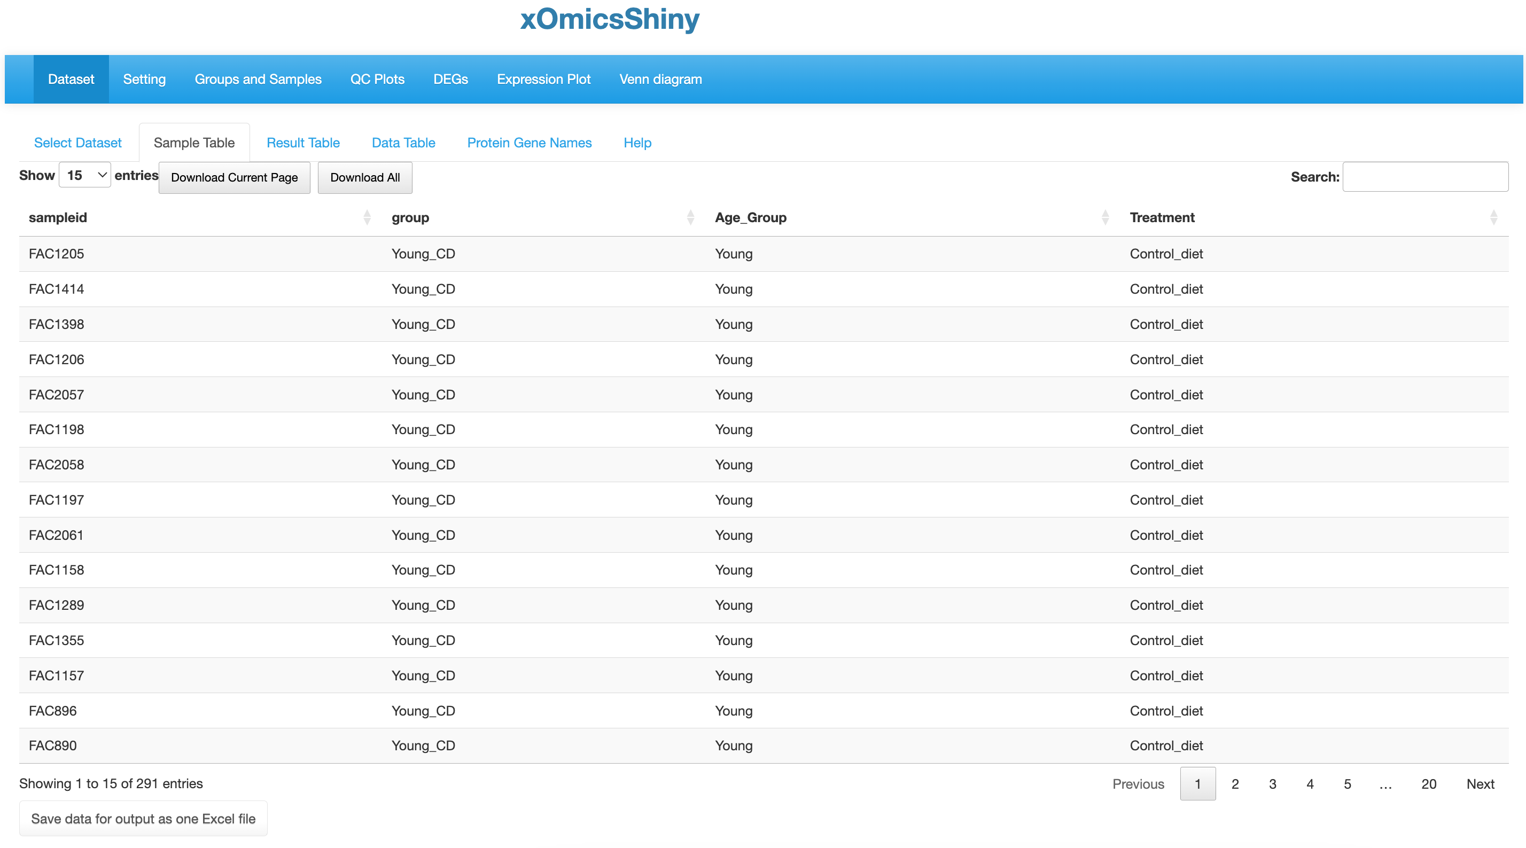
  2. 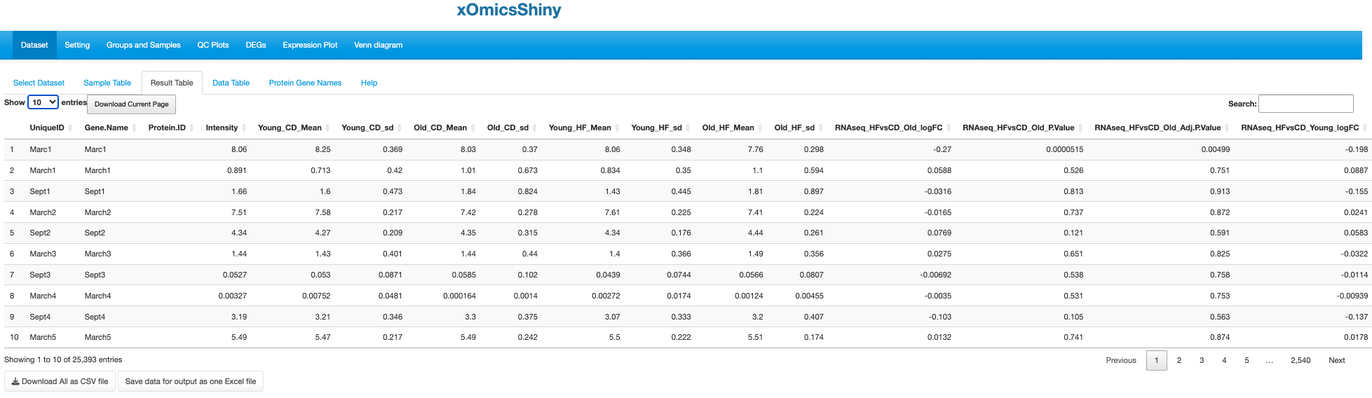

Mean and SD per group.

logFC, P value and adjusted P value for each comparison and SD per group.

* 1. 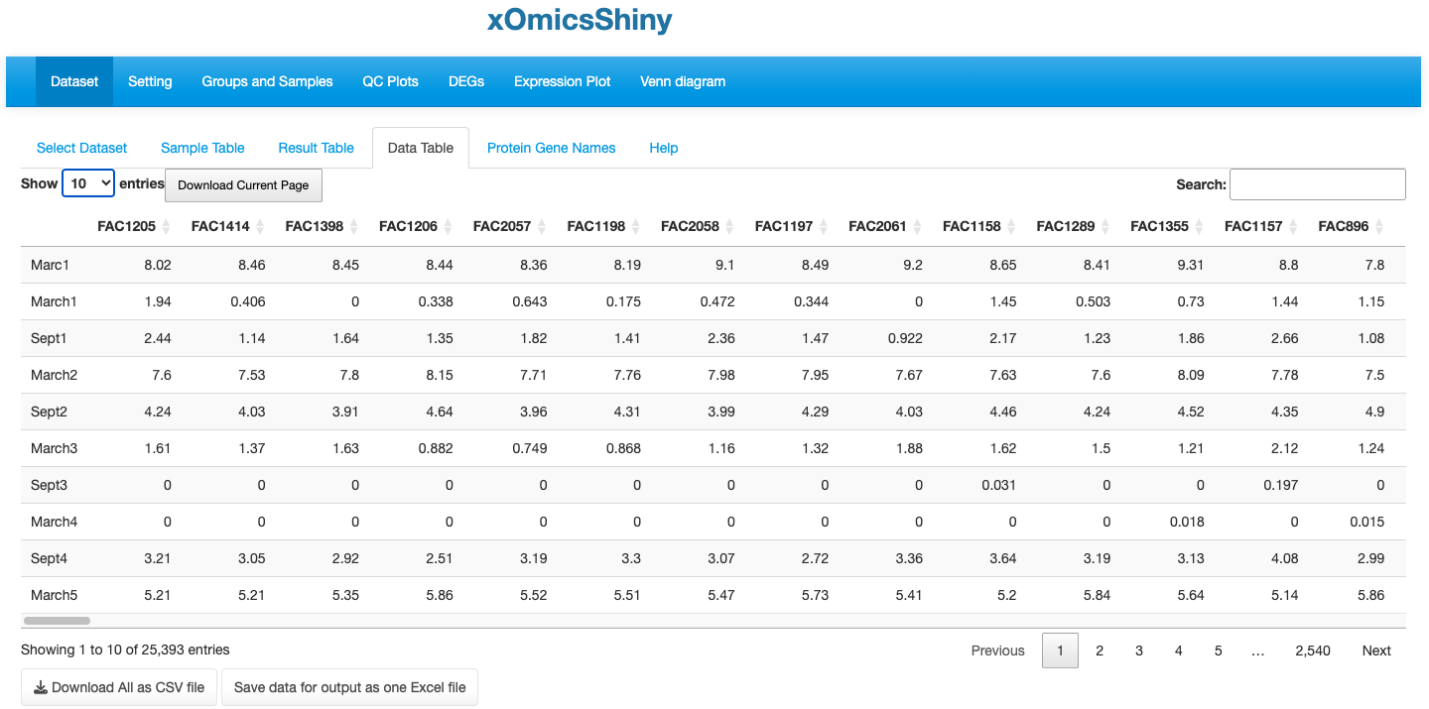

Each column is one sample.

Each row is one gene.

* 1. 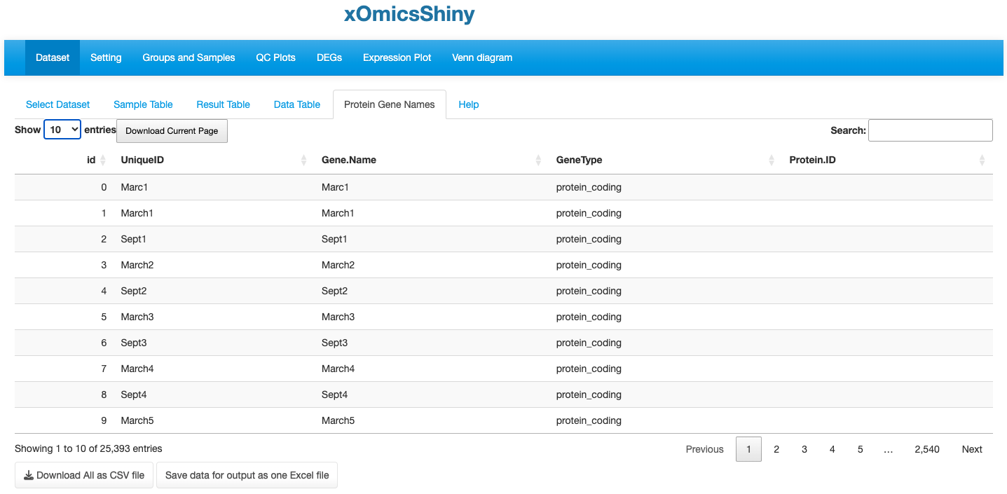

For proteomic data, Protein.ID can be matched to Gene.Name.

For metabolomic data, it only lists all the KEGG compound IDs.

* 1. 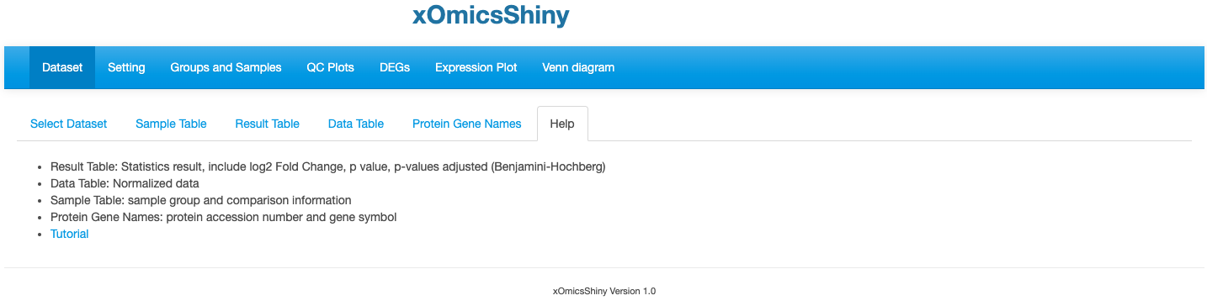

1. Groups And Samples
   1. 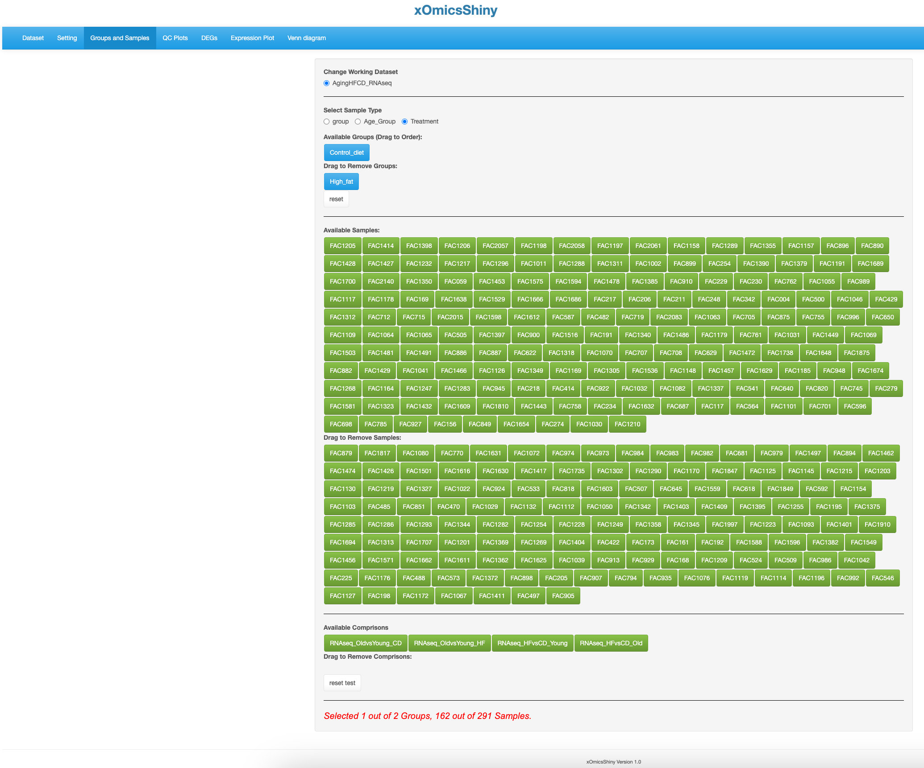

Include or exclude samples based on comparisons.

Include or exclude samples based on sample name.

Include or exclude samples based on meta data.

1. QC Plots Module
   1. 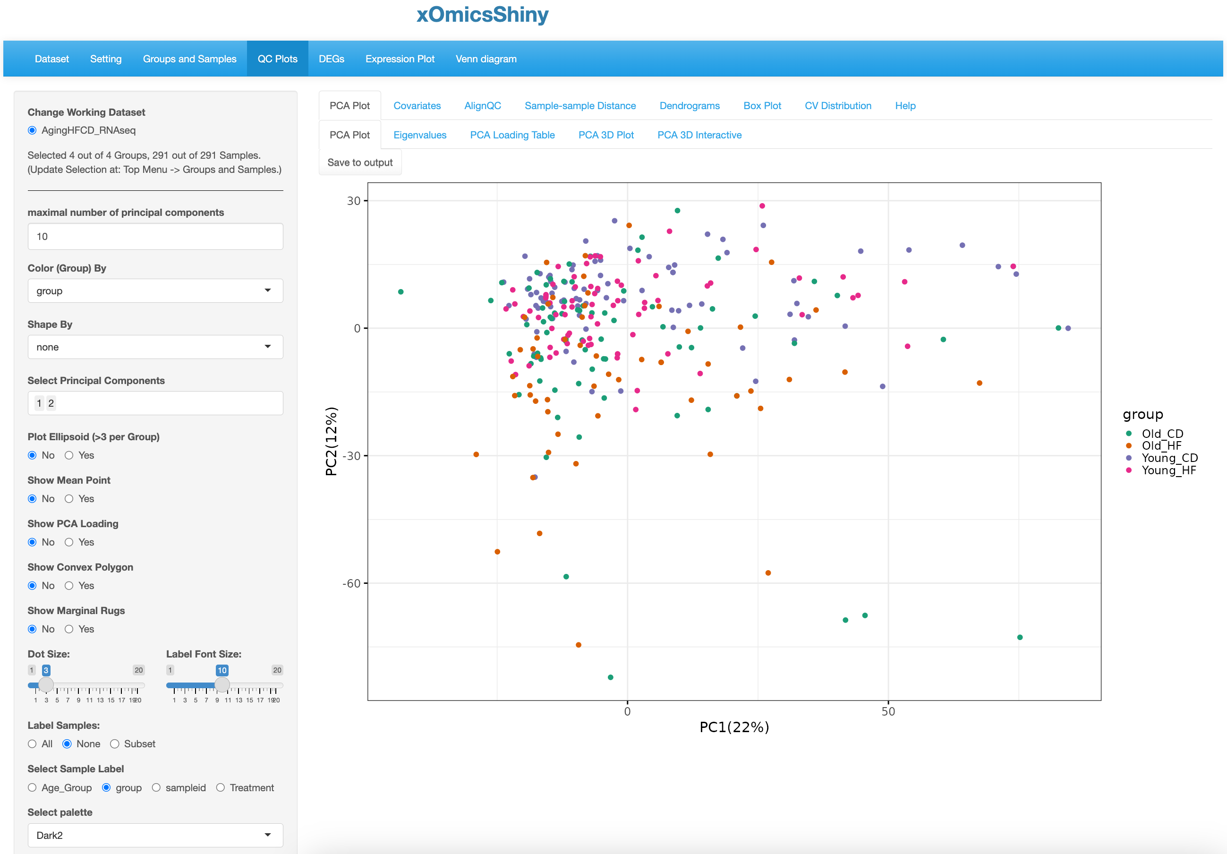

Customizable panel

Label for color.

* 1. 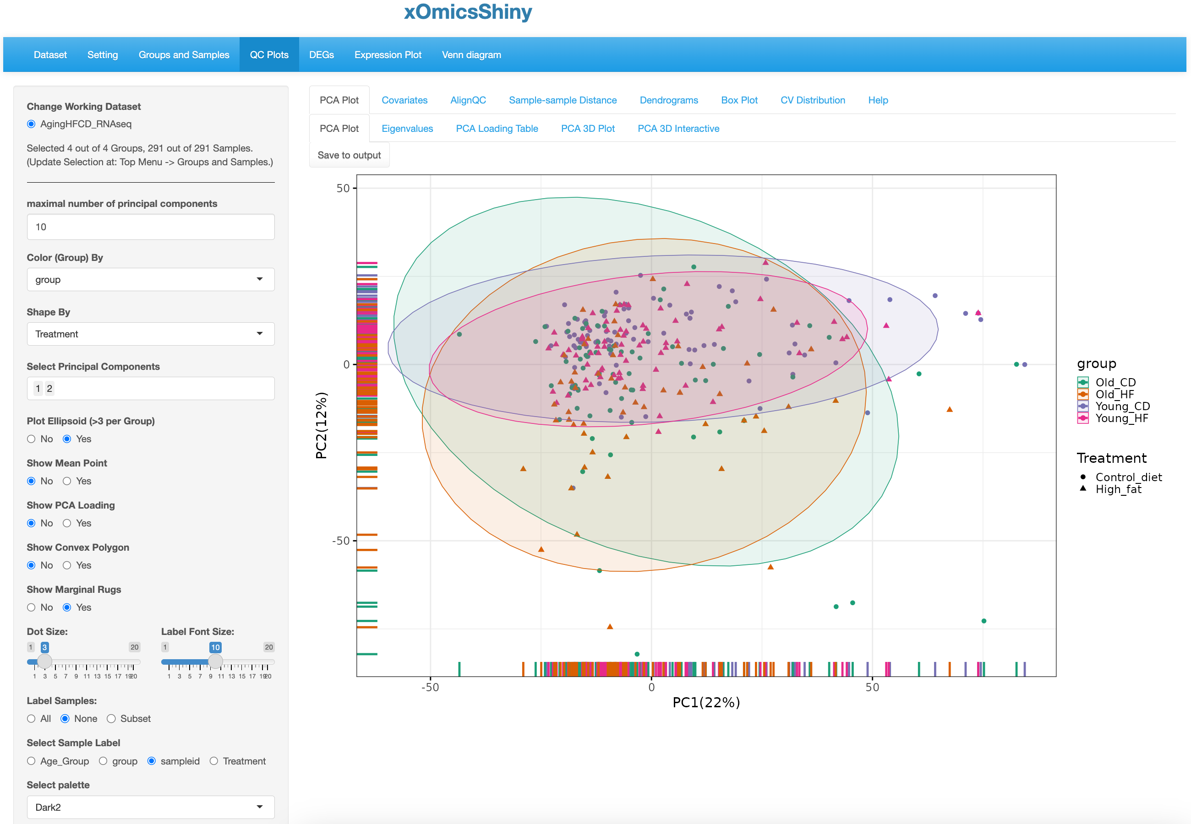

Show sample distribution along the axis

Show separation of all groups by Ellipsoid

Shape by Treatment

Click to save

* 1. 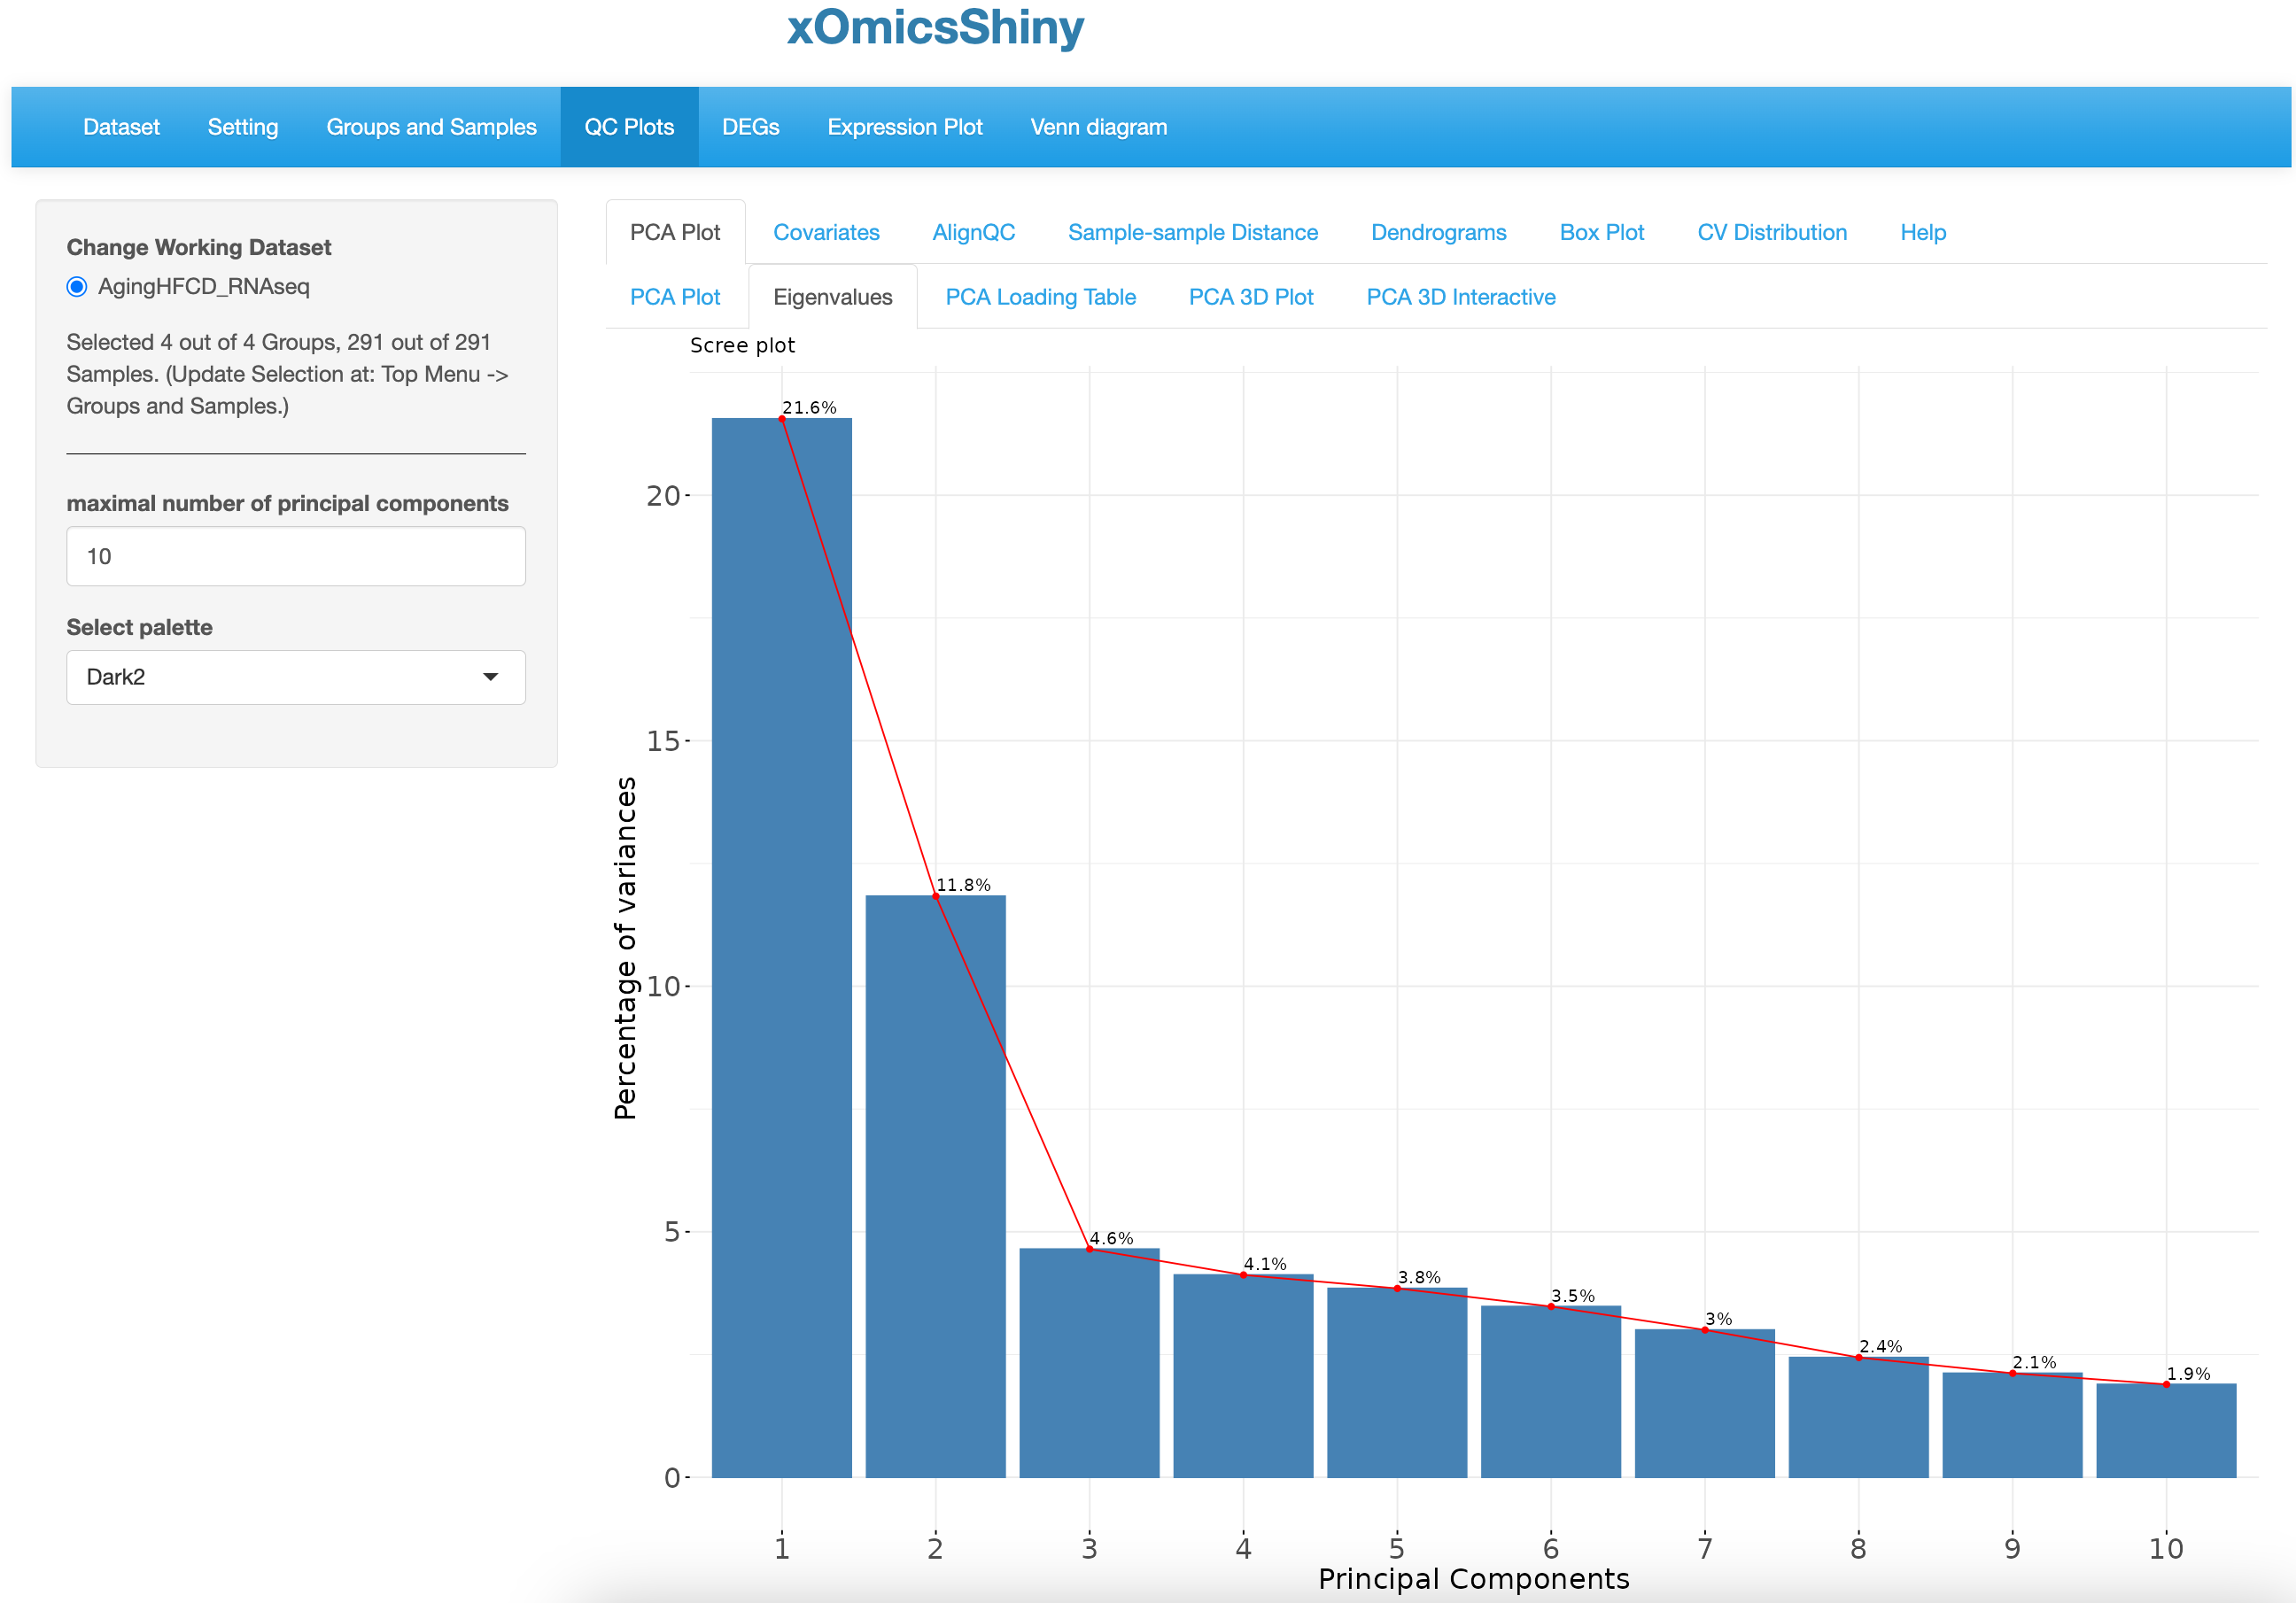
  2. 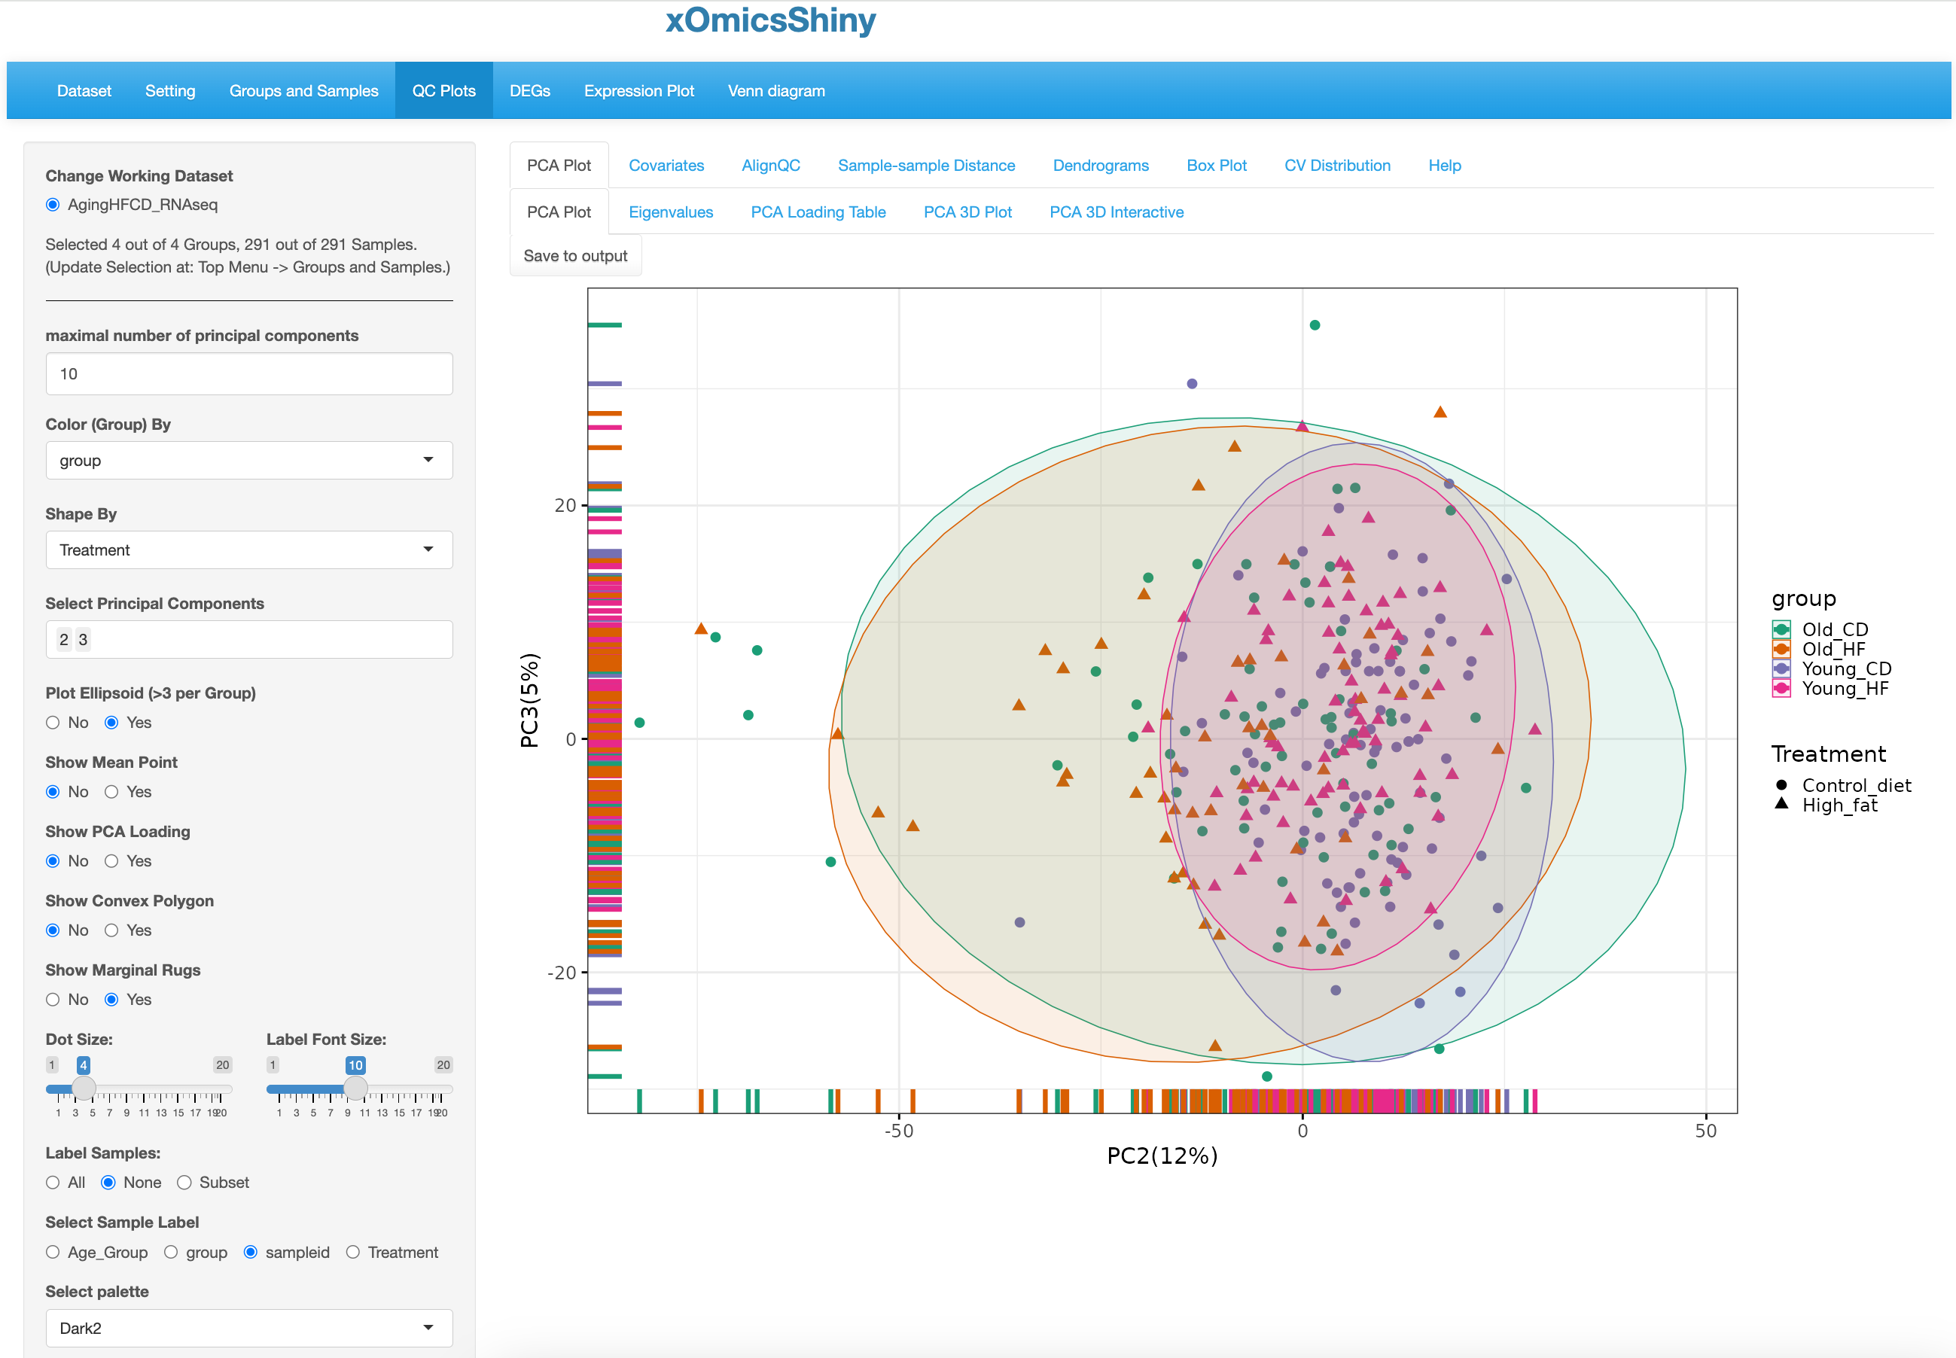
  3. 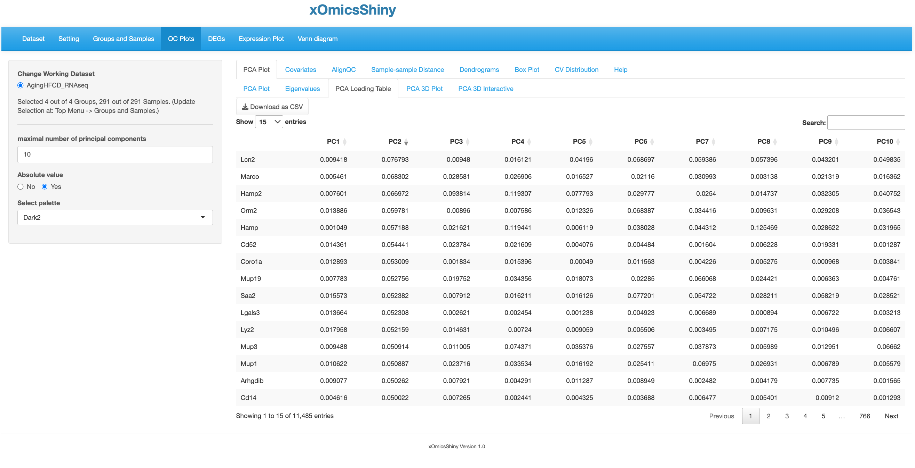

Sort by PC2

Use absolute value so that you can see the genes of both directions together by sorting a PC column.

* 1. 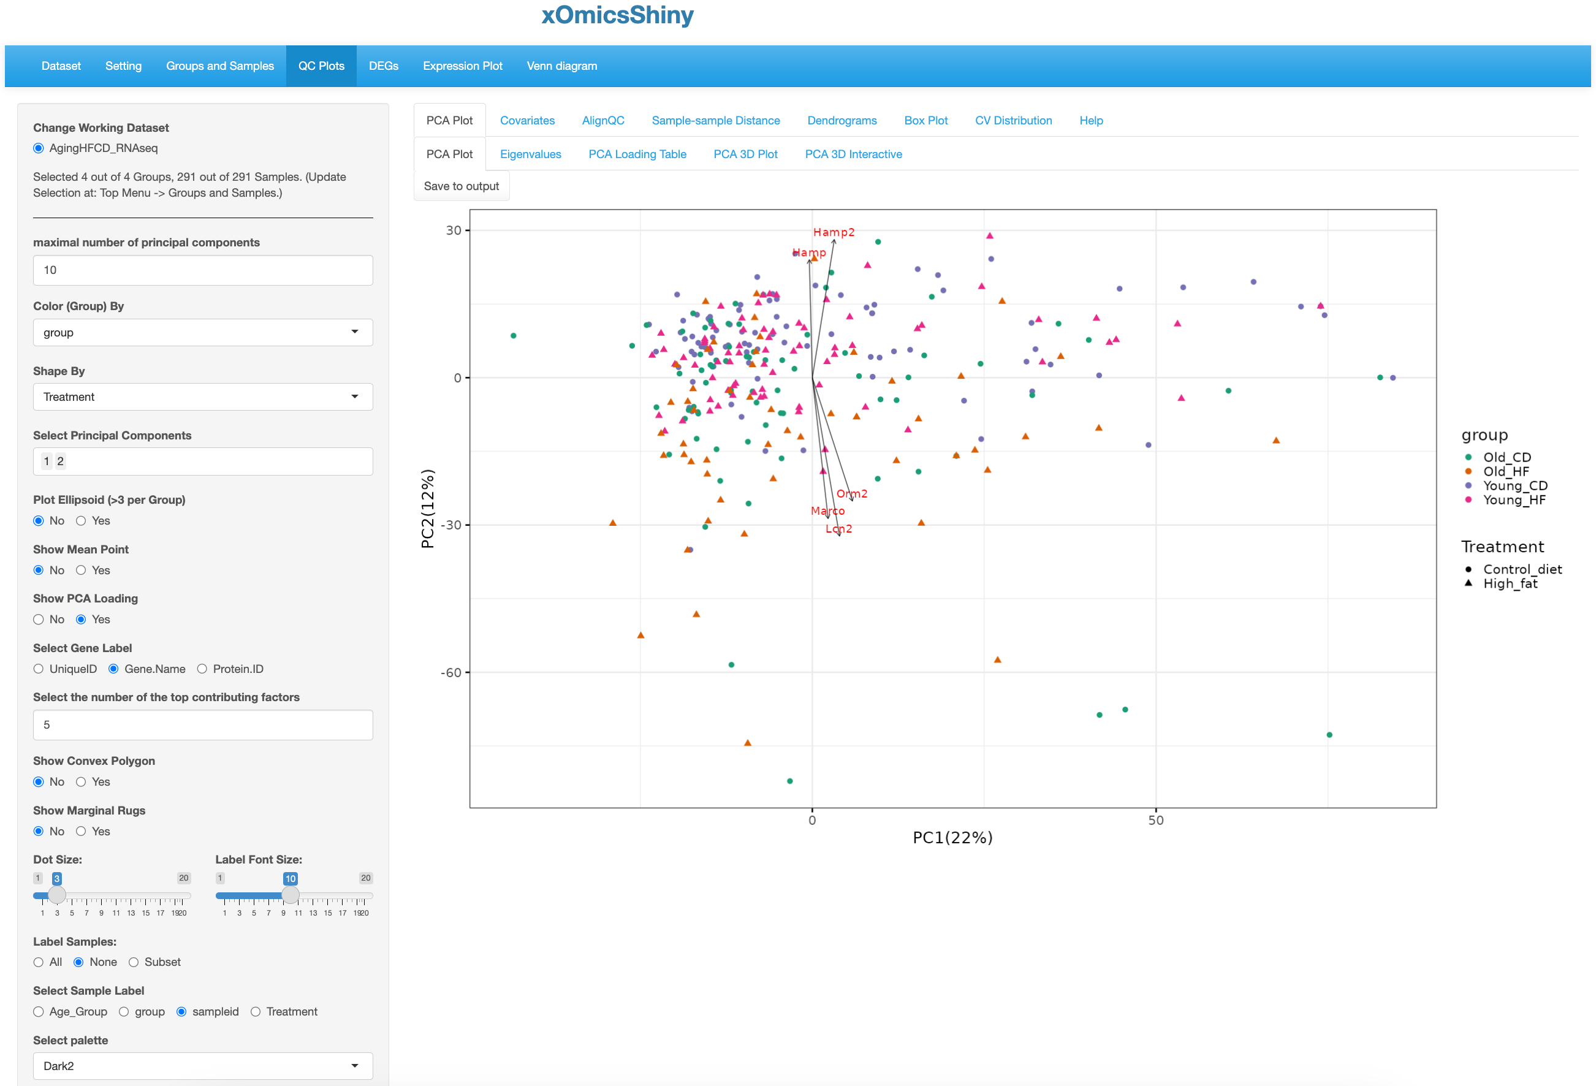

The top five contributing genes are shown using arrows pointed to their coordinates from the origin.

Select to show PCA loading, select gene label and set the number of top genes here.

* 1. 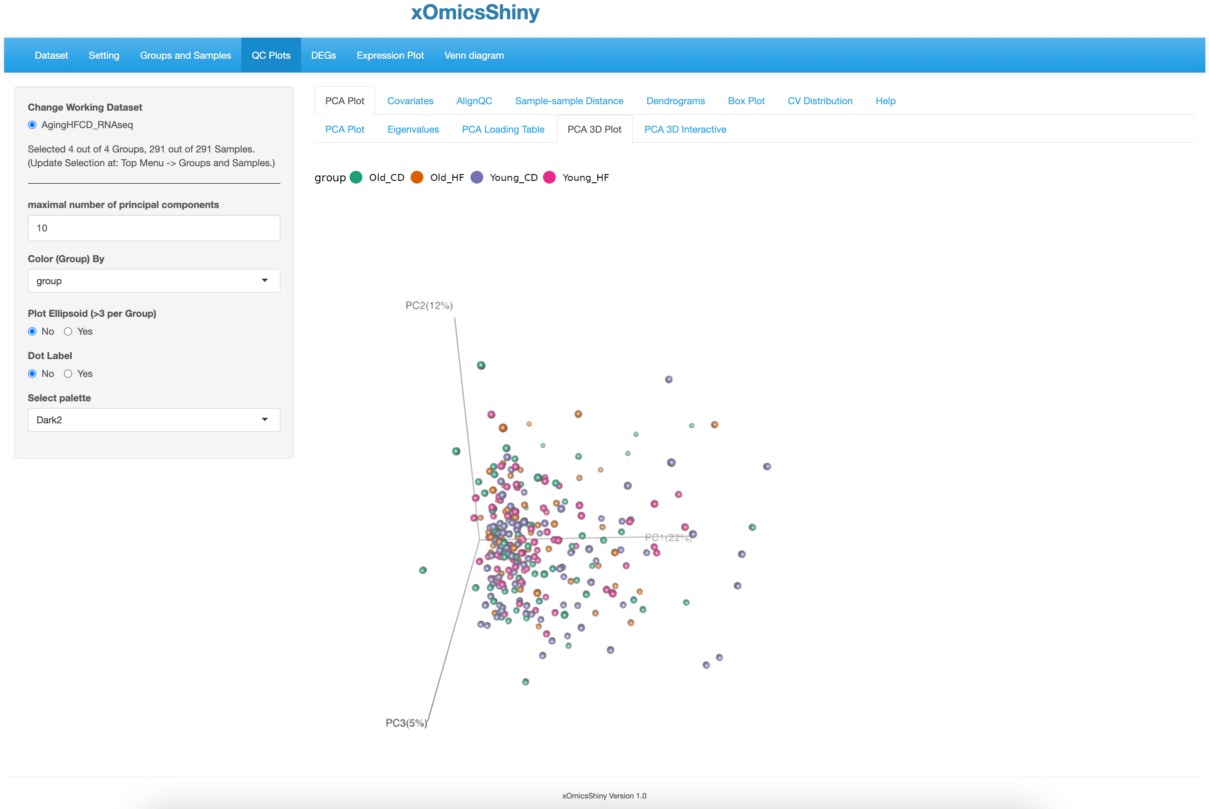

Rotate the plot to view 3D structure.

* 1. 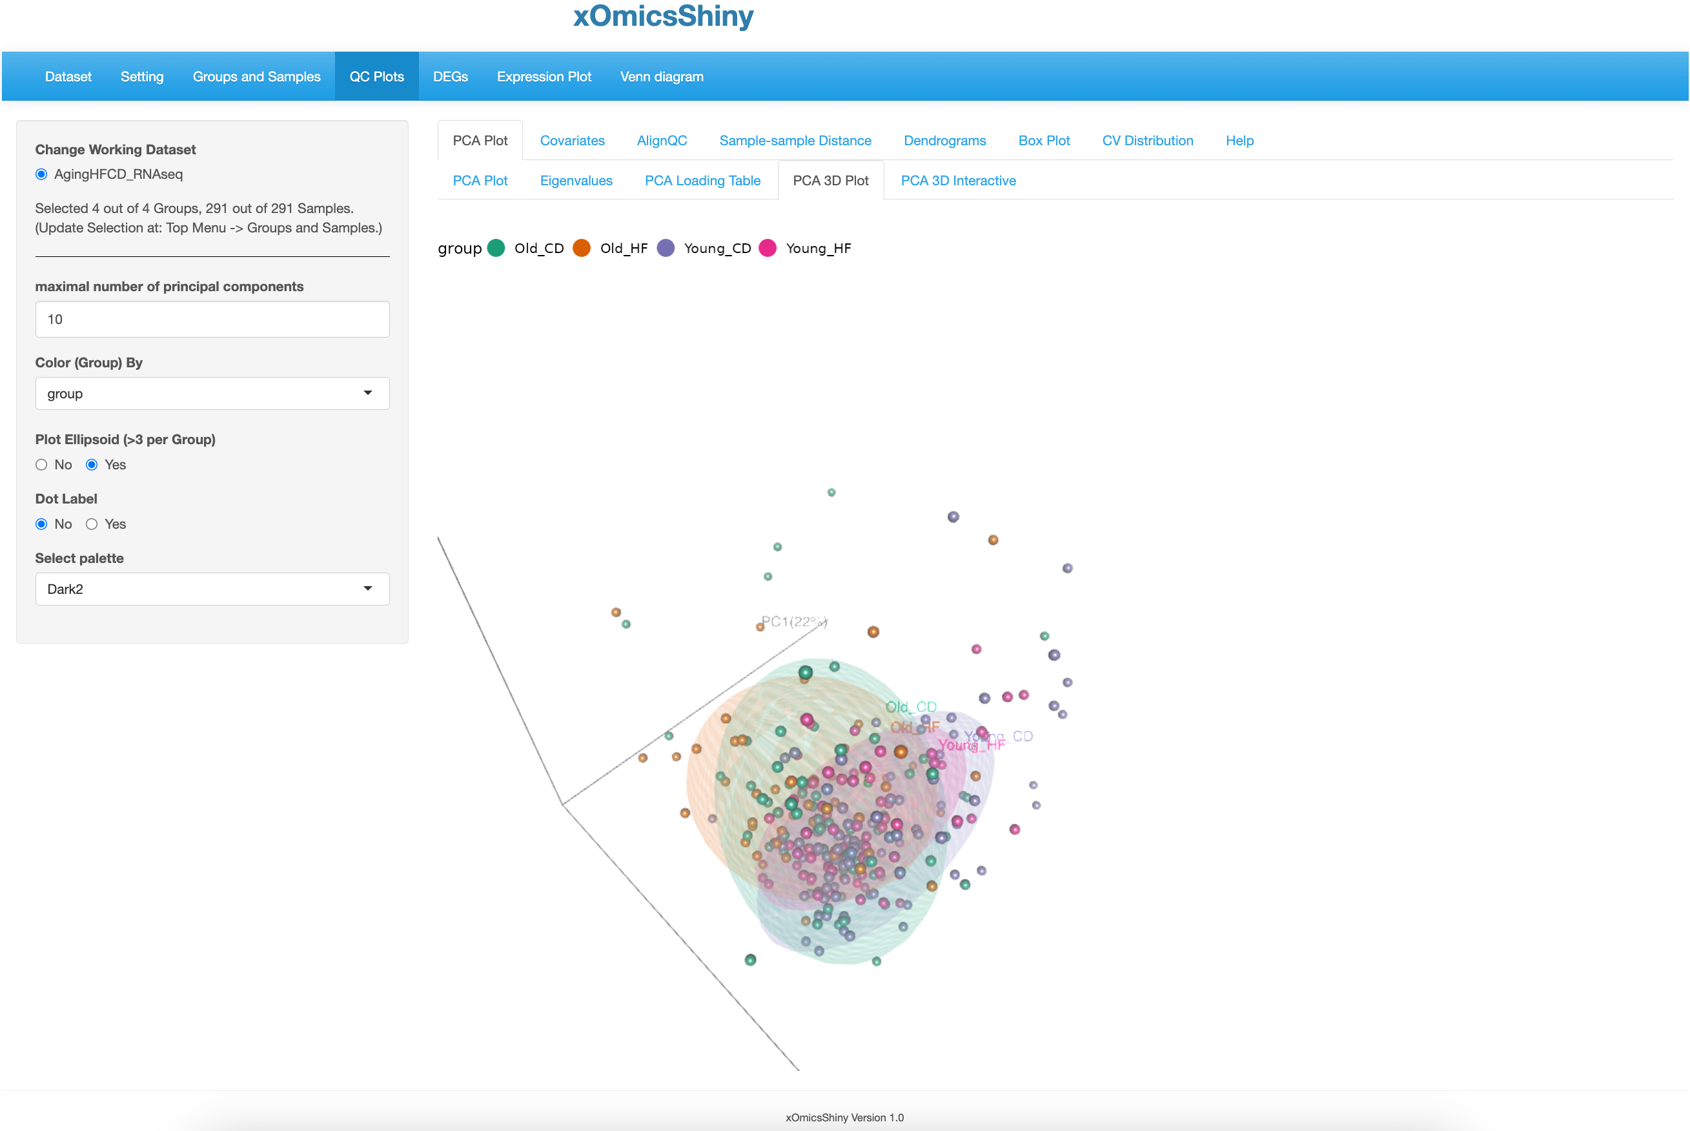

Rotate the plot to view the overlap and separation of the groups.

* 1. 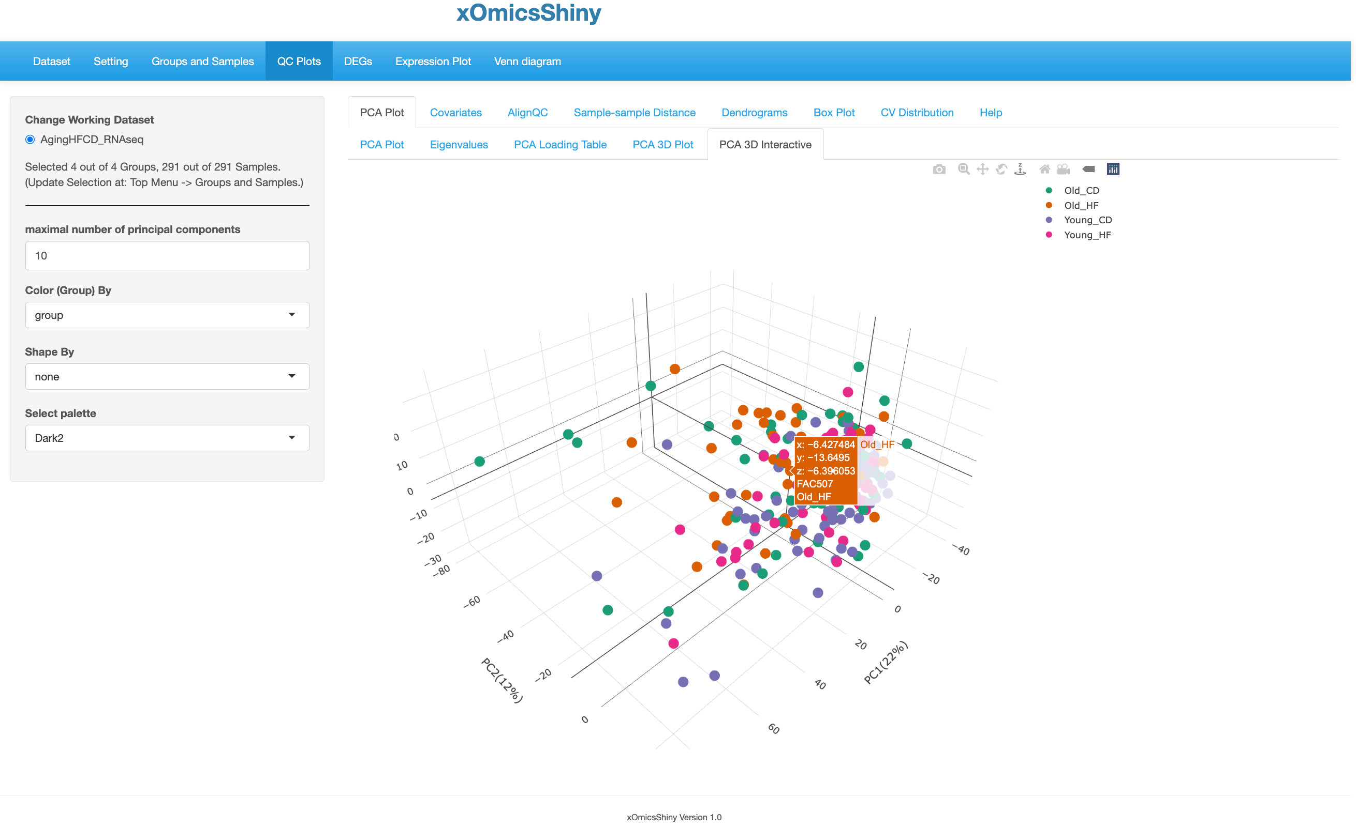

Hover over sample to get detailed information.

* 1. 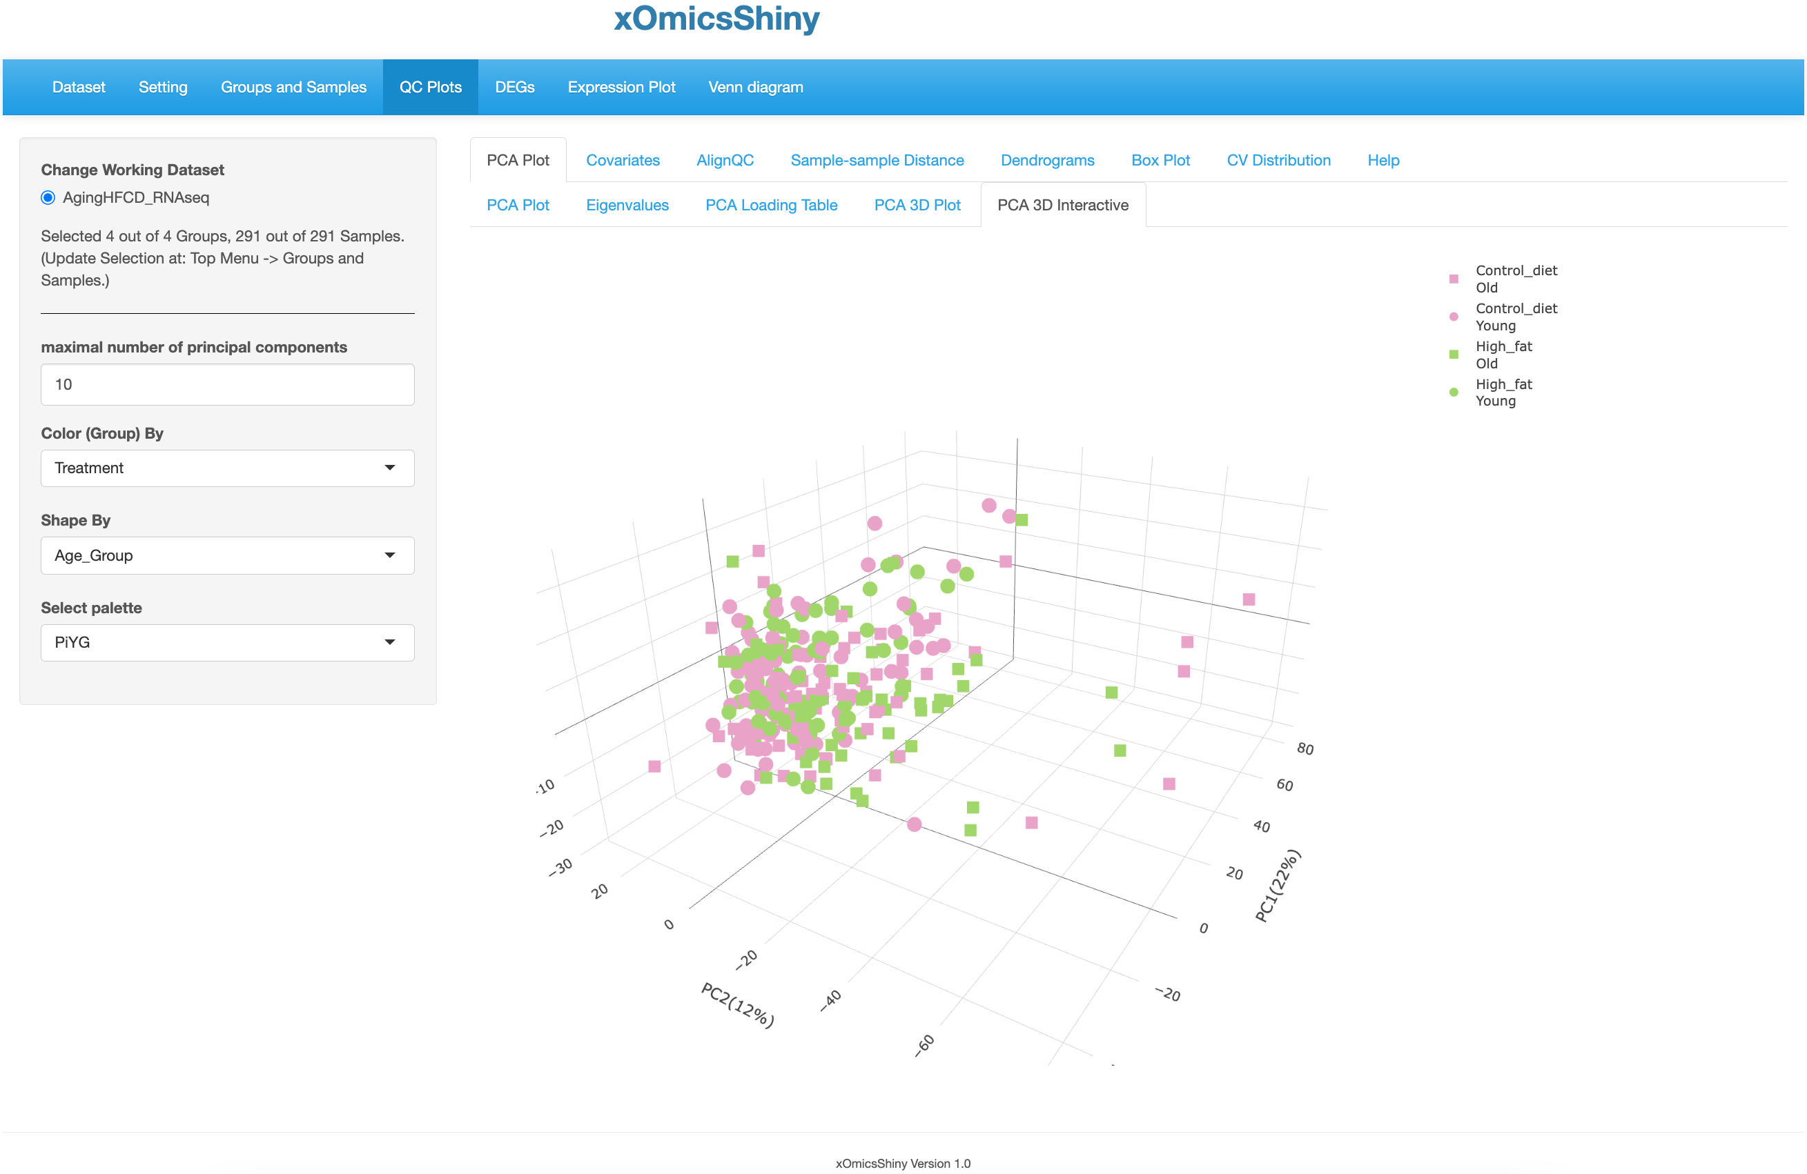
  2. 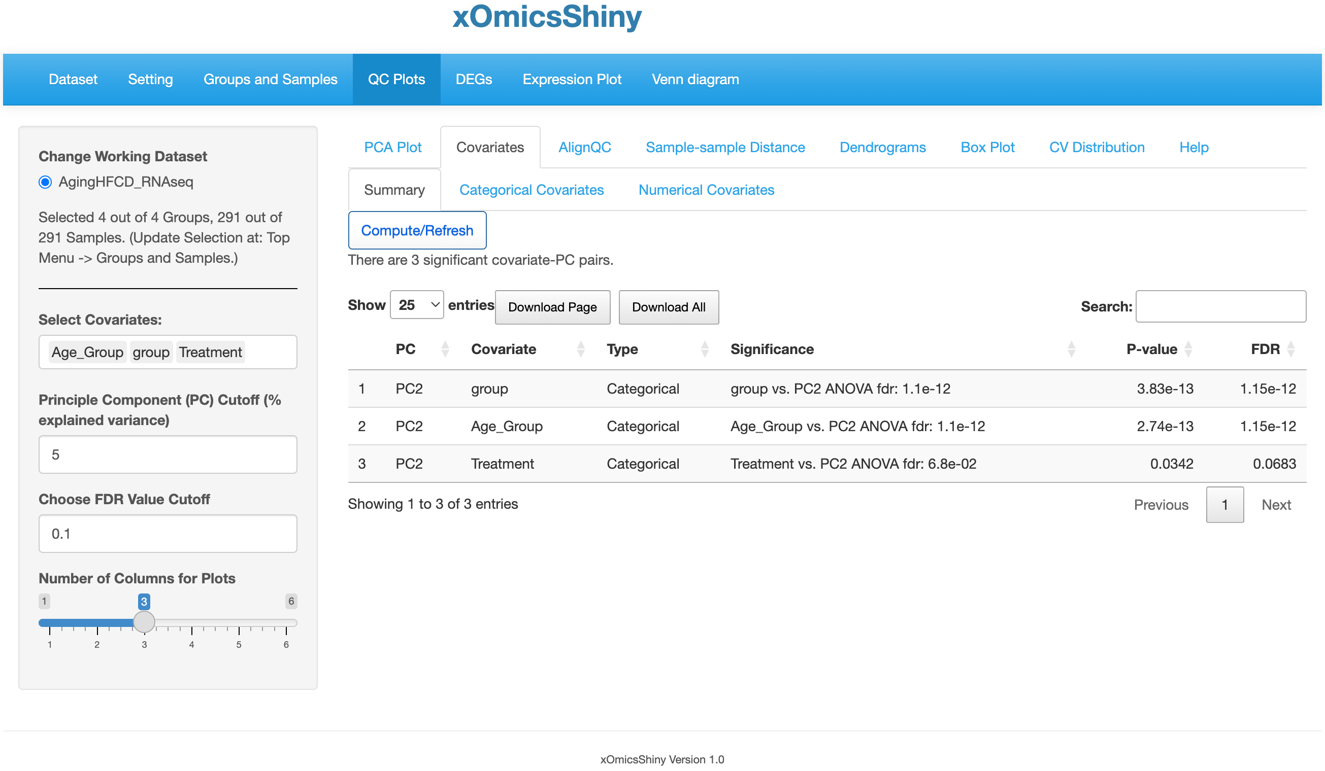

Click to compute or refresh if parameters are changed.

* 1. 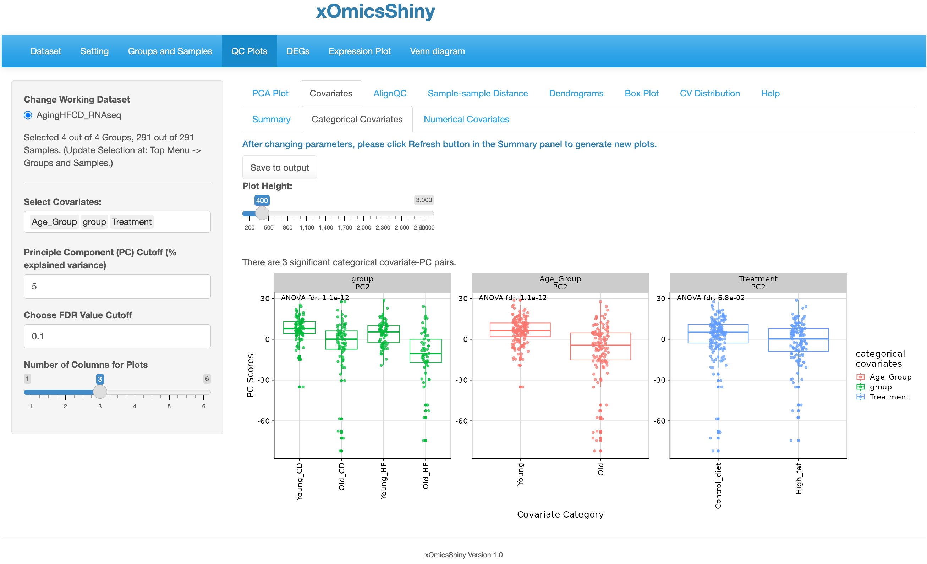
  3. 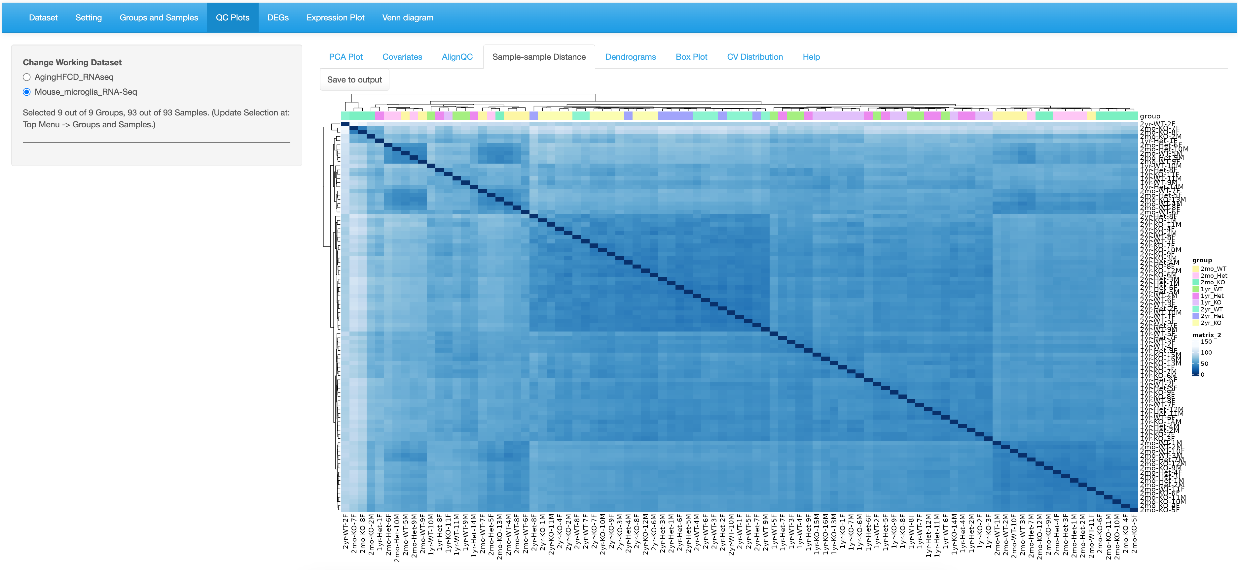
  4. 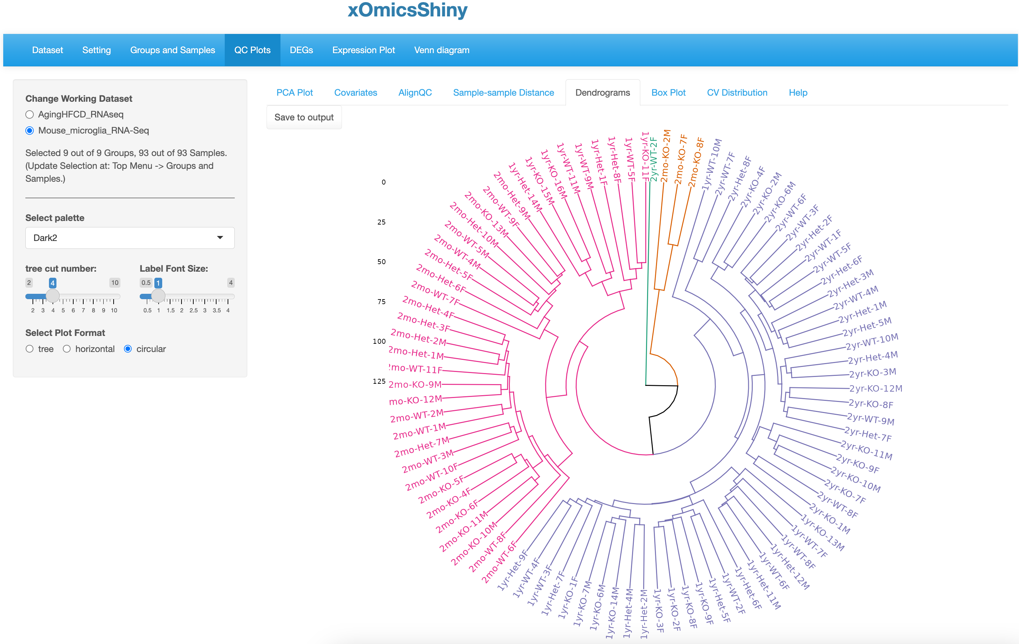

Click to save.

4 regions don’t separate the Age.

* 1. 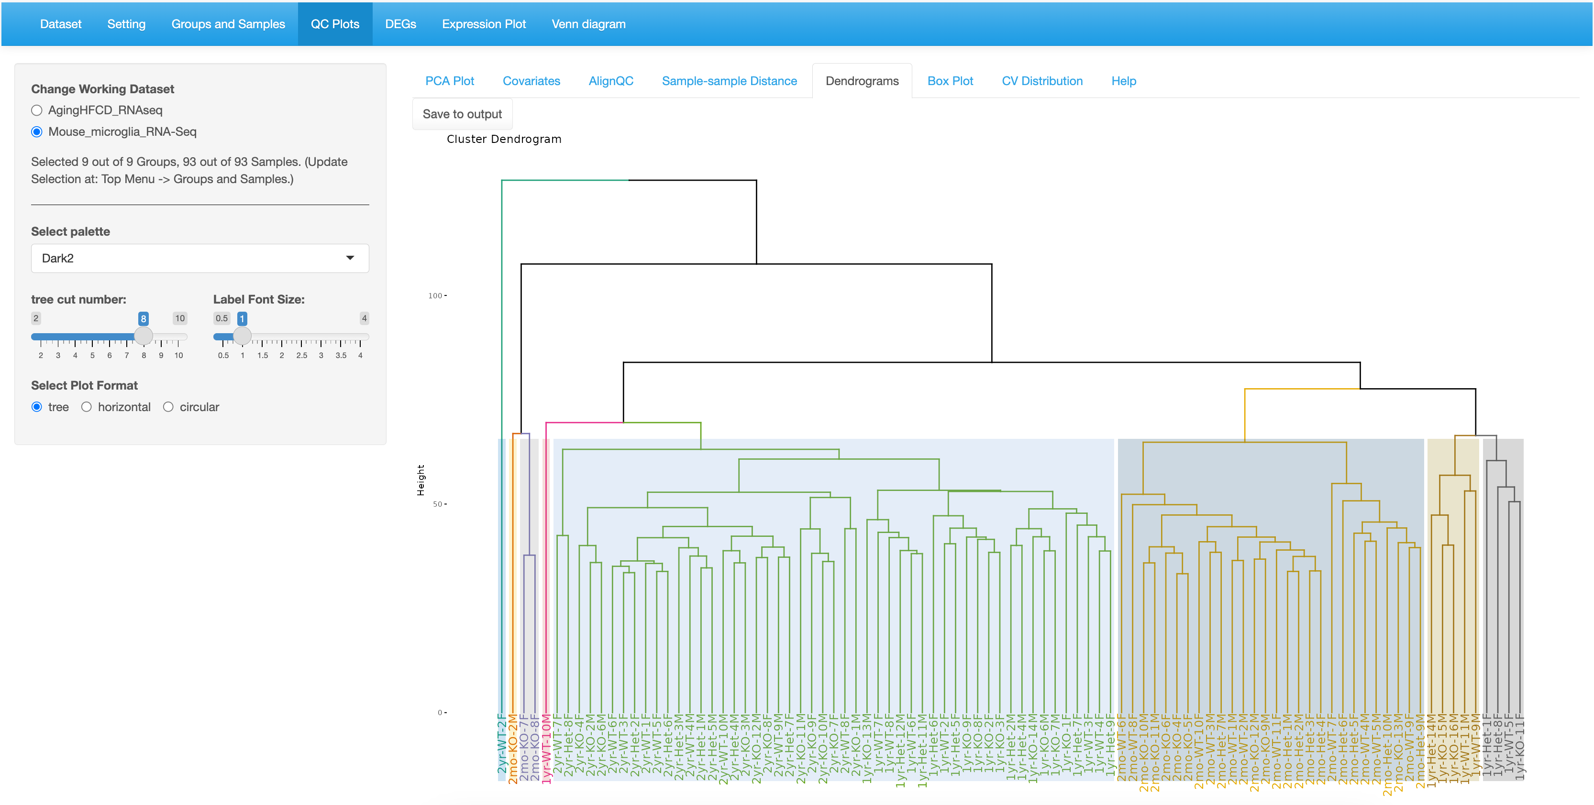

1.Cut into 8.

2. Select tree

2yr samples cluster together.

* 1. 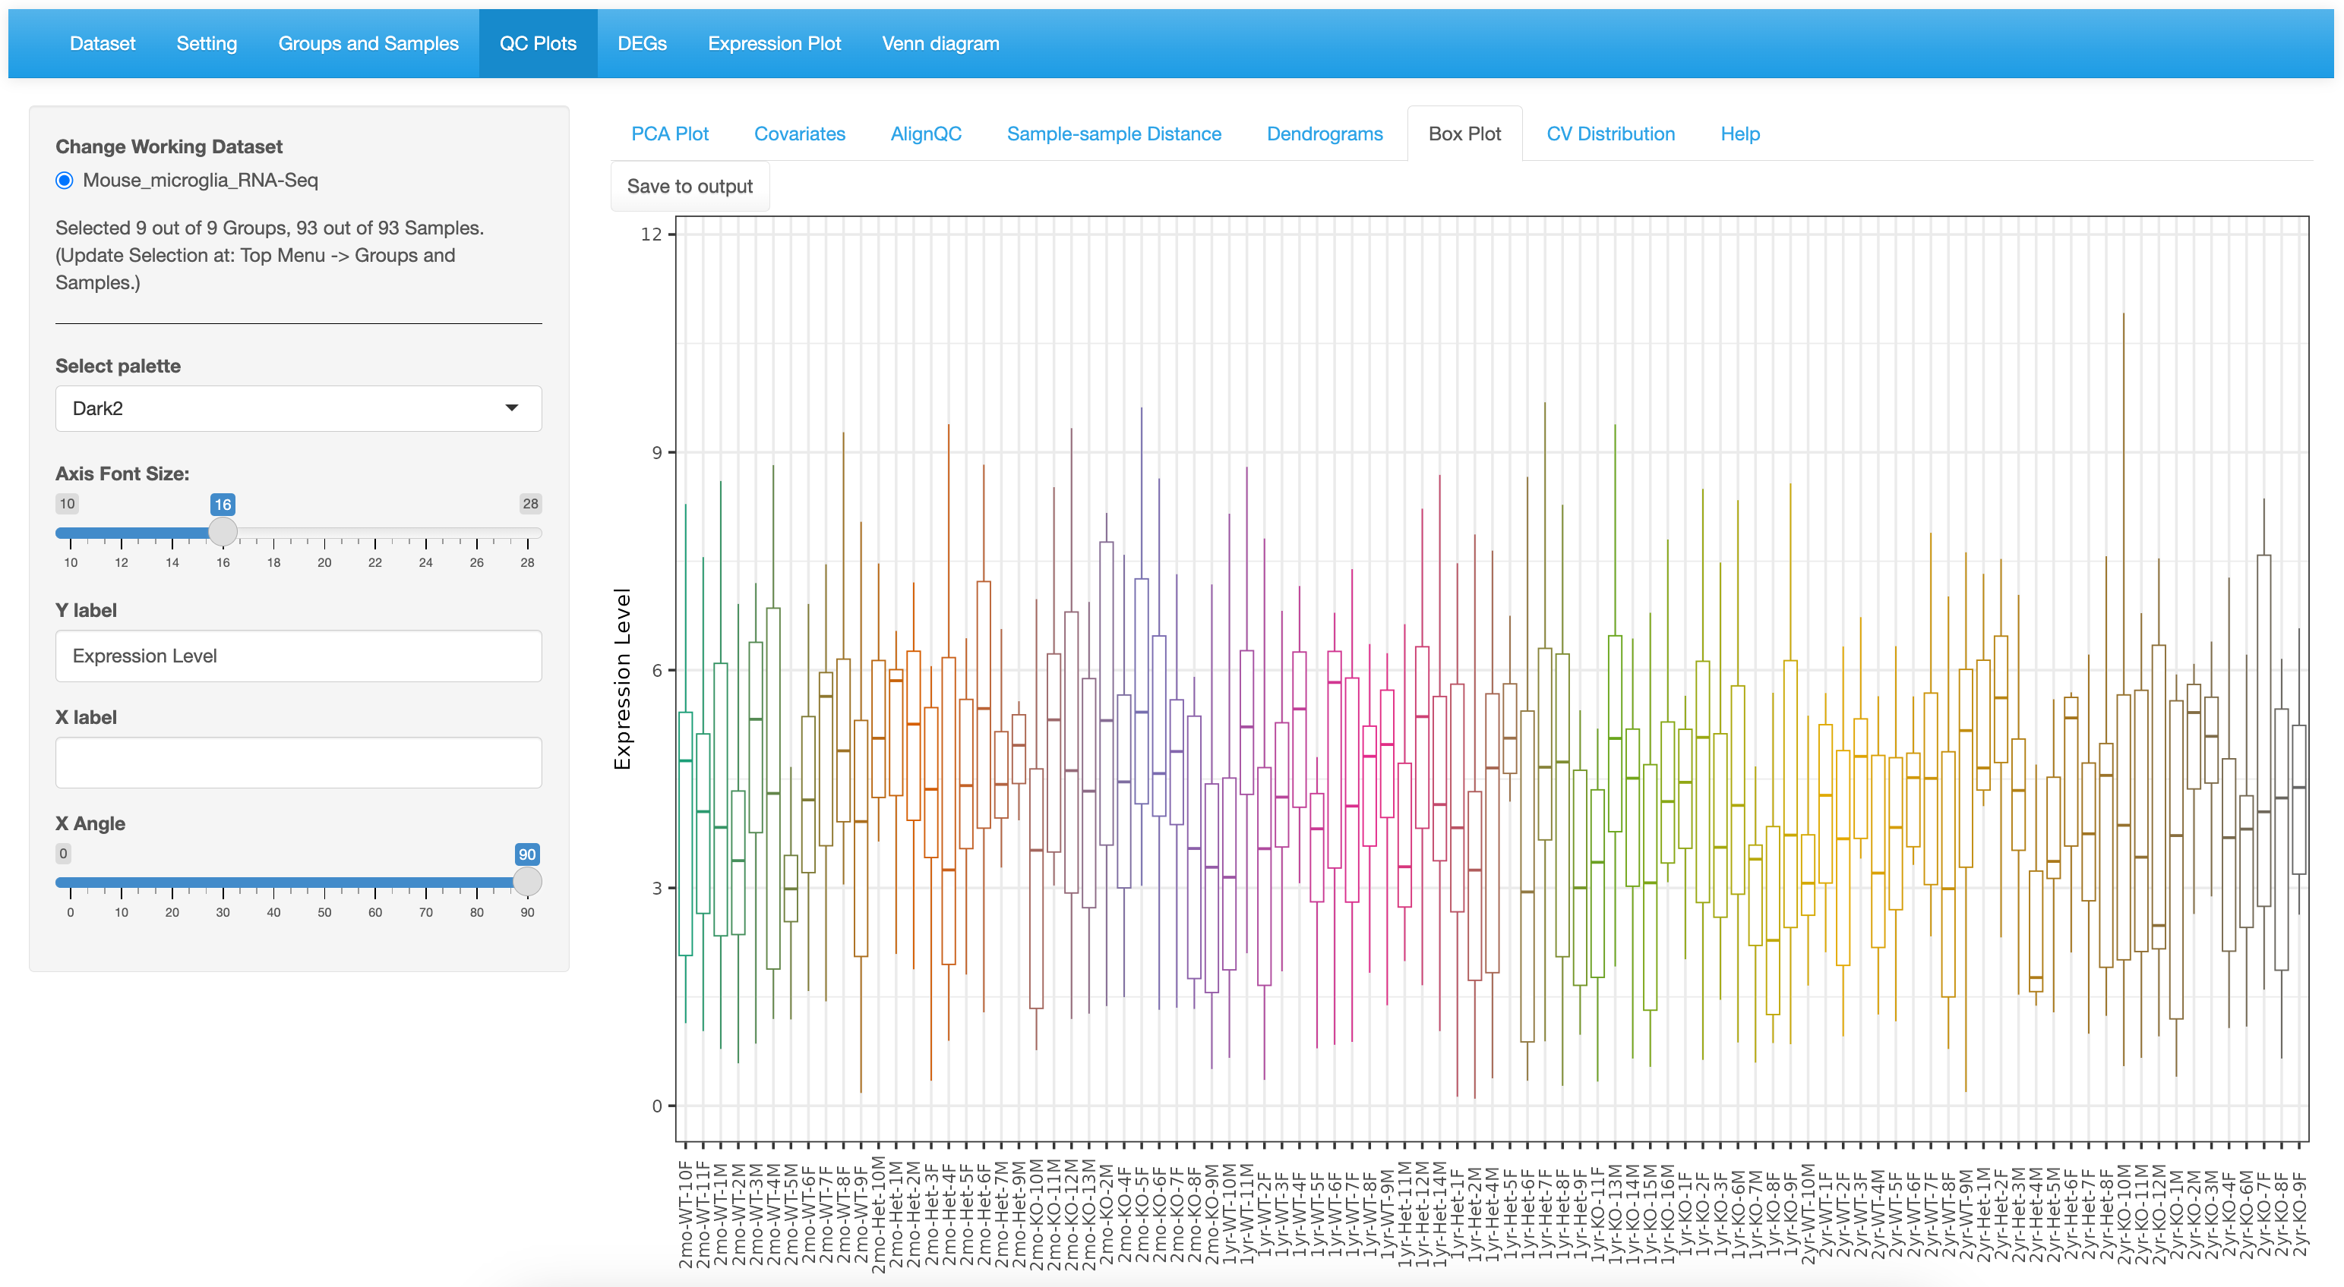

Click to save.

* 1. 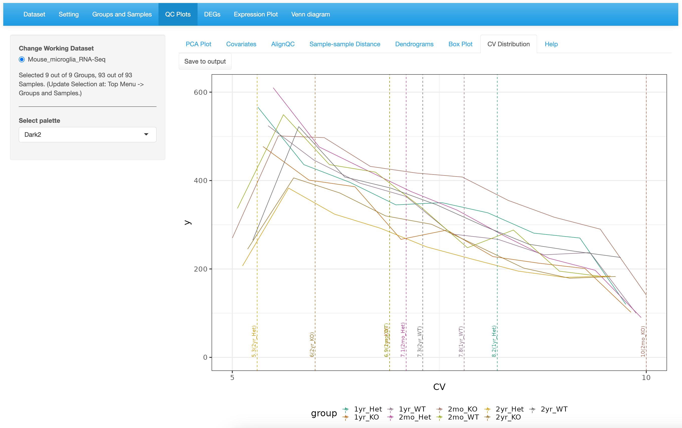

Median values marked by dotted line.

Click to save.

1. DEG
   1. 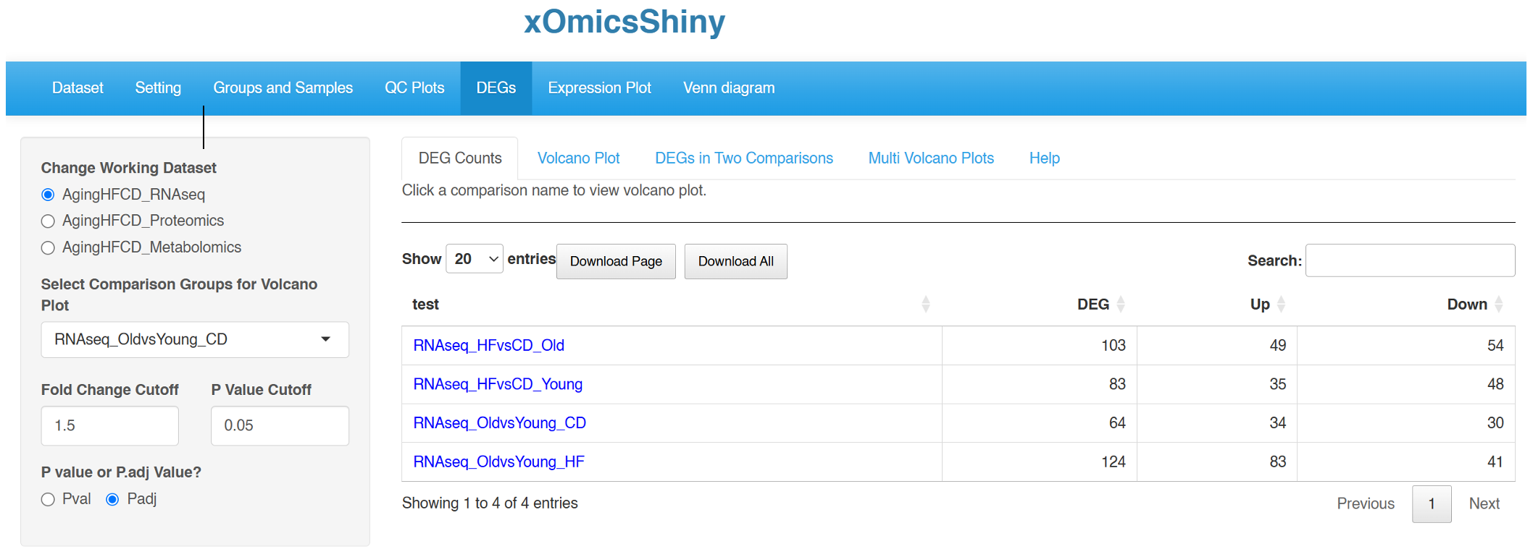

Select Dataset

Set DEG Cutoffs

# of DEGs per Comparison

* 1. 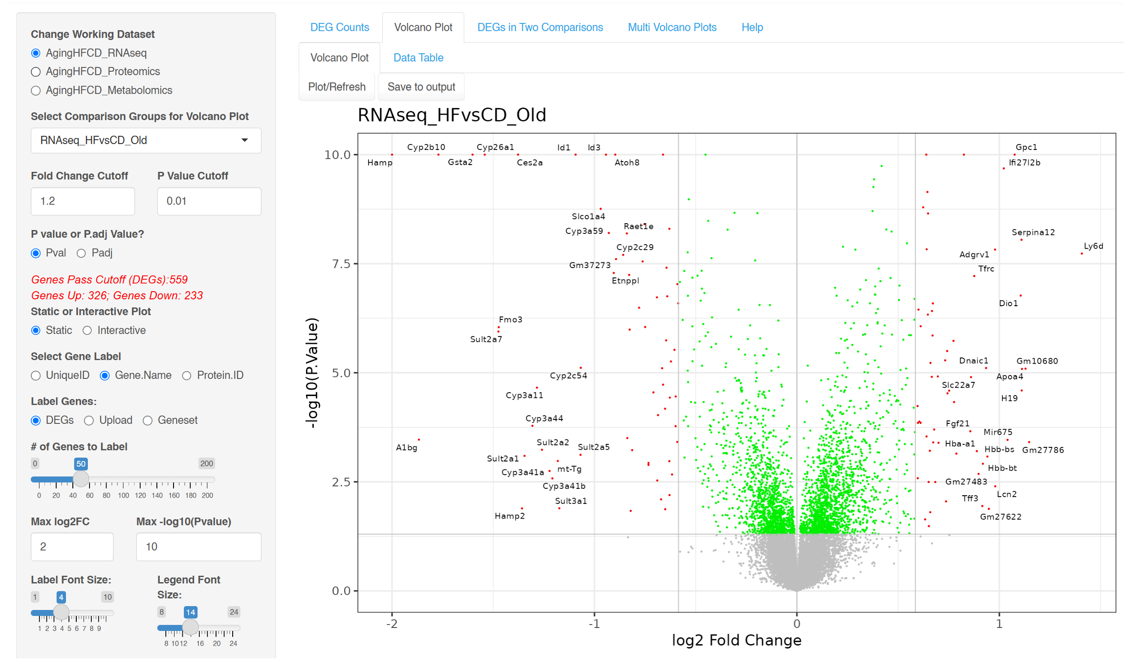

Up-Regulated Genes

Down-Regulated Genes

Adjust to limit extreme values.

# of DEGs Based on the Cutoffs (dynamic)

DEG Cutoffs

Select Dataset and Comparison

* 1. 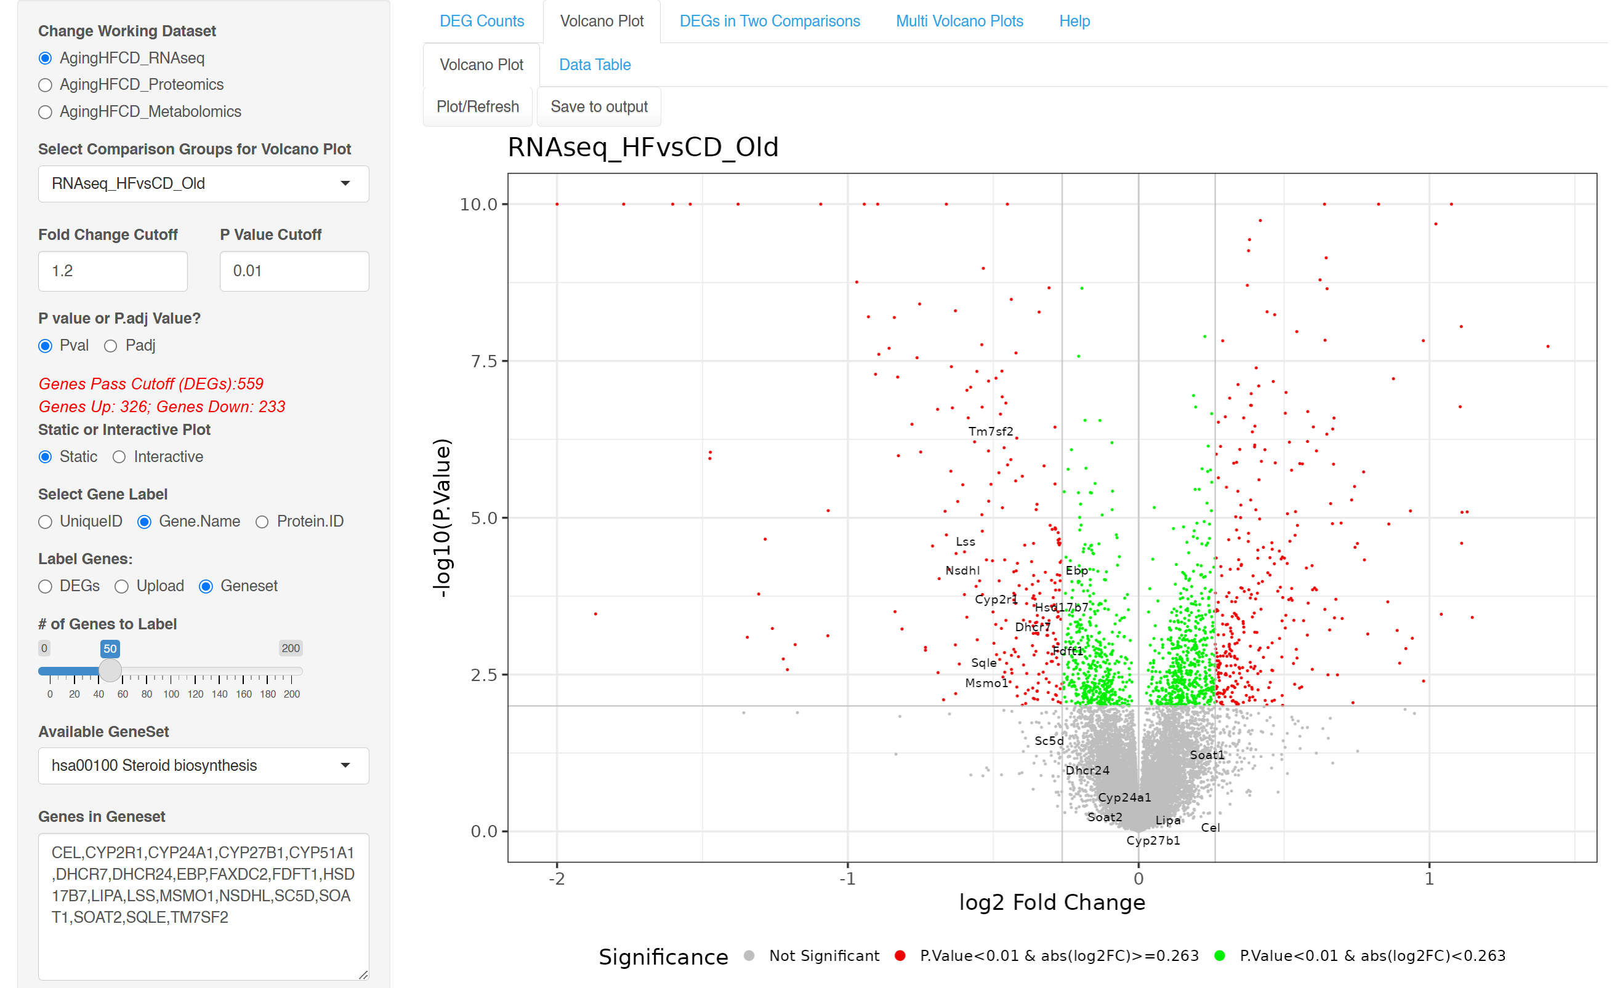

Most of the hsa00100 steroid biosynthesis genes are down-regulated.

3.Click Plot/Refresh button

Genes from the pathway are auto-populated.

2.Choose the KEGG pathway hsa00100

1.Select Geneset to label

* 1. 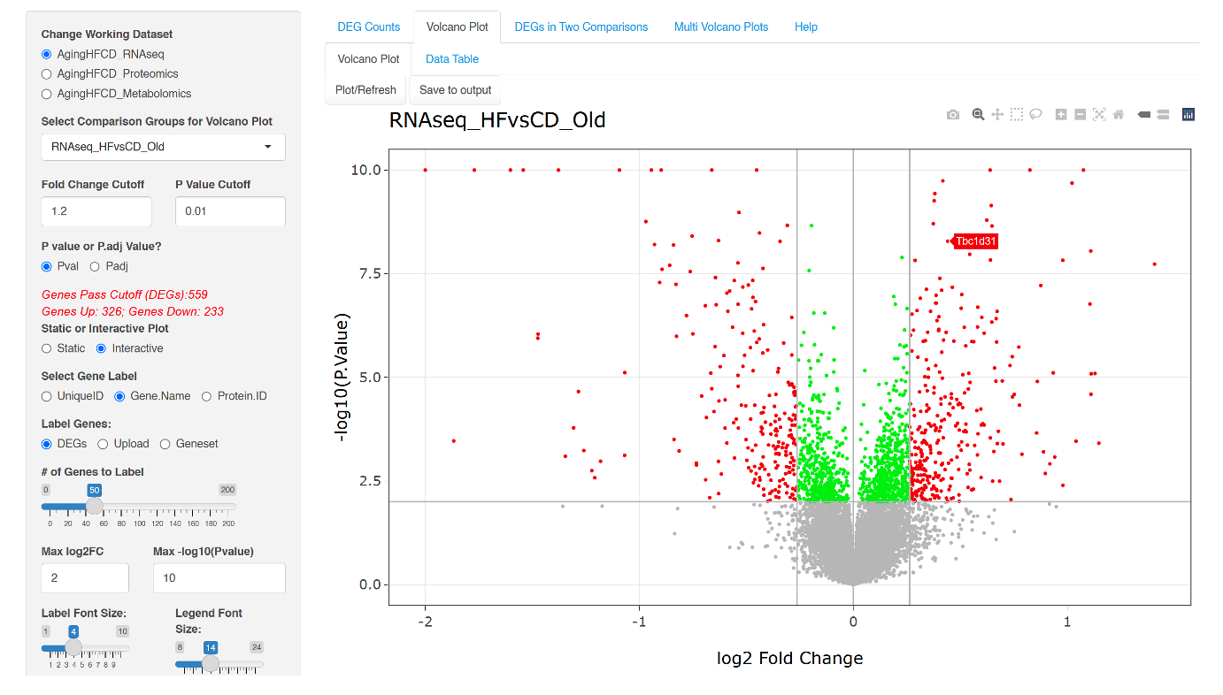

Zoom in/out and other controls

Mouse over to view gene name.

Choose Interactive Plot

* 1. 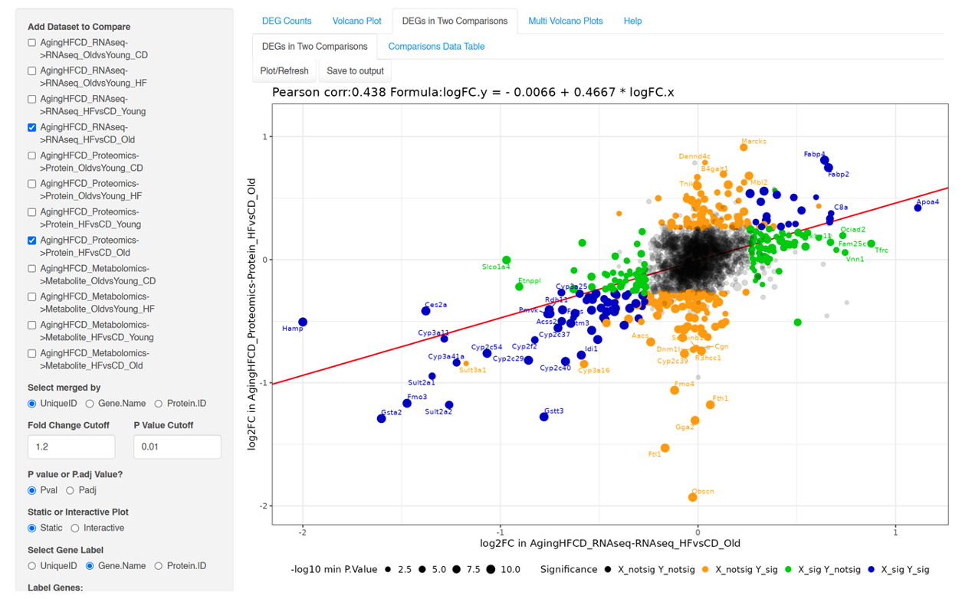

Correlation score

Set DEG Cutoffs

Select 2nd comparison proteomics.

Select 1st comparison RNA-Seq

* 1. 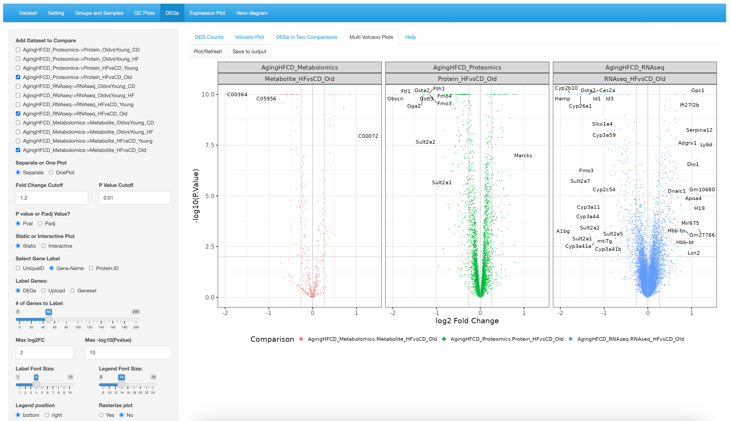

Select Comparisons across datasets

Set DEG Cutoffs

1. Heatmap
   1. 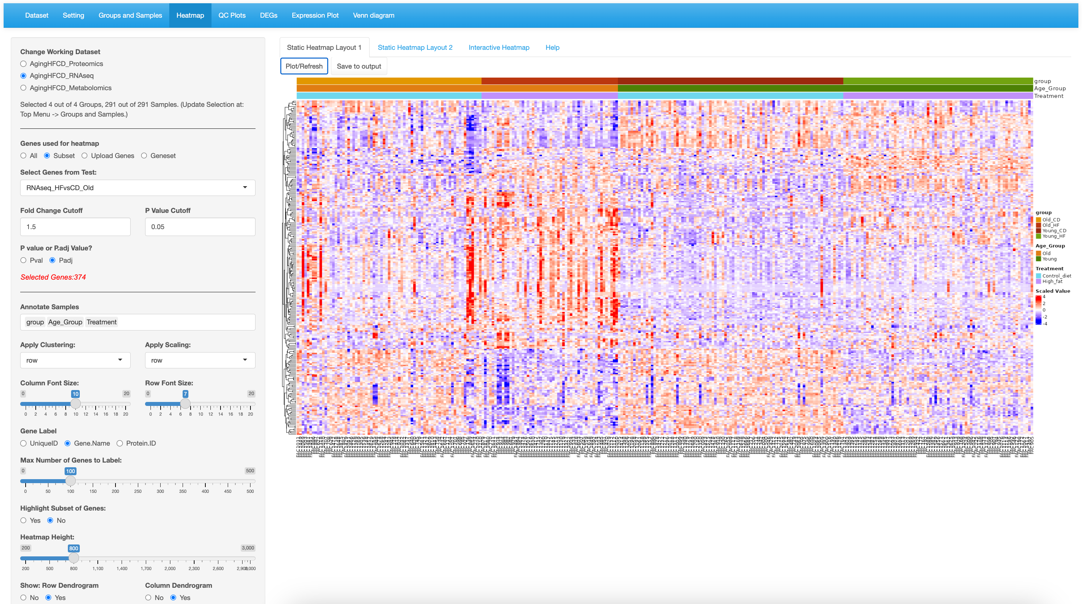

Top up-regulated genes in CD group including Old_CD and Young_CD. Young_HF.

Top up-regulated genes in CD group including Old_CD and Young_CD. Young_HF.

Each column is 1 sample.

Top up-regulated genes in Old_HF.

1.Change genes to “Subset” for DEGs

2.Select comparison and pick cutoffs

3. Annotation categories for columns

4. Click Plot/Refresh to view

Column annotation legend

Each row is 1 gene (out of 374)

Top up-regulated genes in young group including Young_CD and Young_HF.

* 1. 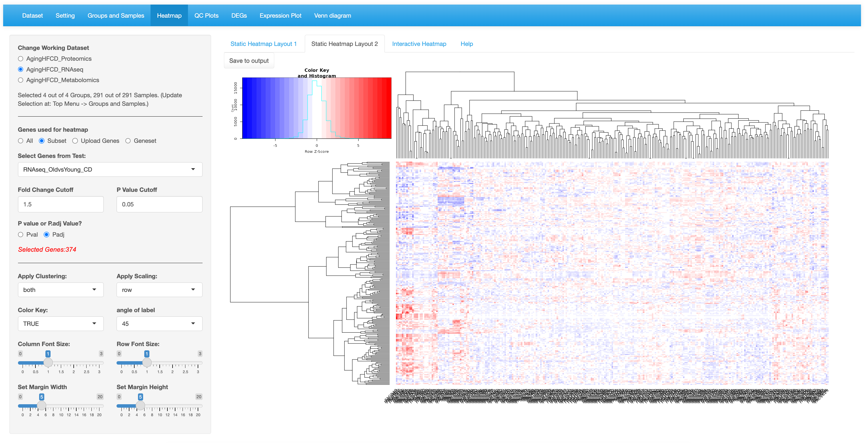

Click to save.

* 1. 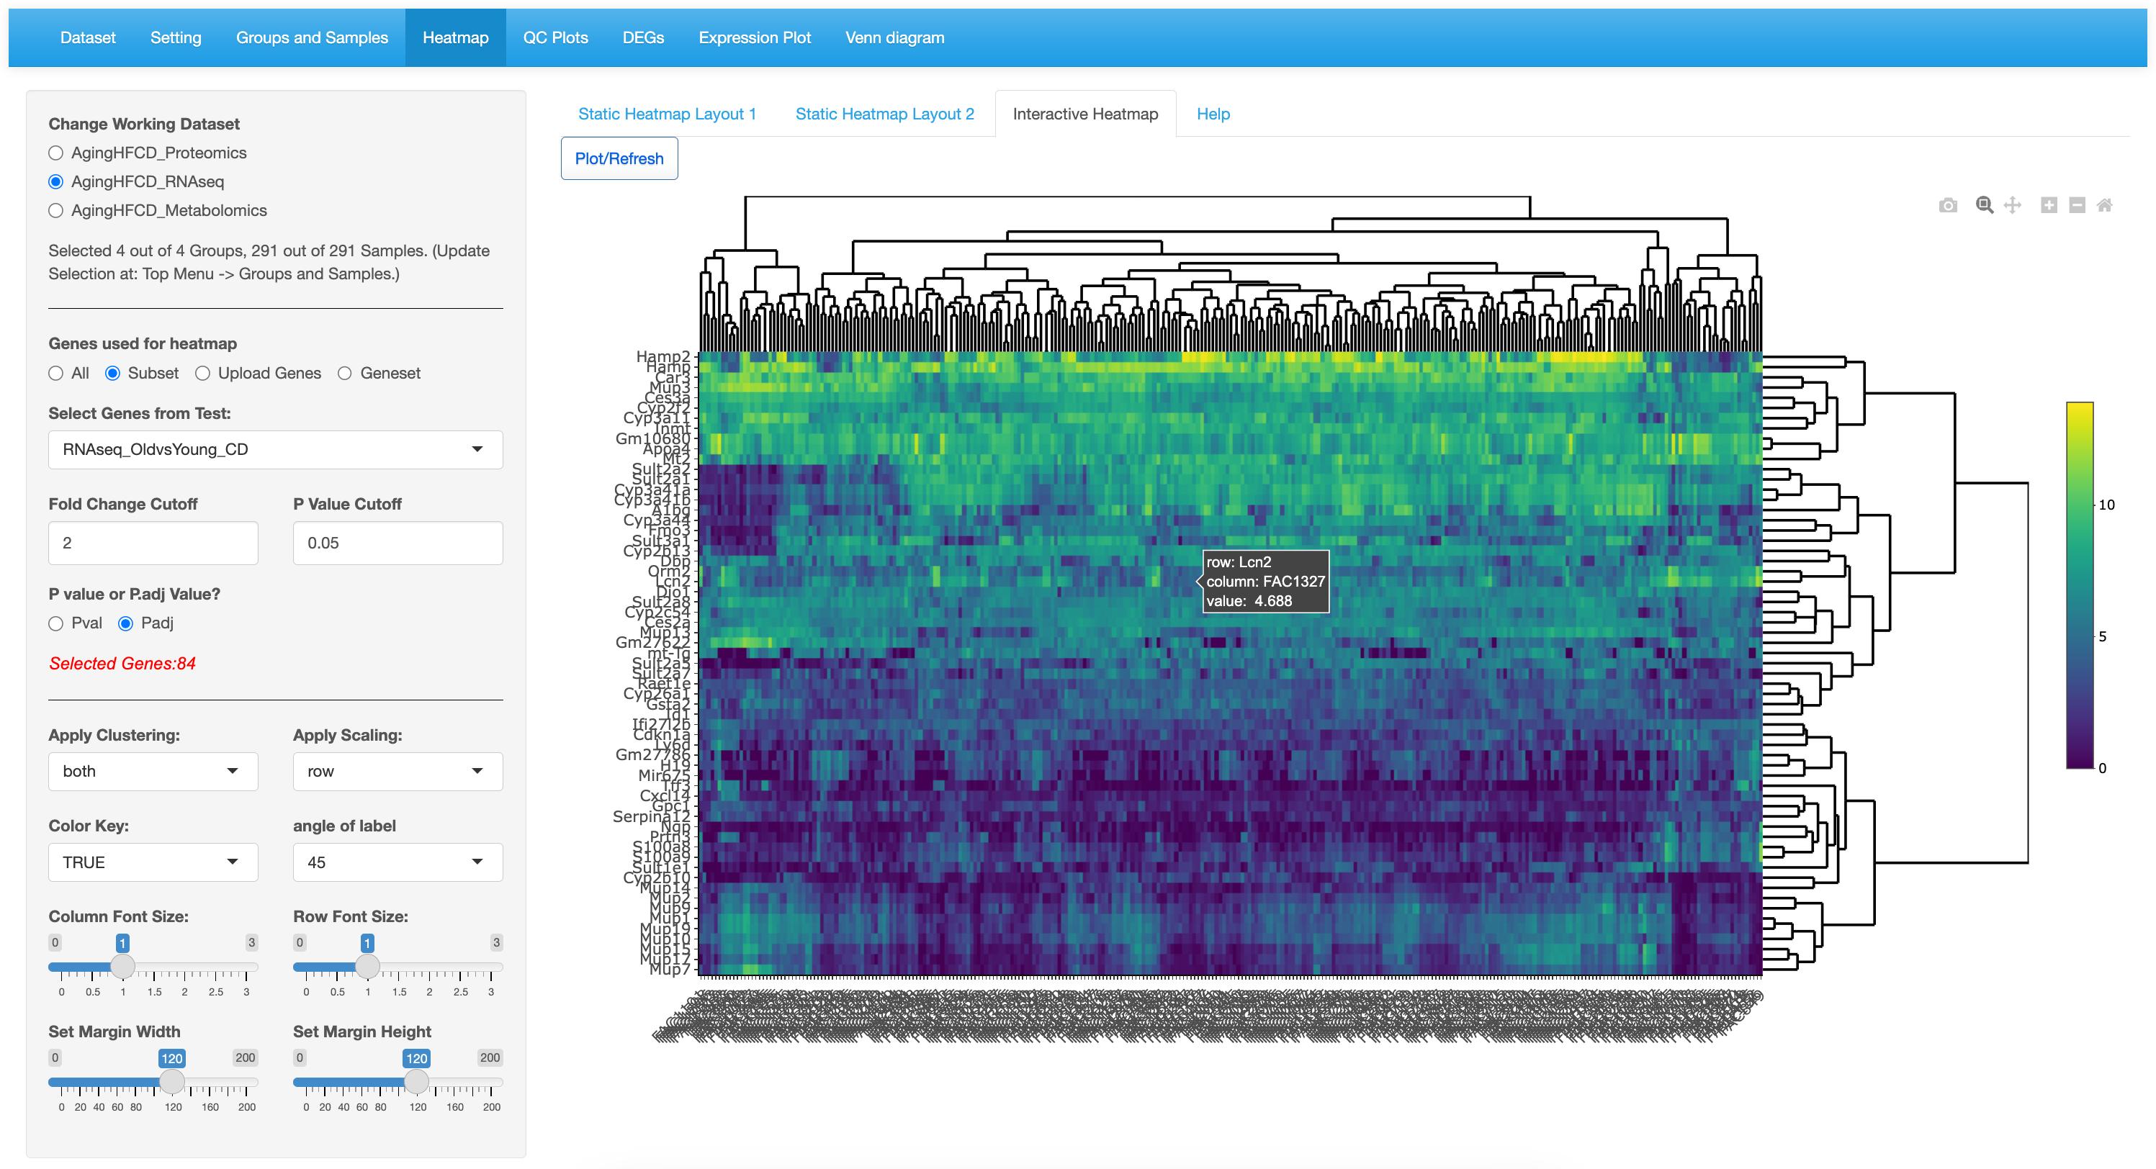

Functional button to save, zoom and move the plot.

Mouse over to see detail.

1. Expression
   1. 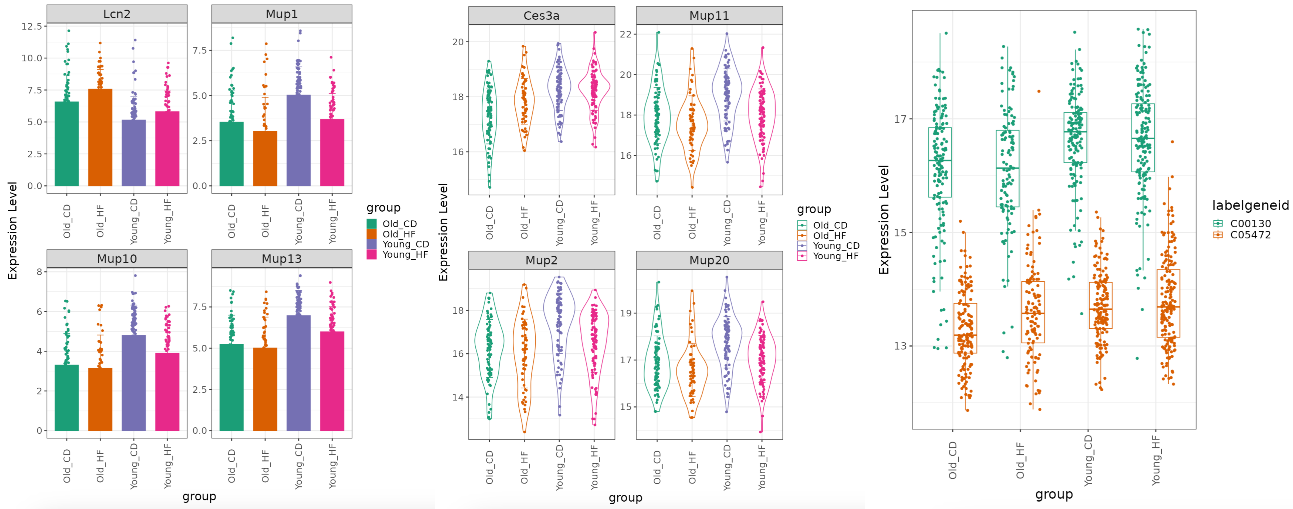

Individual bar plots

Metabolomics metabolites

Proteomics proteins

RNAseq genes

Combined box plots

Individual violin plots

Individual bar plots

* 1. 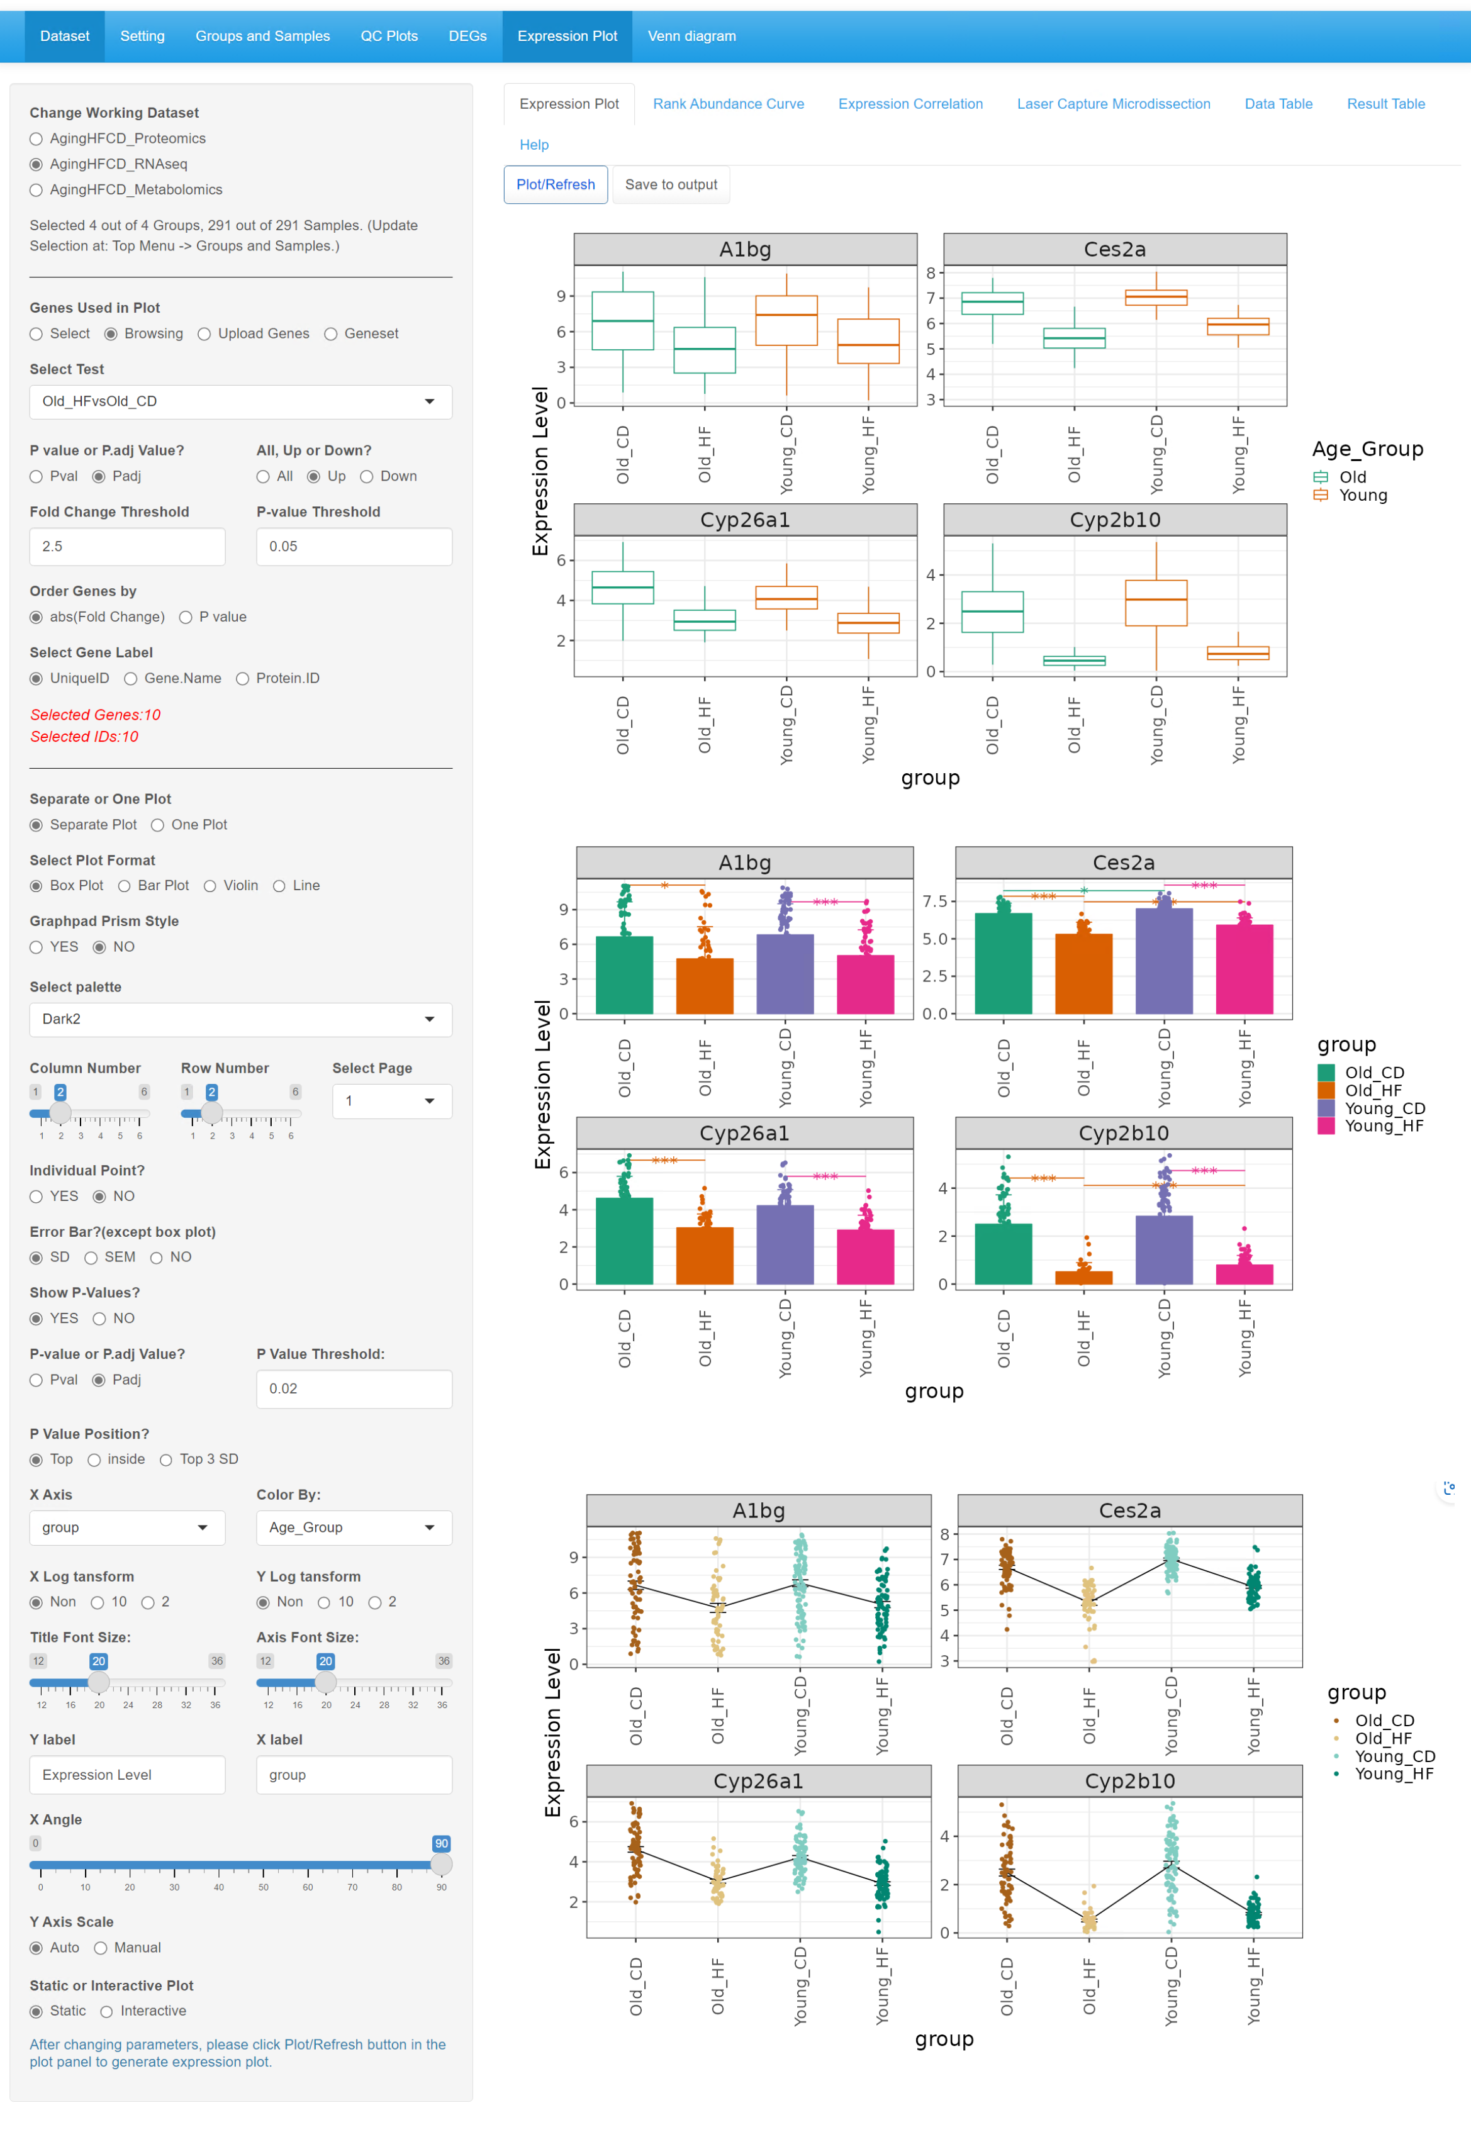

Bar plot  
separate plot  
show error bar (SD)  
show individual point  
show P-values.

Line plot  
separate plot  
show error bar (SEM)  
show individual point  
don’t show P-values.

Box plot  
separate plot  
no individual point  
don’t show P-values.

Plot options and preference options.

Select the data source and the organize way.

Select a data set.

* 1. 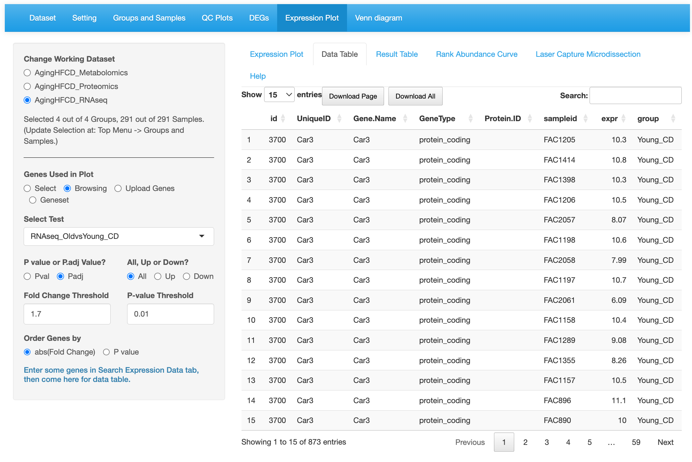
  2. 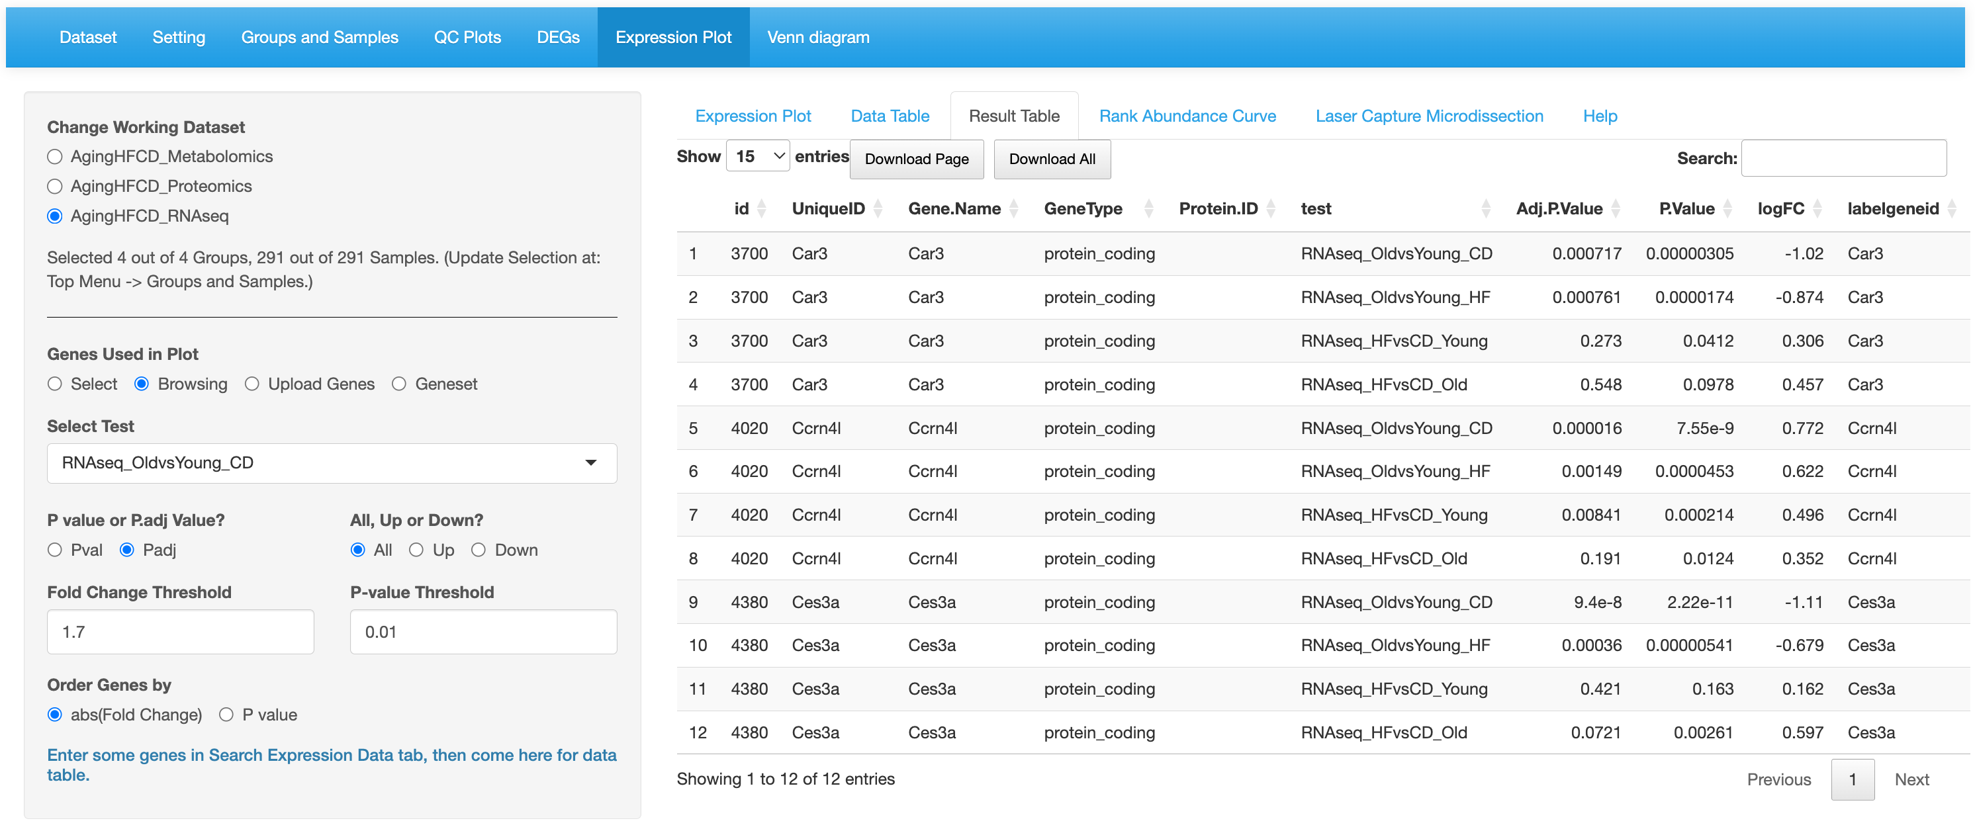
  3. 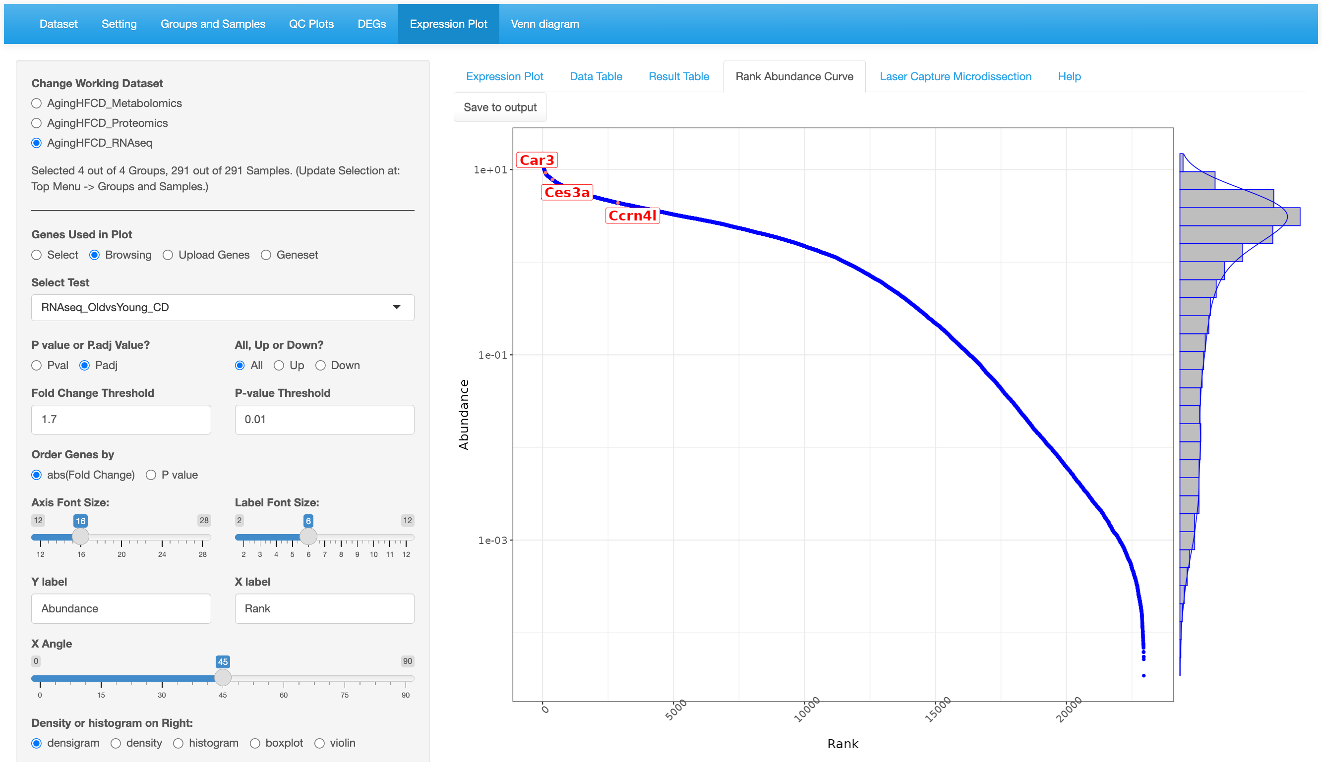

Steep gradient indicating that those few genes have different expression and abundances

Shallow gradient indicating that those genes have similar expression and abundances

* 1. 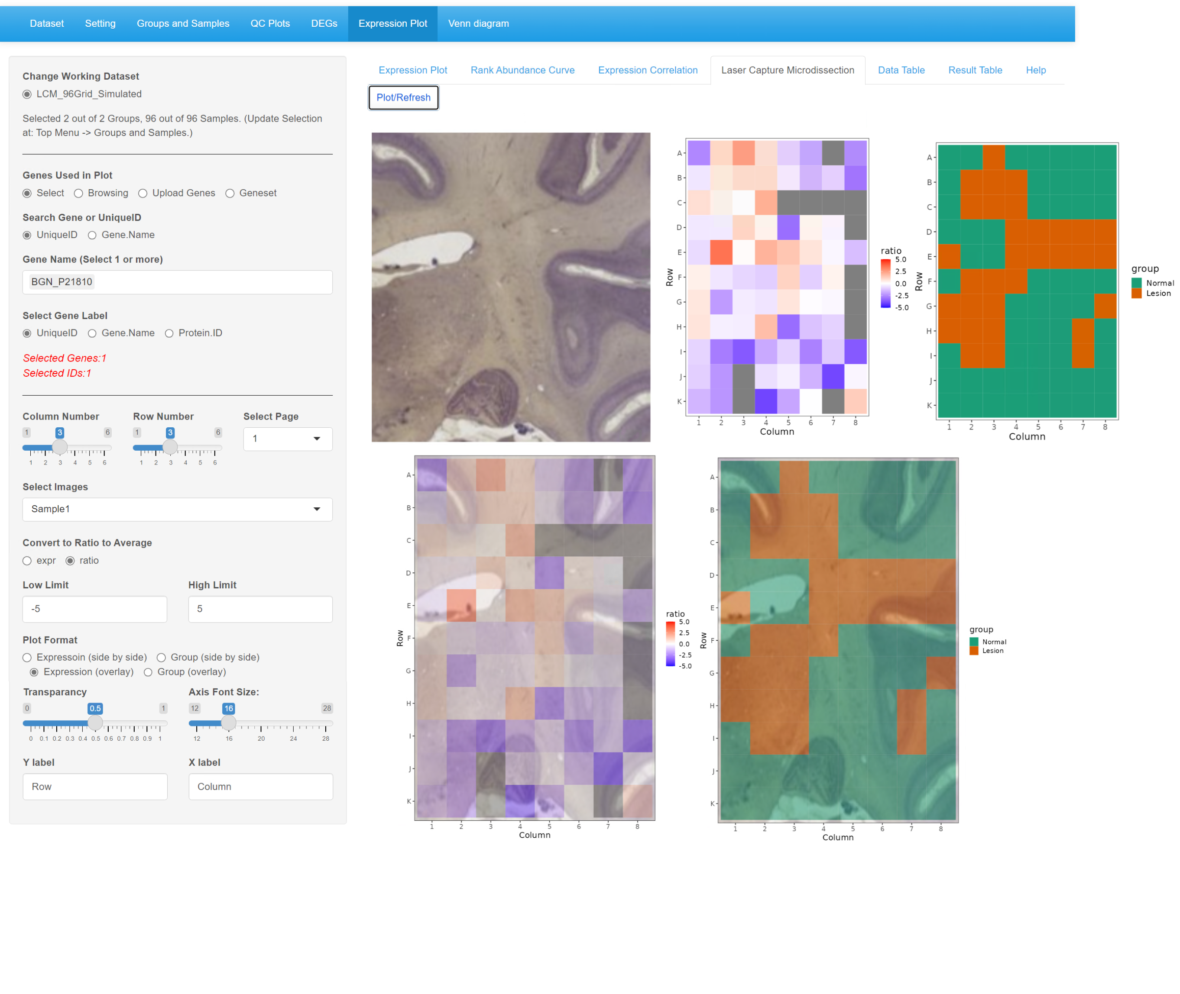

Side by side

Display options.

Select data source.

Group

Overlay

Expression

Group

Expression

1. GeneSet enrichment
   1. 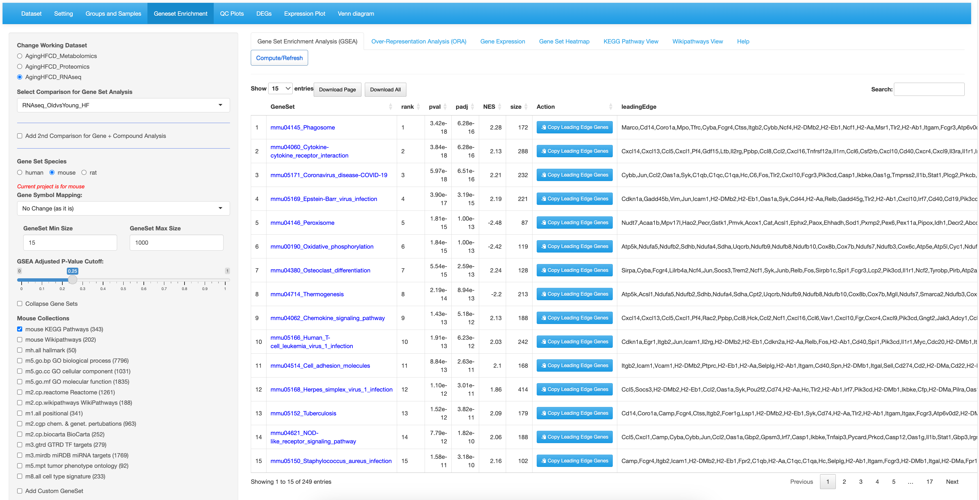

Click a Gene Set name will go to the Gene Expression tab and show detailed expression data.

4.select database. Multiple selection is supported. Or upload your own list.

3.Set GSEA cutoffs

2.Select species. User can select different species by gene symbol mapping methods.

1.Select data set, comparison of RNAseq, Proteomics and metabolomics (optional).

Top regulated pathways are infection related.

Pathways identified sorted by rank.

* 1. 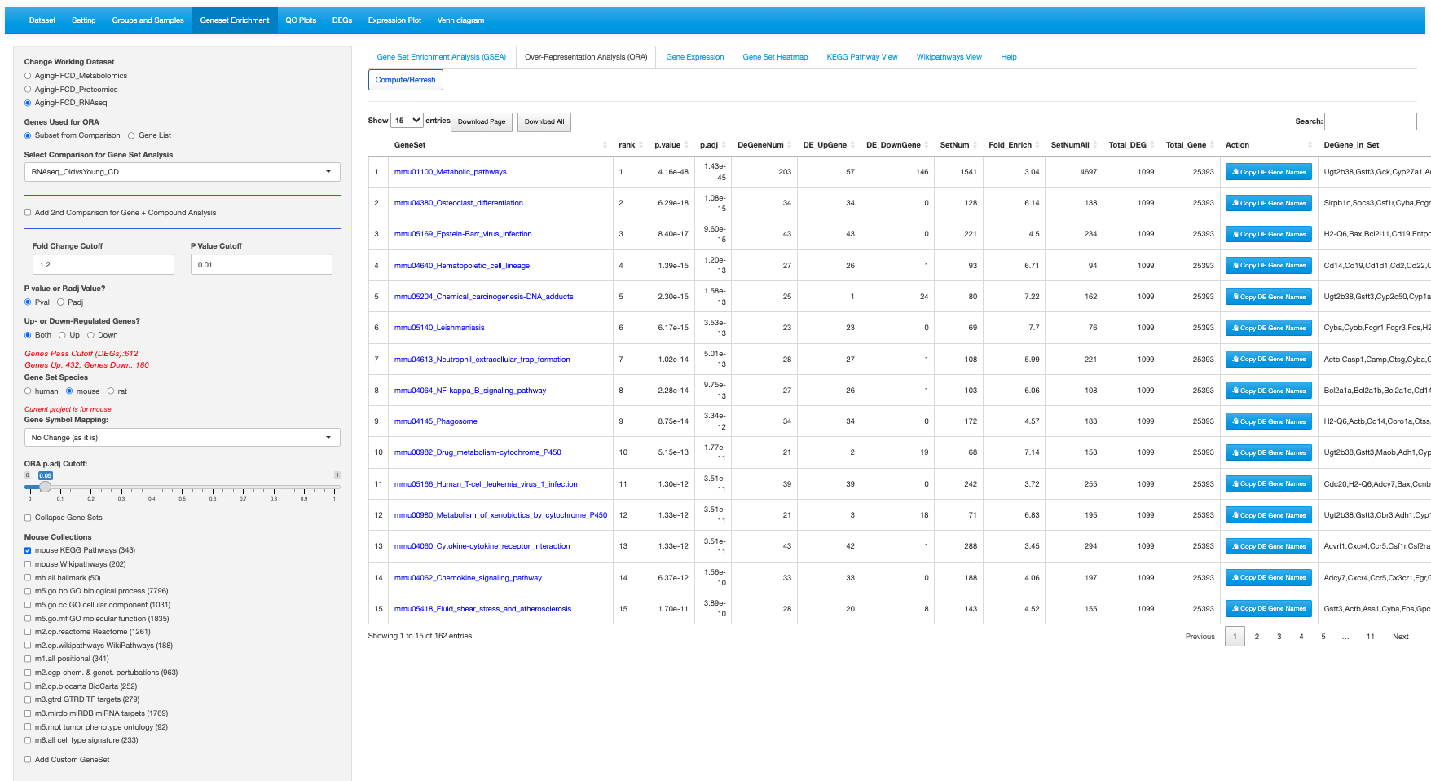  
       
       
     9.2-1  
     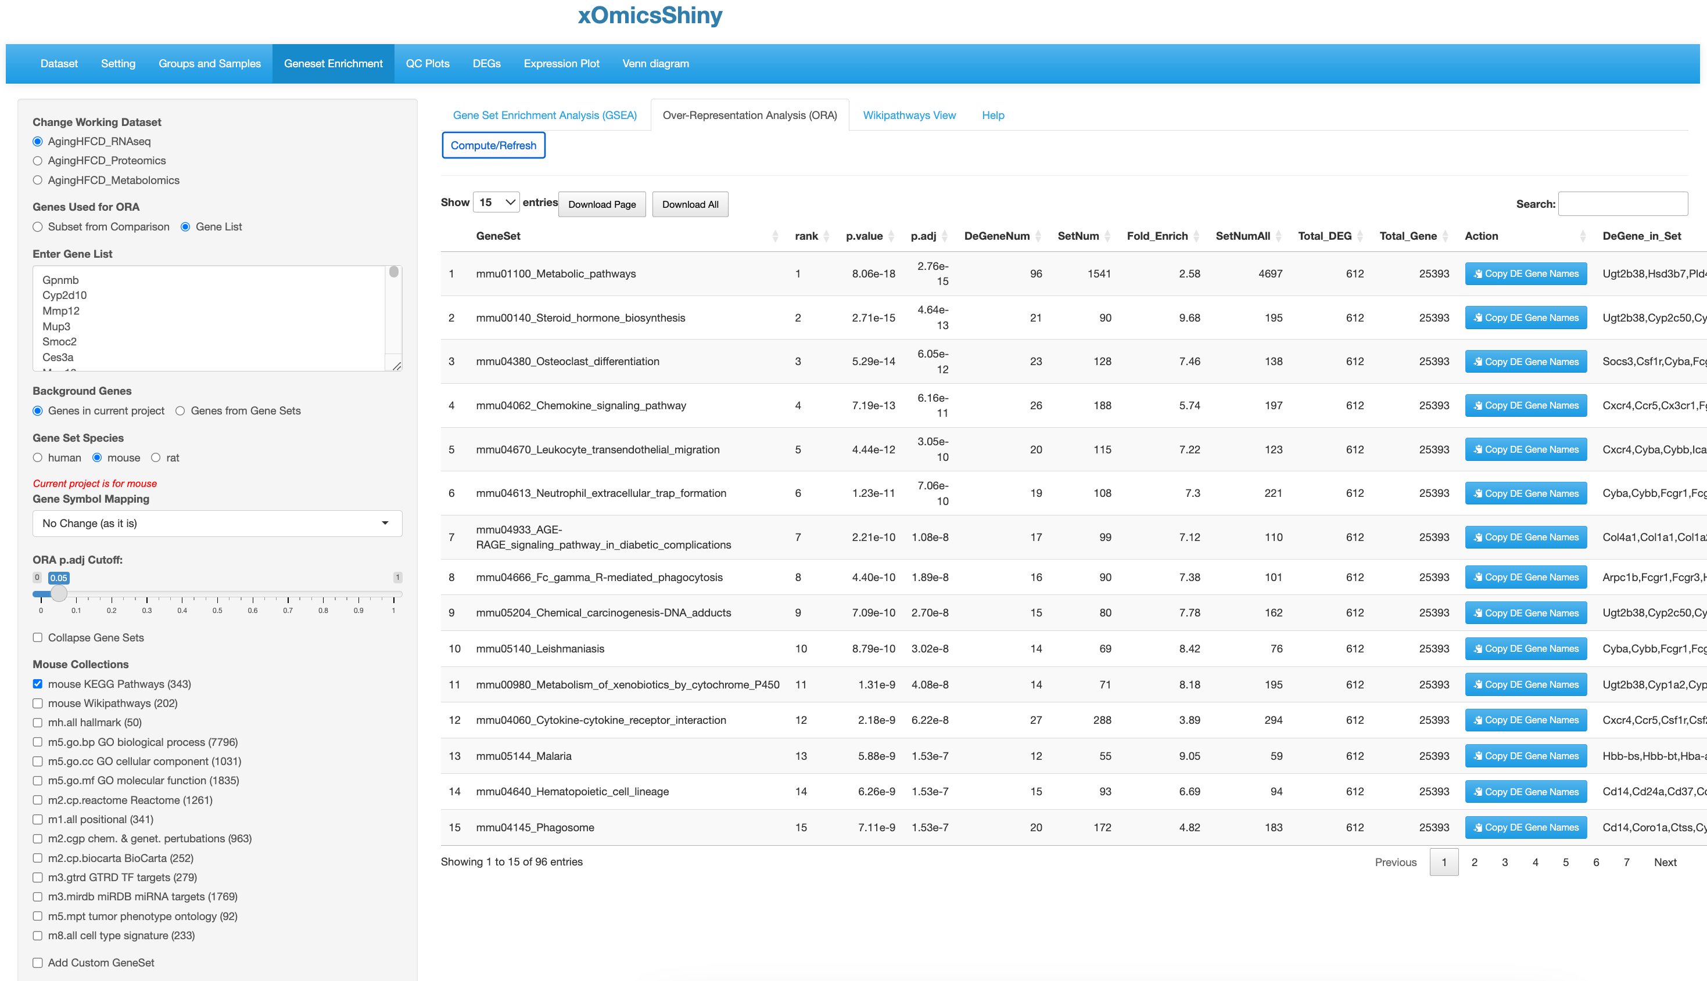

Enrichment results

summary for DEGs in each gene set

Click a Gene Set name will go to the Gene Expression tab and show detailed expression data.

Pathways identified sorted by rank.

4.Set ORA cutoff

3.Select species. User can select different species by gene symbol mapping methods.

2.If selected Subset from Comparison, then set comparison cutoffs to get the gene list.

1.Select data set(s). Then select or provide gene list.

5.select database. Multiple selection is supported. Or upload your own list.

2.If selecting Gene List, then select Background Genes.

Only report total DEGs in each gene set.

* 1. 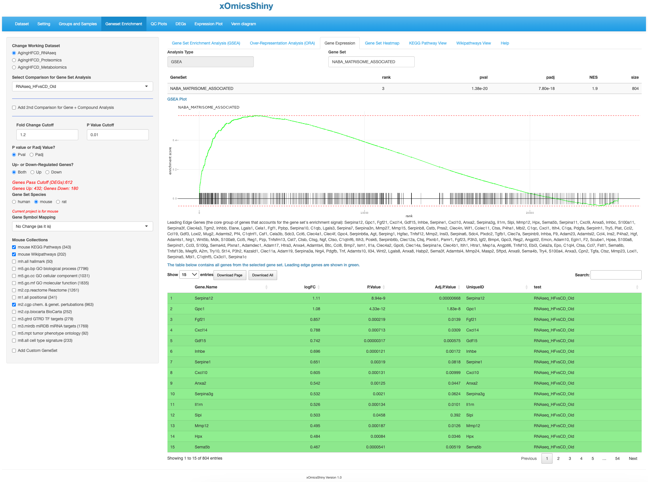

Gene set name

GSEA result summary and plot

Analysis type

Comparison results for all the genes in the gene set. The leading genes are highlighted in green.

* 1. 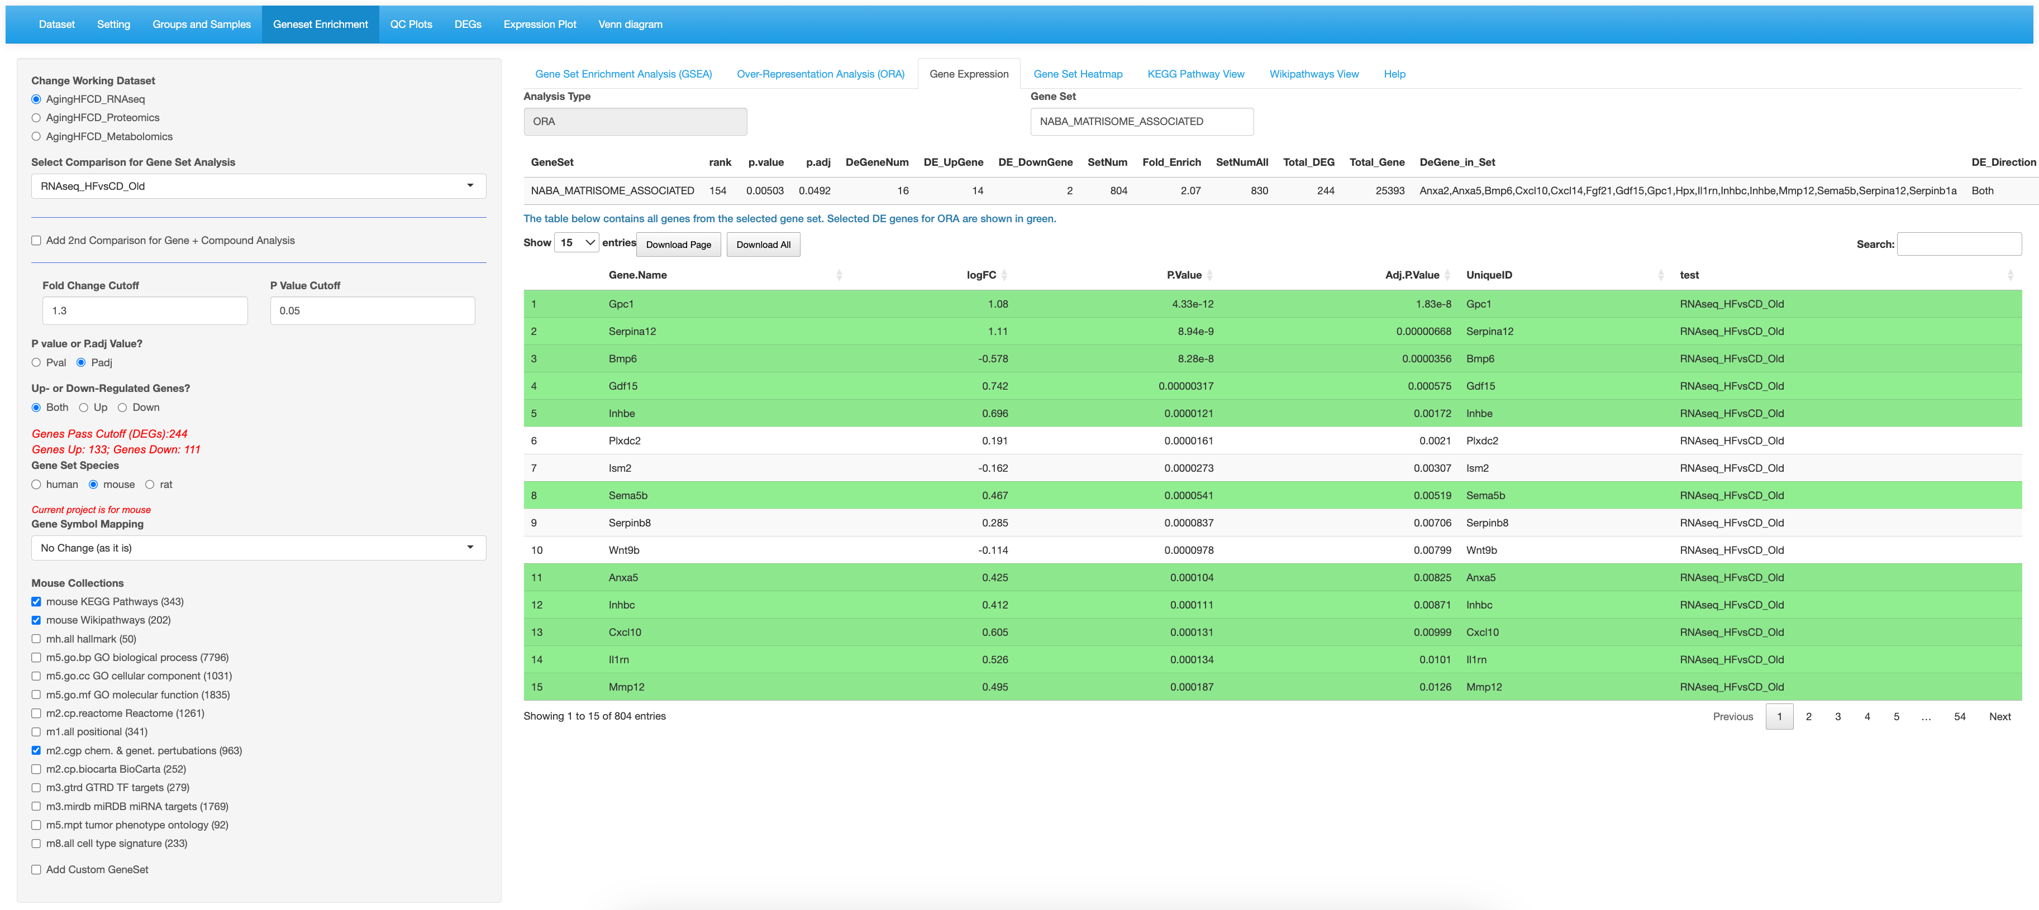

ORA analysis shows the result summary and comparison results for all the genes in the gene set. Selected DE genes are highlighted in green.

* 1. 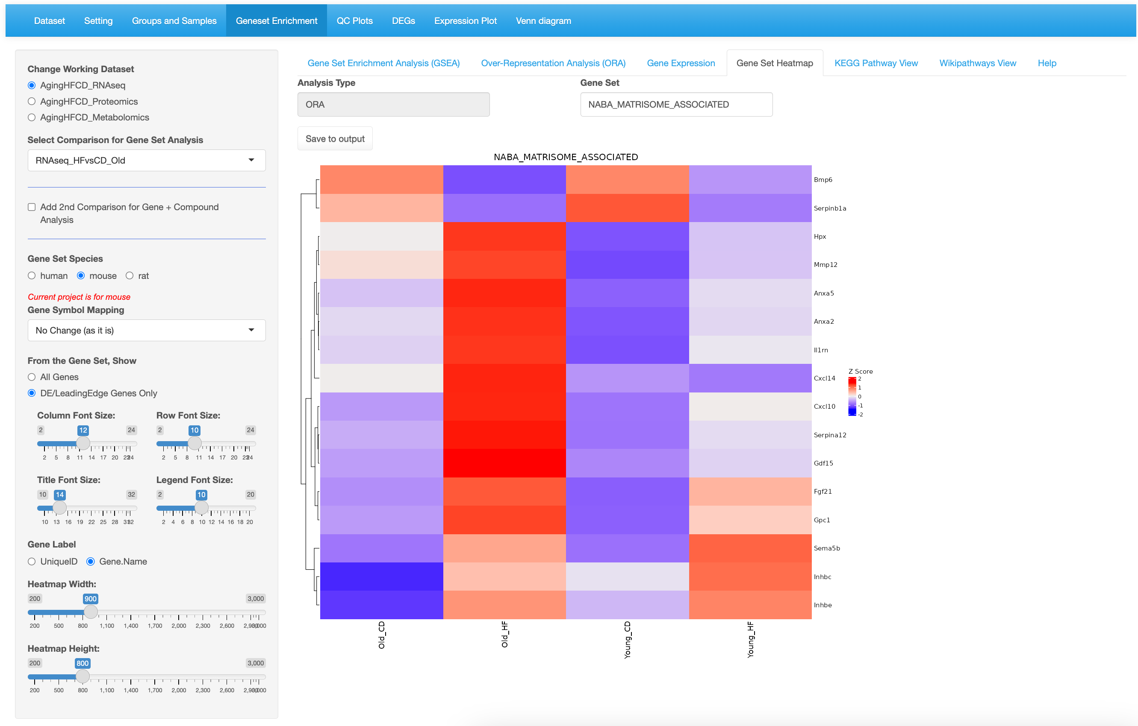

DE/LeadingEdge genes in the gene set.

Select to show DE genes only.

Gene set being probed

* 1. 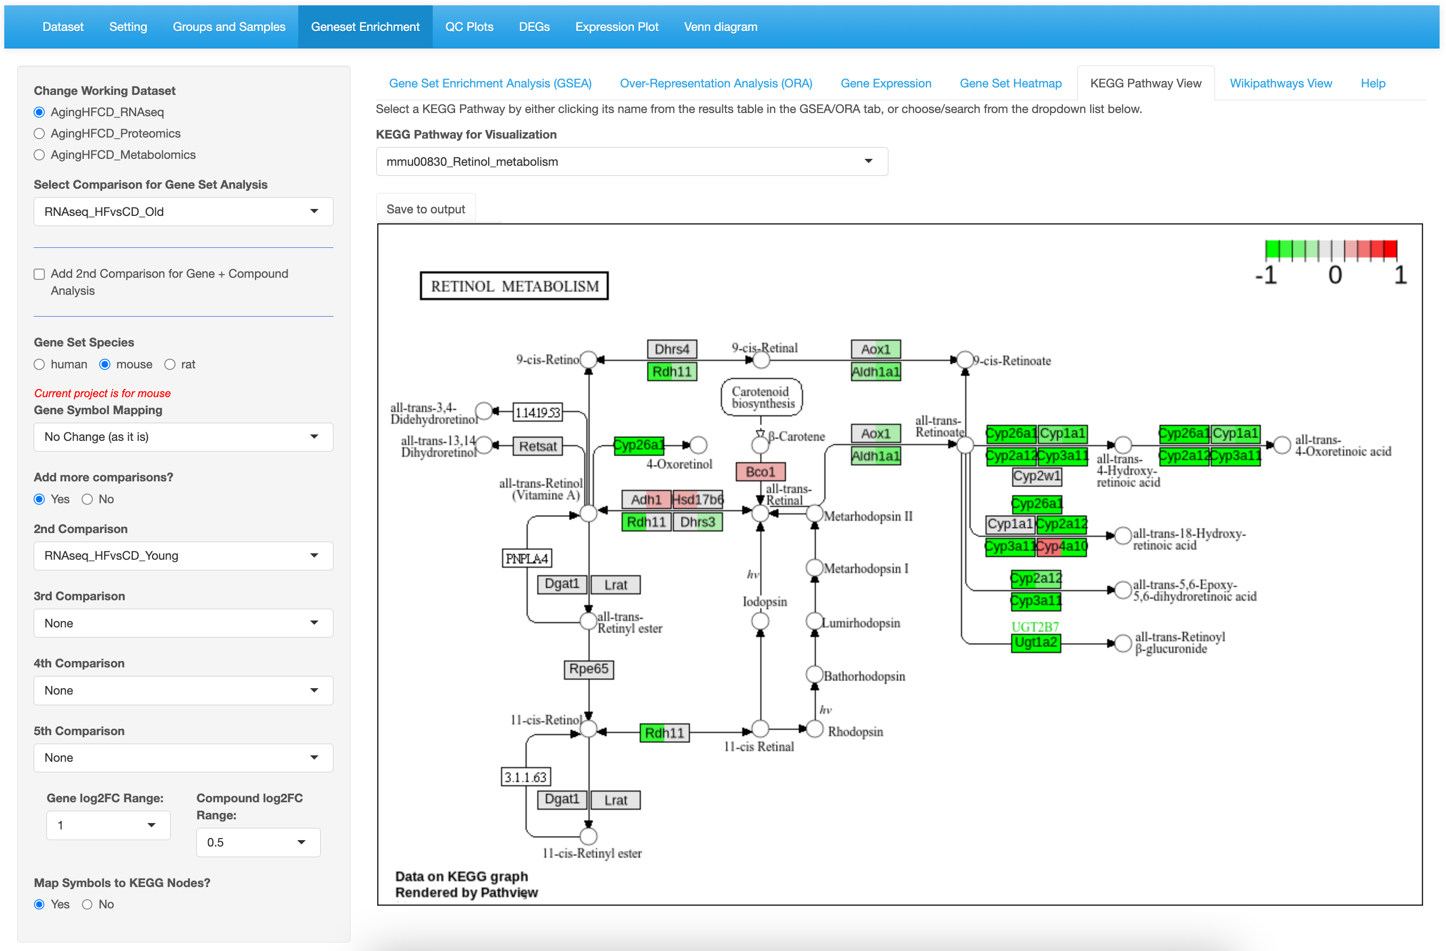

Expression is shown for all the comparisons in order.

Select up to 5 comparisons in the data set. only.

* 1. 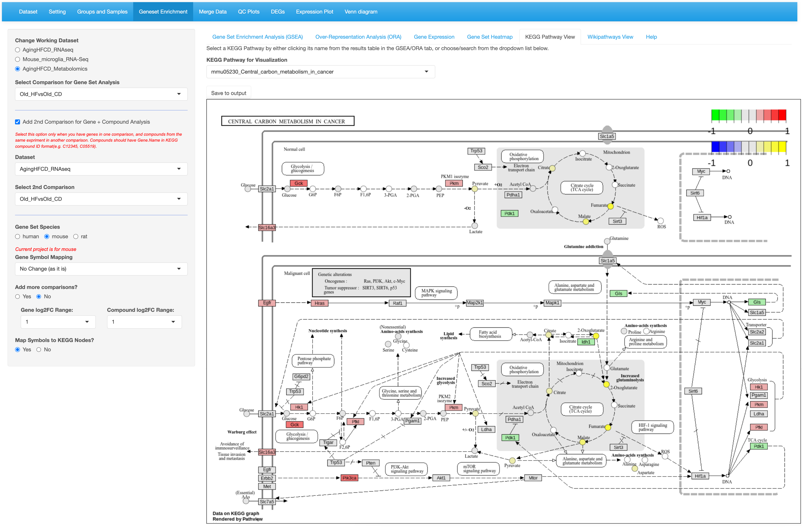

Select “Old_HFvsOld_CD” comparison for both Metabolomics and RNAseq.

Genes are the rectangles and metabolites are the circles.

Gene set name

* 1. 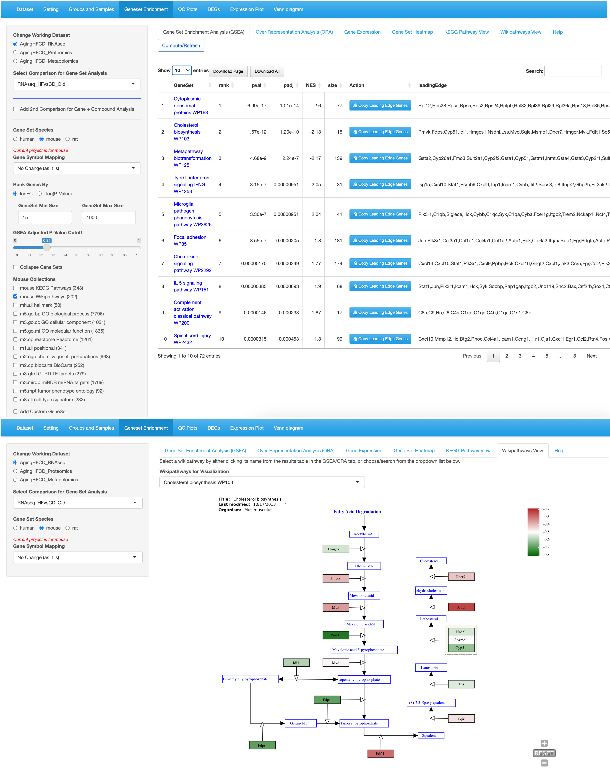

All the genes in the gene set are down-regulated.

Cholesterol biosynthesis pathway is ranked top 2 for HF vs CD comparison in old age group.

Gene sets from the WikiPathways database can be checked for the pathway scheme overlay.

1. Pattern module
   1. 1-1  
      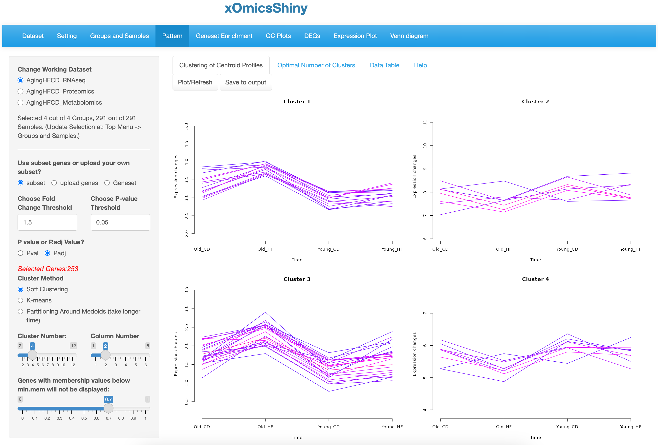  
        
      1-2  
      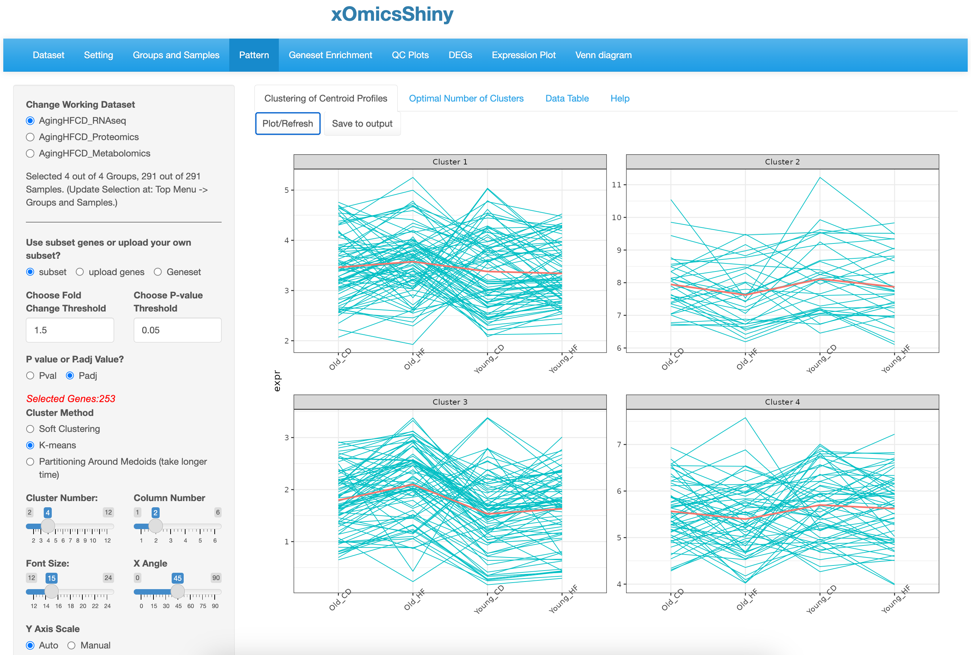  
        
      1-3  
      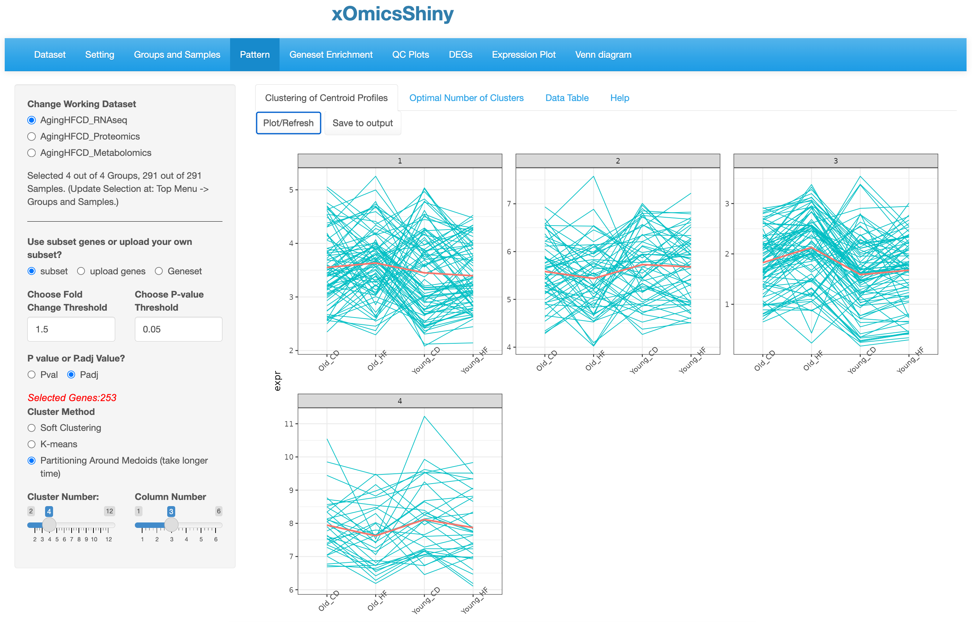

Lines are in different colors. Red color indicates membership value is high.

Set the minimal membership cutoff for soft clustering.

Set the number of clusters and display preference.

Choose the soft clustering method.

Choose the input gene list.

Centroid line is shown in red.

Set the number of clusters and display preference.

Choose the K-mean cluster method.

Choose the input gene list.

Choose the PAM cluster method.

Centroid line is shown in red.

* 1. 2-1  
     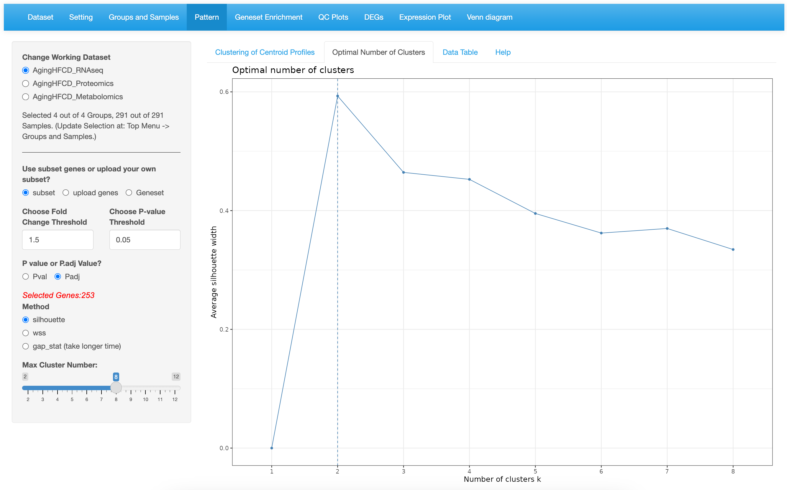  
       
     2-2  
     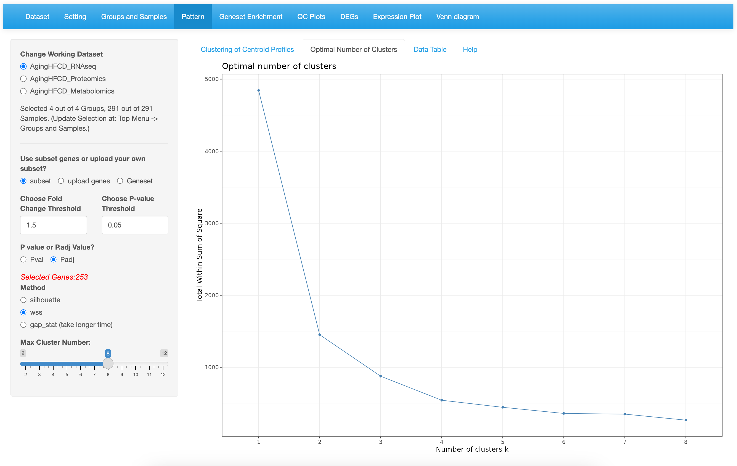  
       
     2-3  
       
     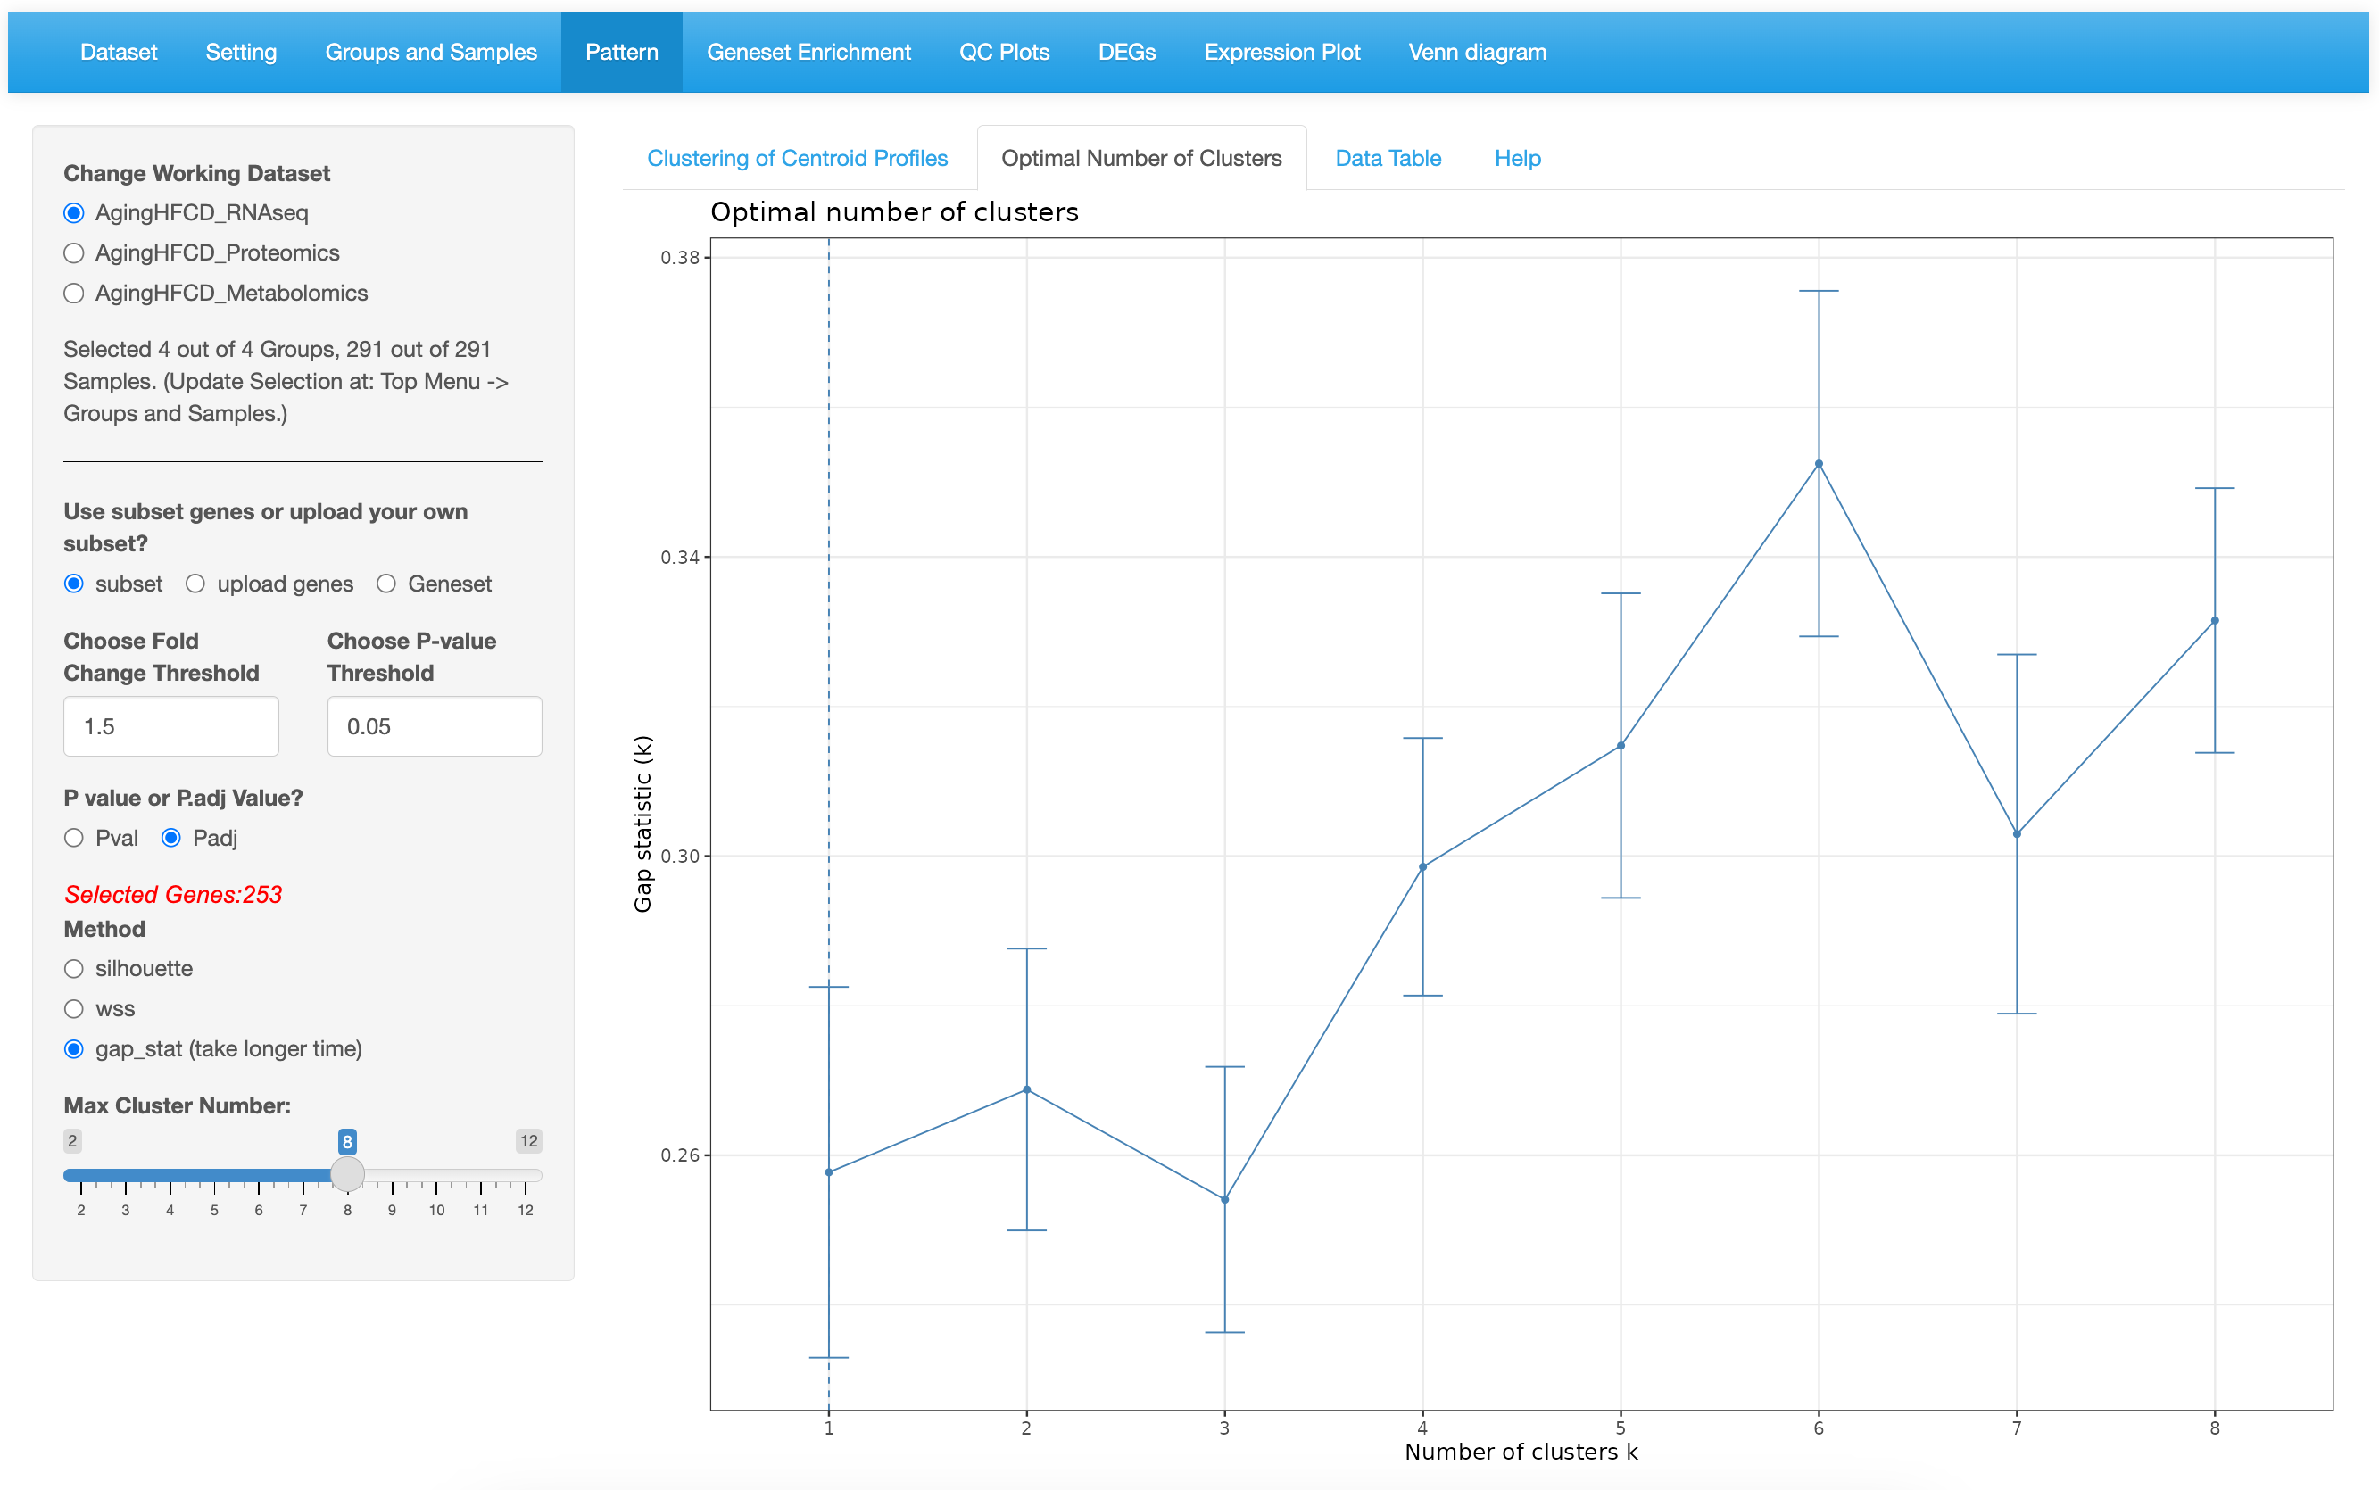

Optimal number of clusters shows the largest silhouette coefficient.

Choose the method.

Optimal number of clusters locates at the bend of the plot.

Choose the method.

Optimal number of clusters is the smallest k such that the gap statistic is within one sd of the gap at k+1.

Choose the method.

* 1. 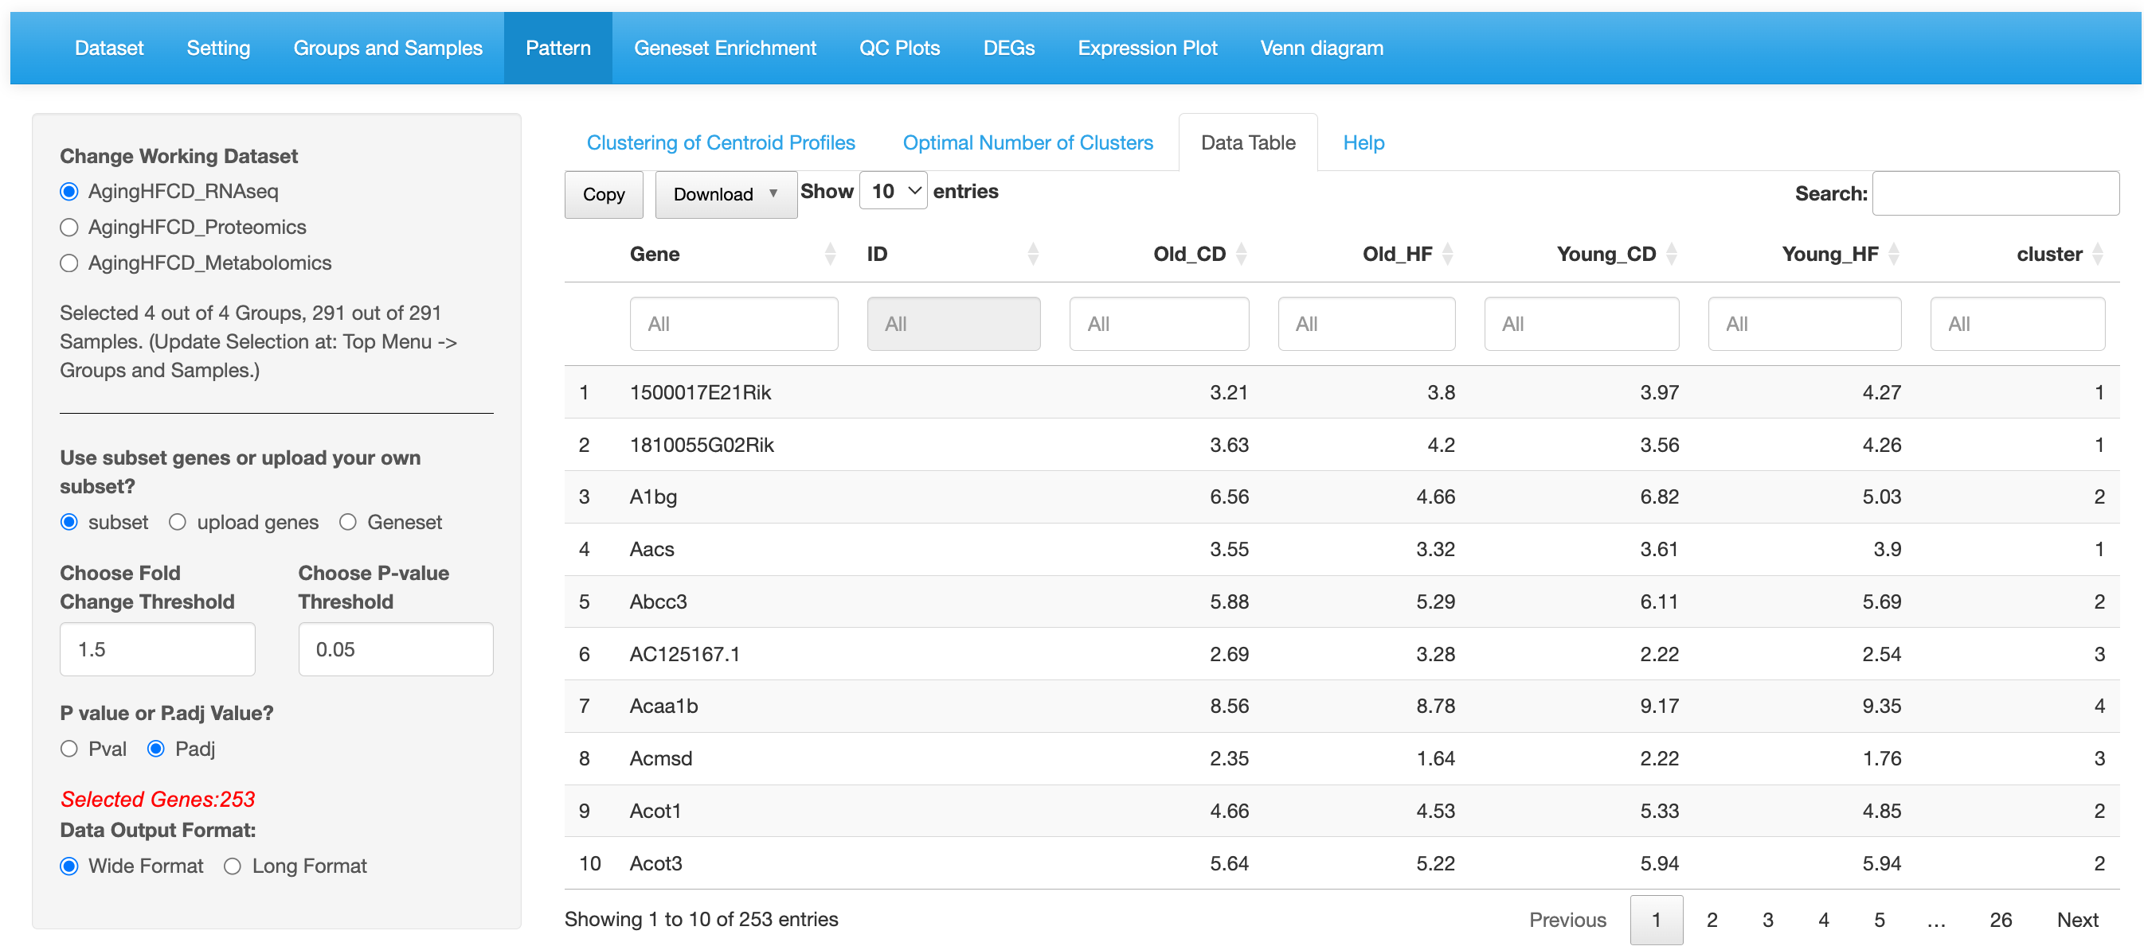

All columns can be sorted or filtered.

Choose table format.



1. WGCNA
   1. 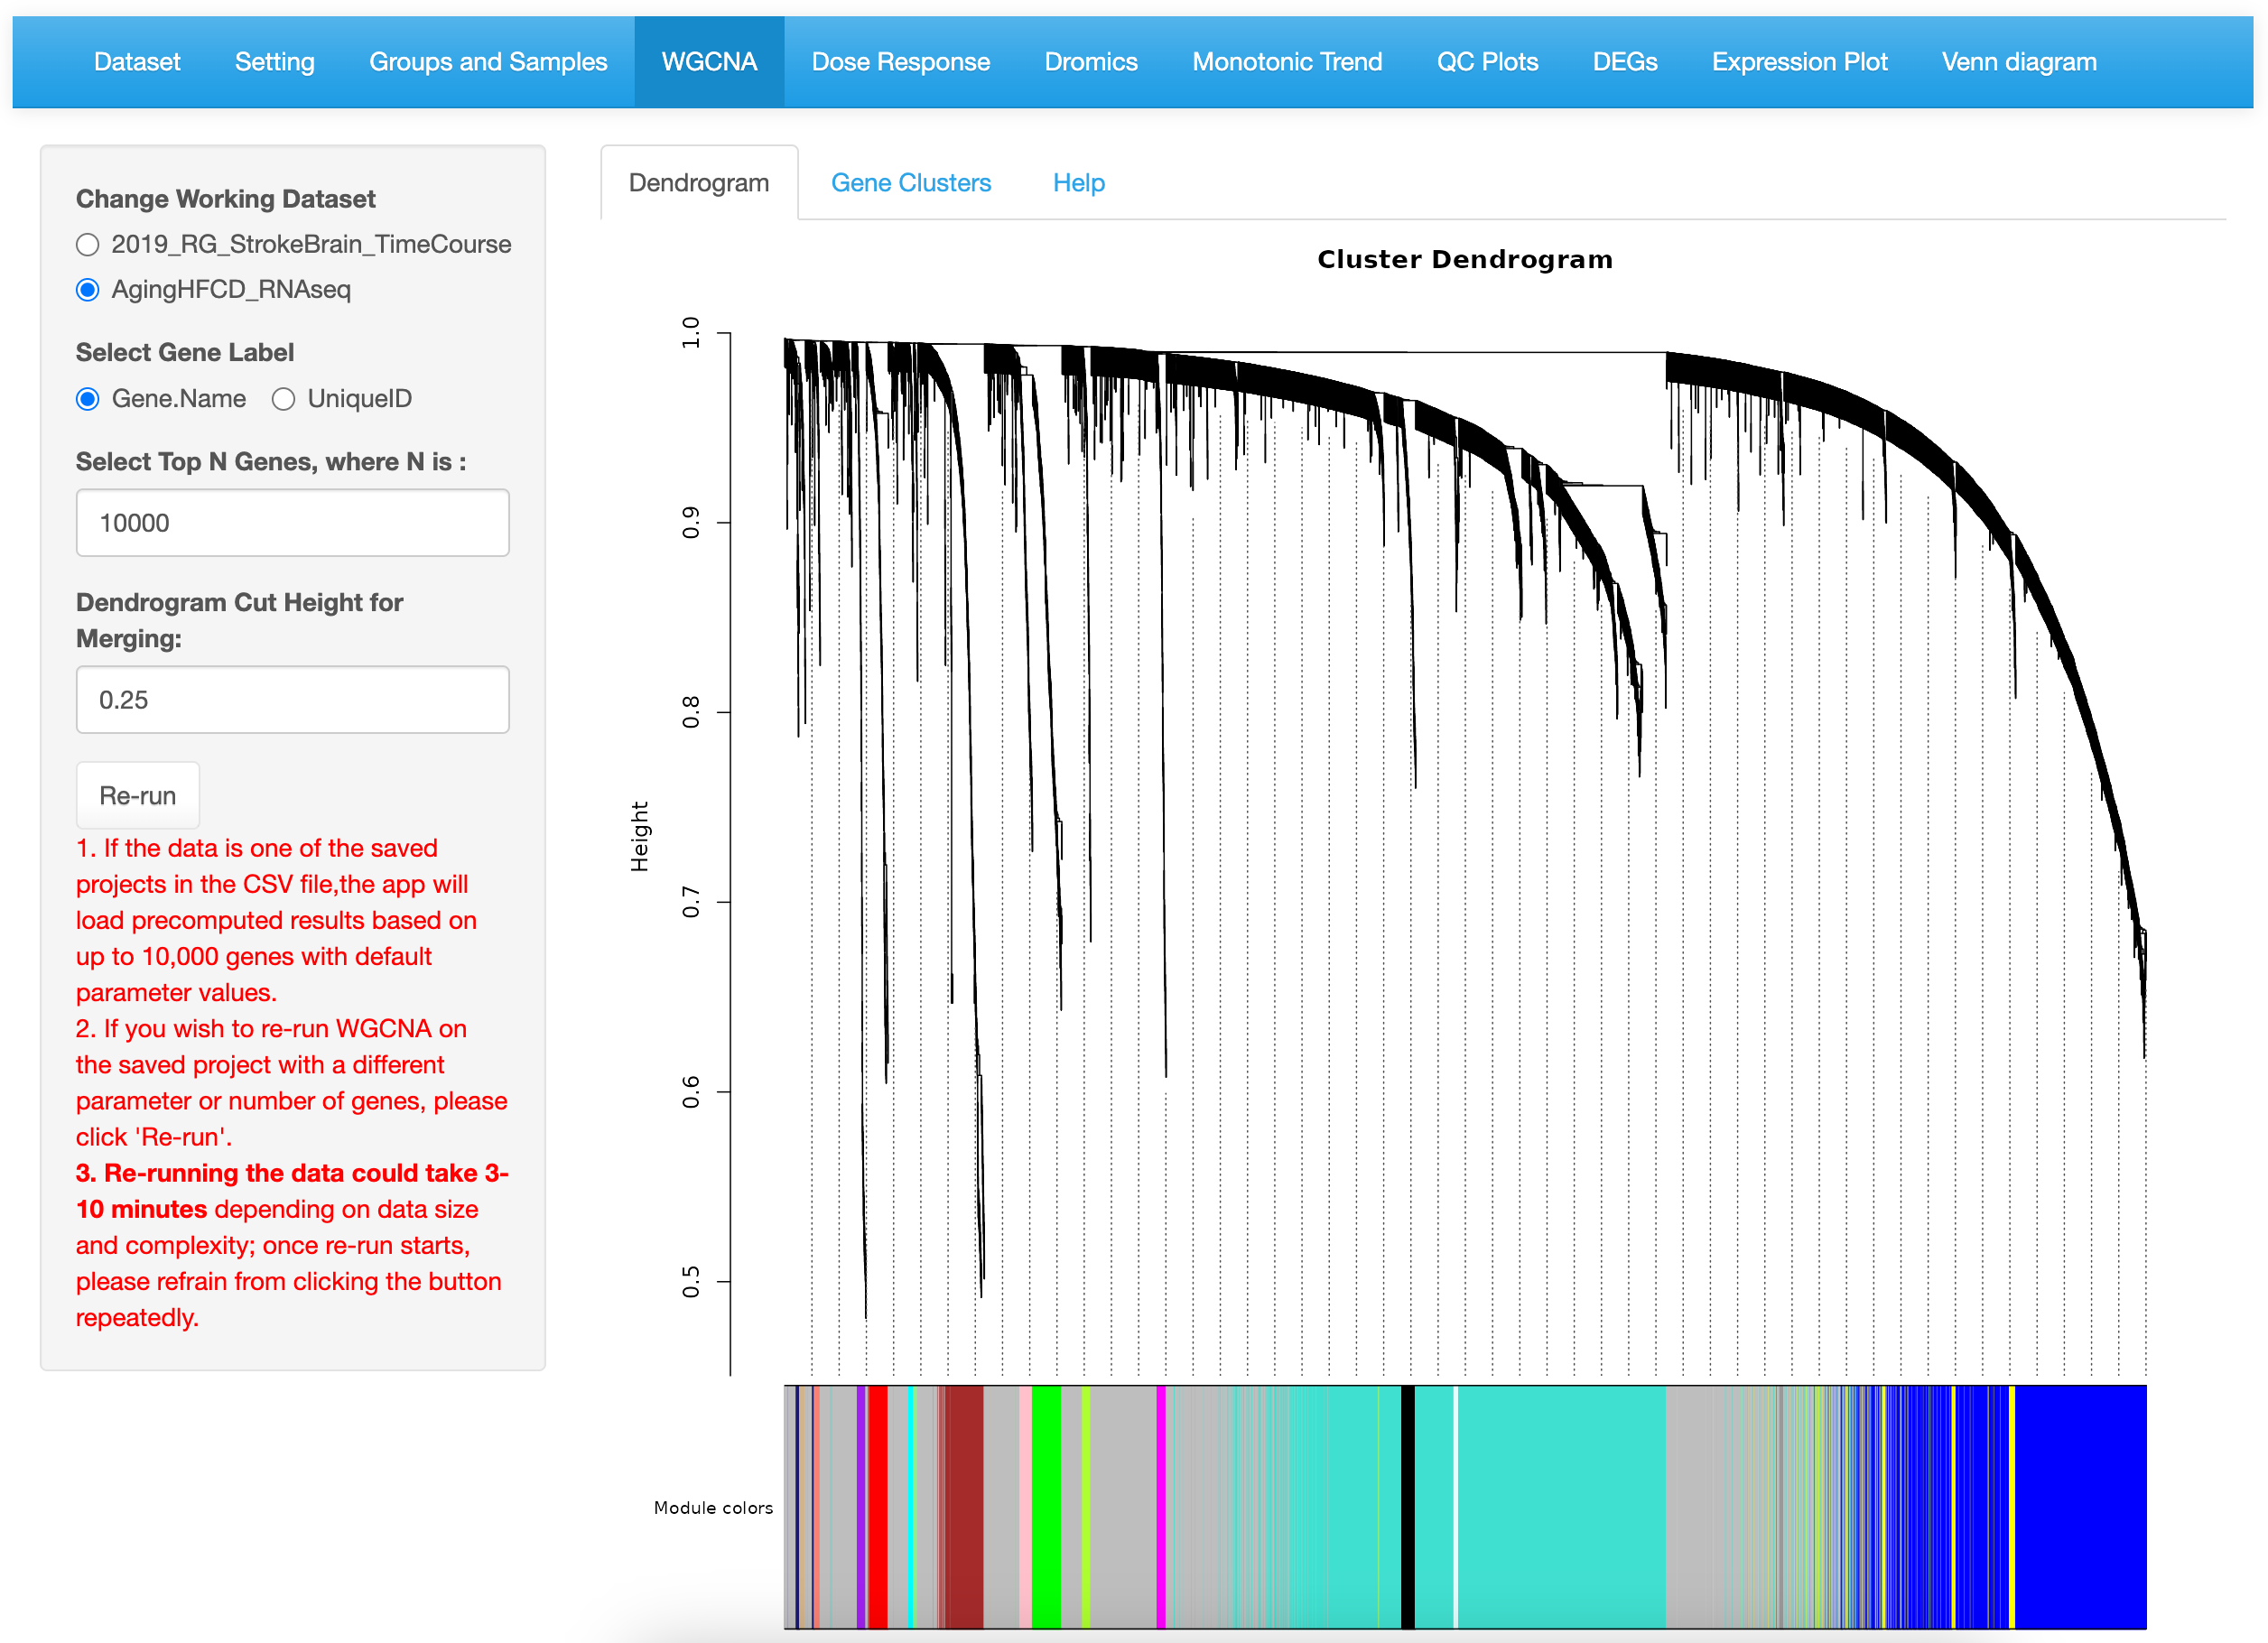
   2. 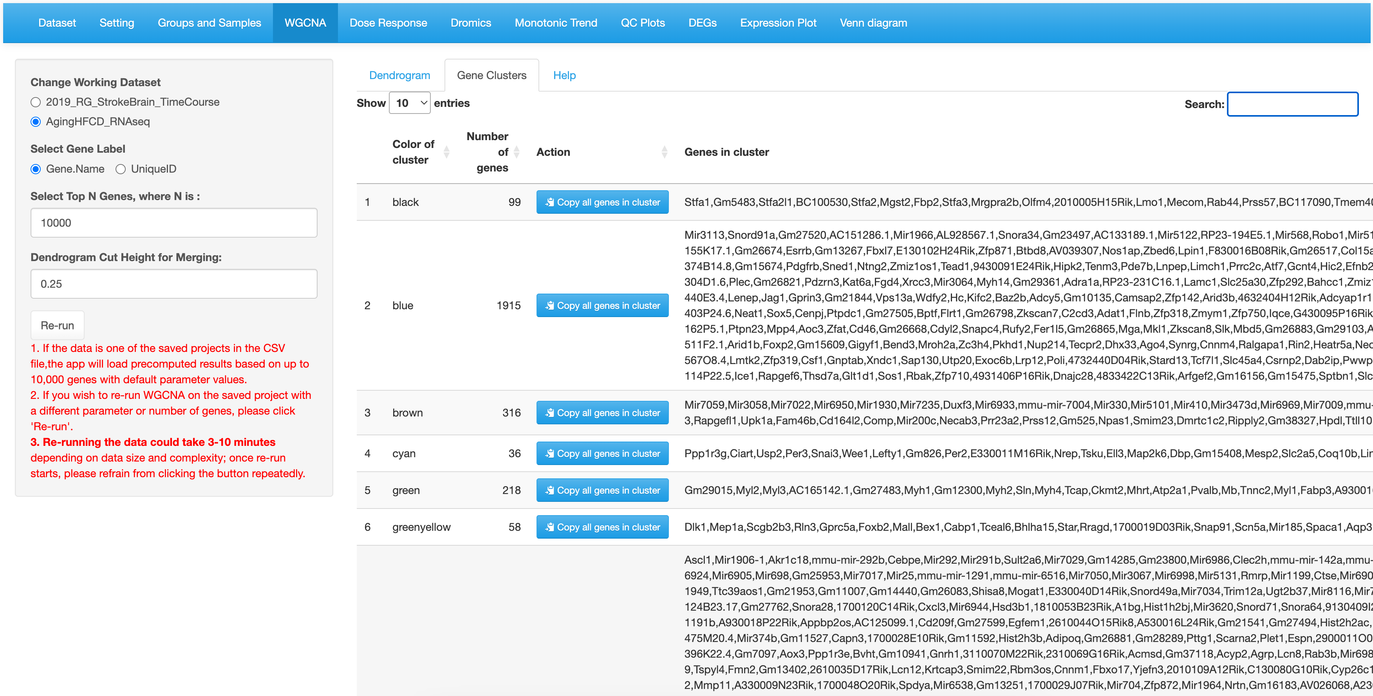
2. CorrelationP
   1. 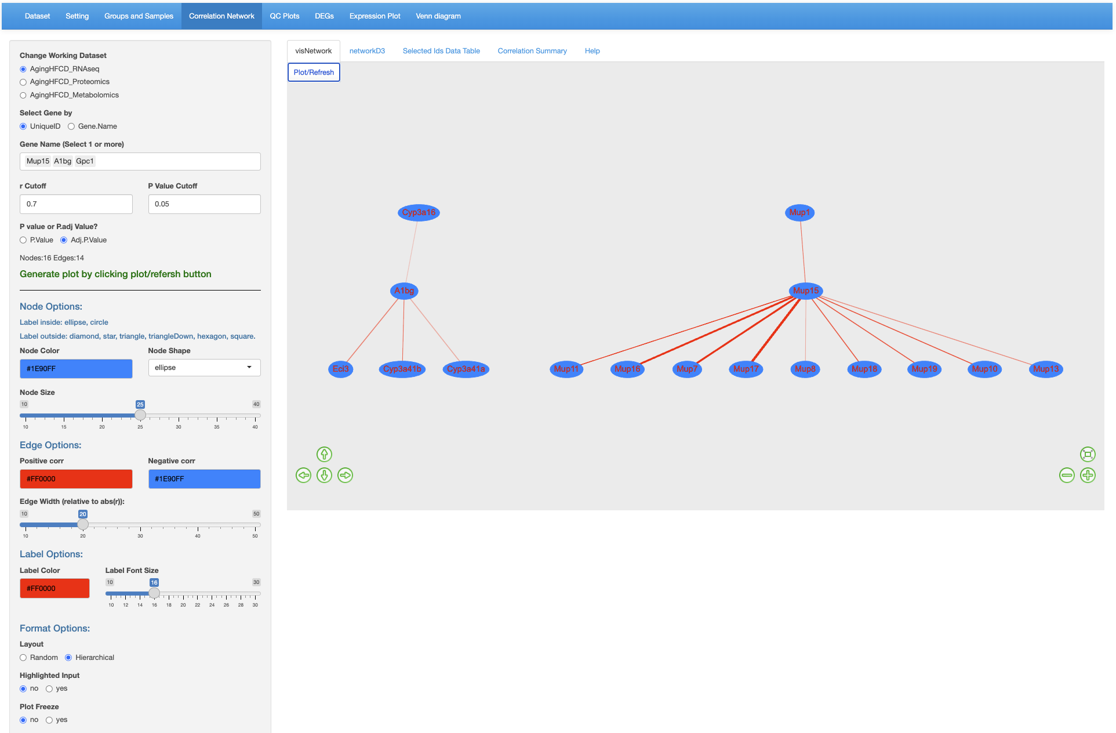

6. Click Plot/Refresh button.

5.Set Plot layout option.

4.Set node and edge appearance.

3.Select cutoffs.

2.Select genes.

1.Select data set.

* 1. 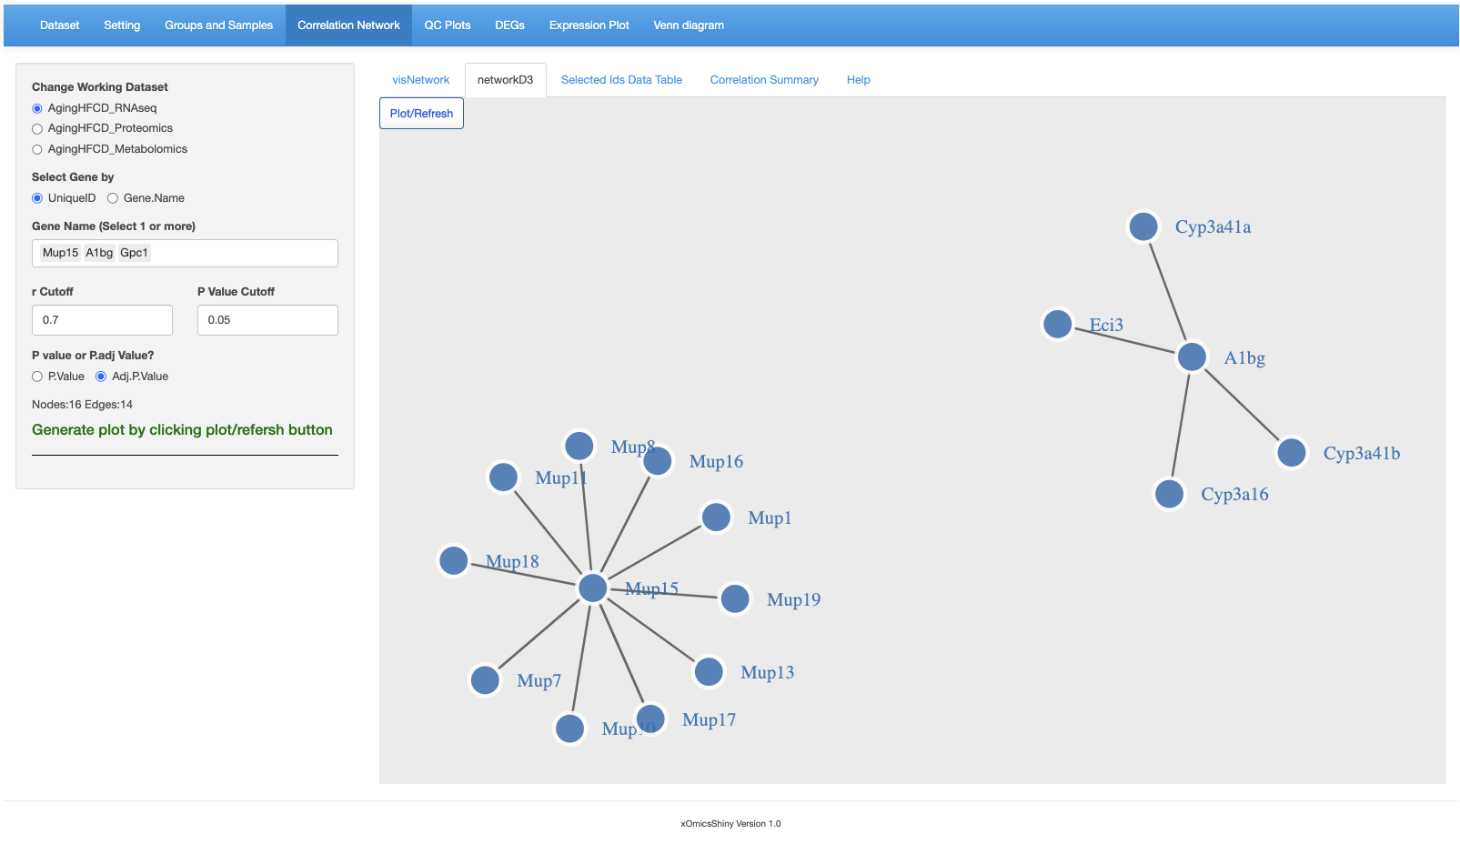
  2. 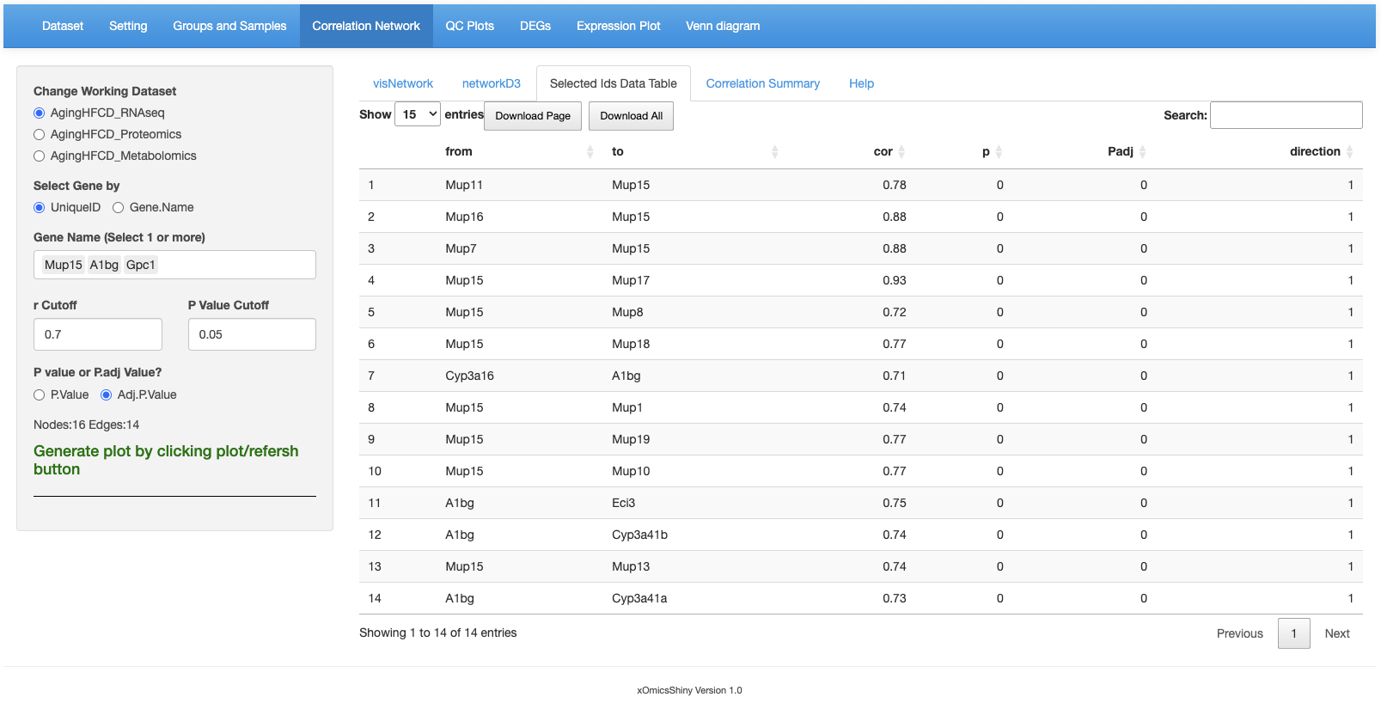
  3. 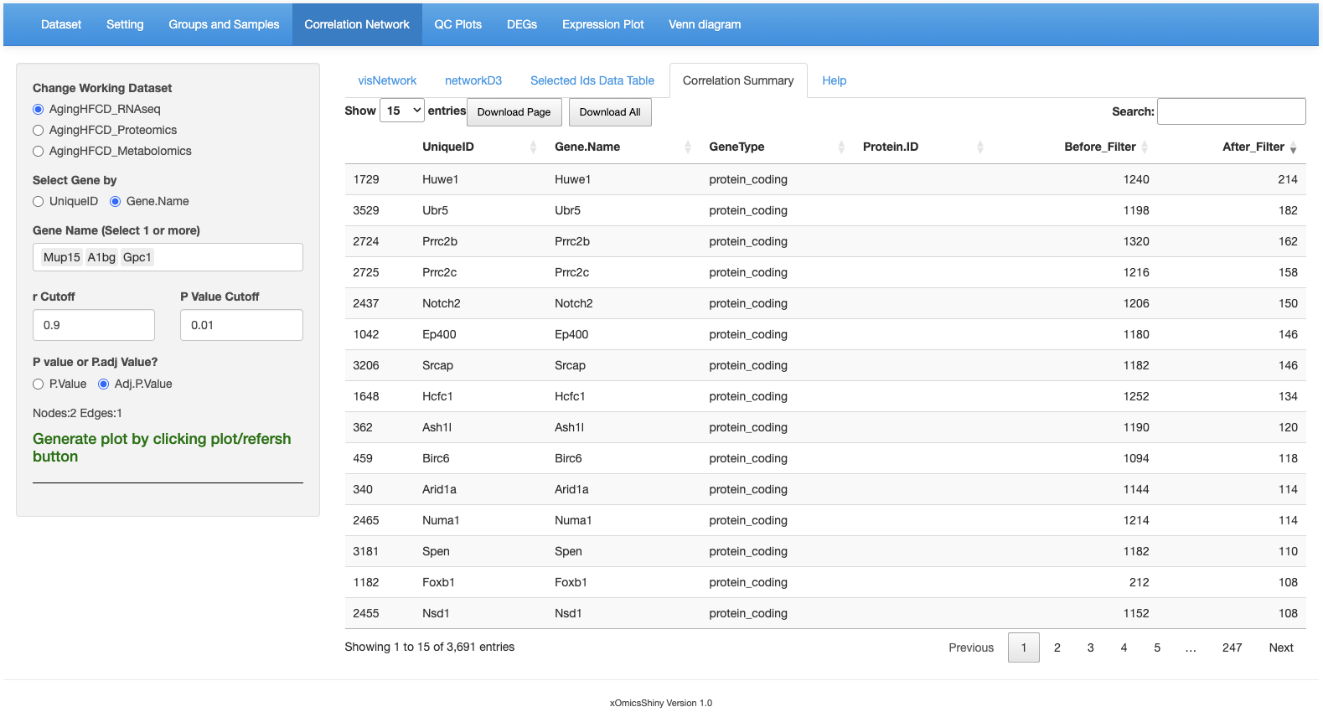

1. Venn Diagram
   1. 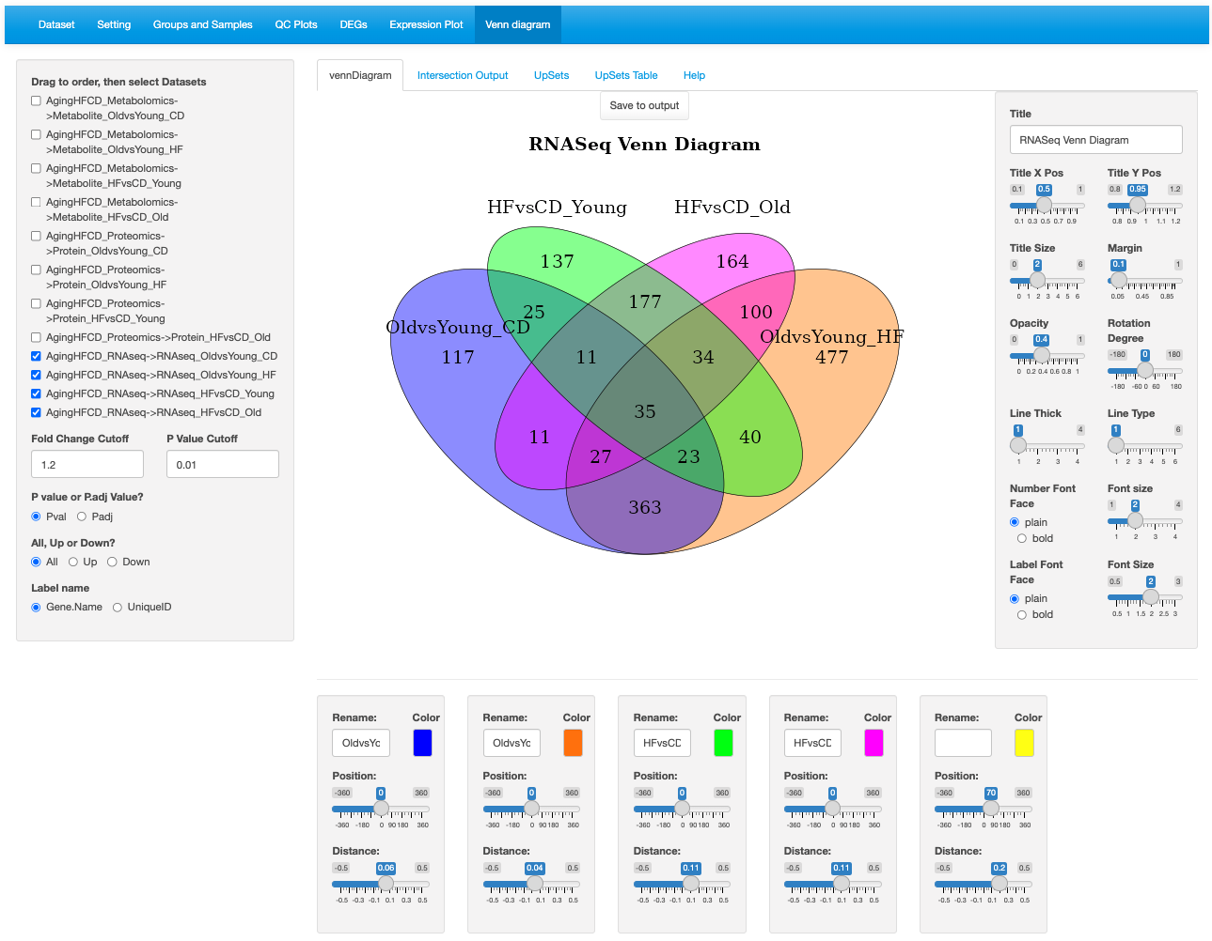

3. Set plot title and annotation preferences.

1.Select data sets (up to 5 sets).

3. Set comparison names, colors and positions.

2.Set cutoffs and DE direction.

* 1. 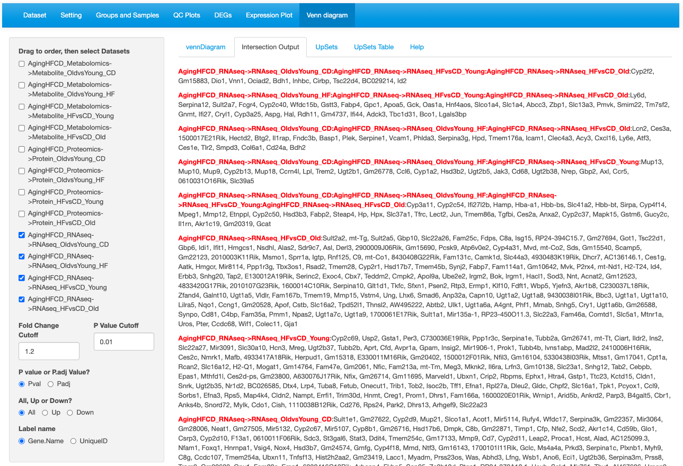

3. The comparison list have the comparisons separated by “:”. The DEGs are present only in these 3 comparisons.

* 1. 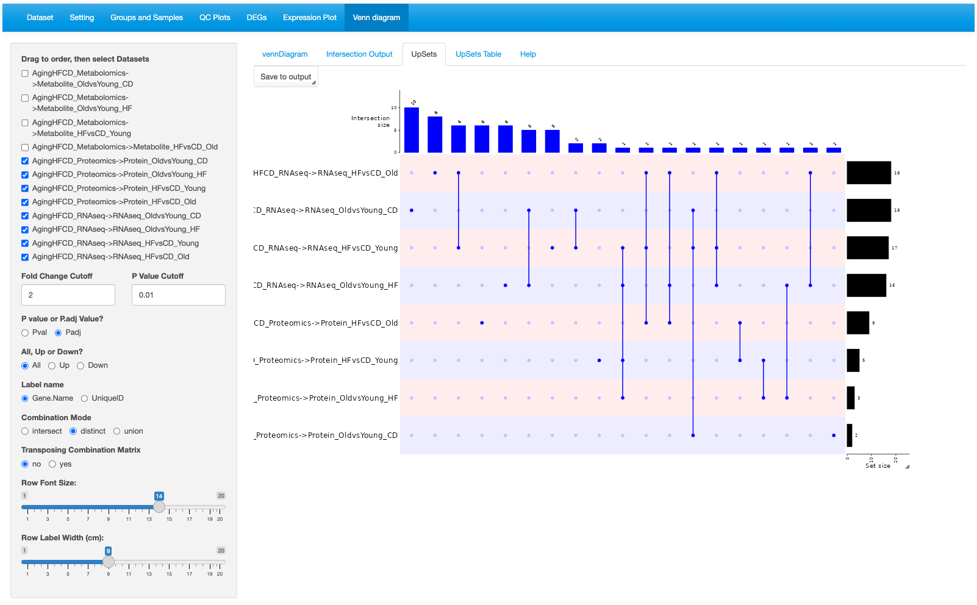

5. Adjust the row labeling.

4. Transpose the plot when there are many comparisons are compared to avoid the plot gets too wide.

3.Select Combination mode. “distinct” mode gets numbers that shows in the Venn Diagram.

2.Set cutoffs and DE direction.

1.Select data sets.

* 1. 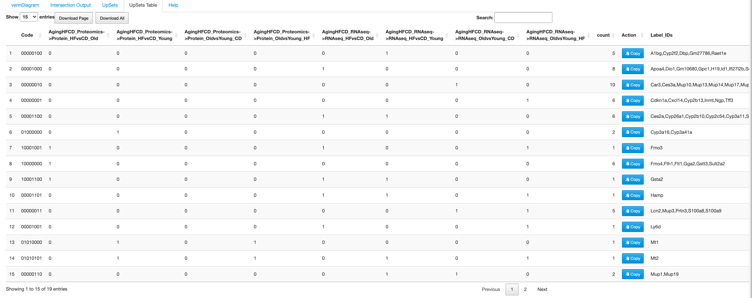

1. PCSF
   1. 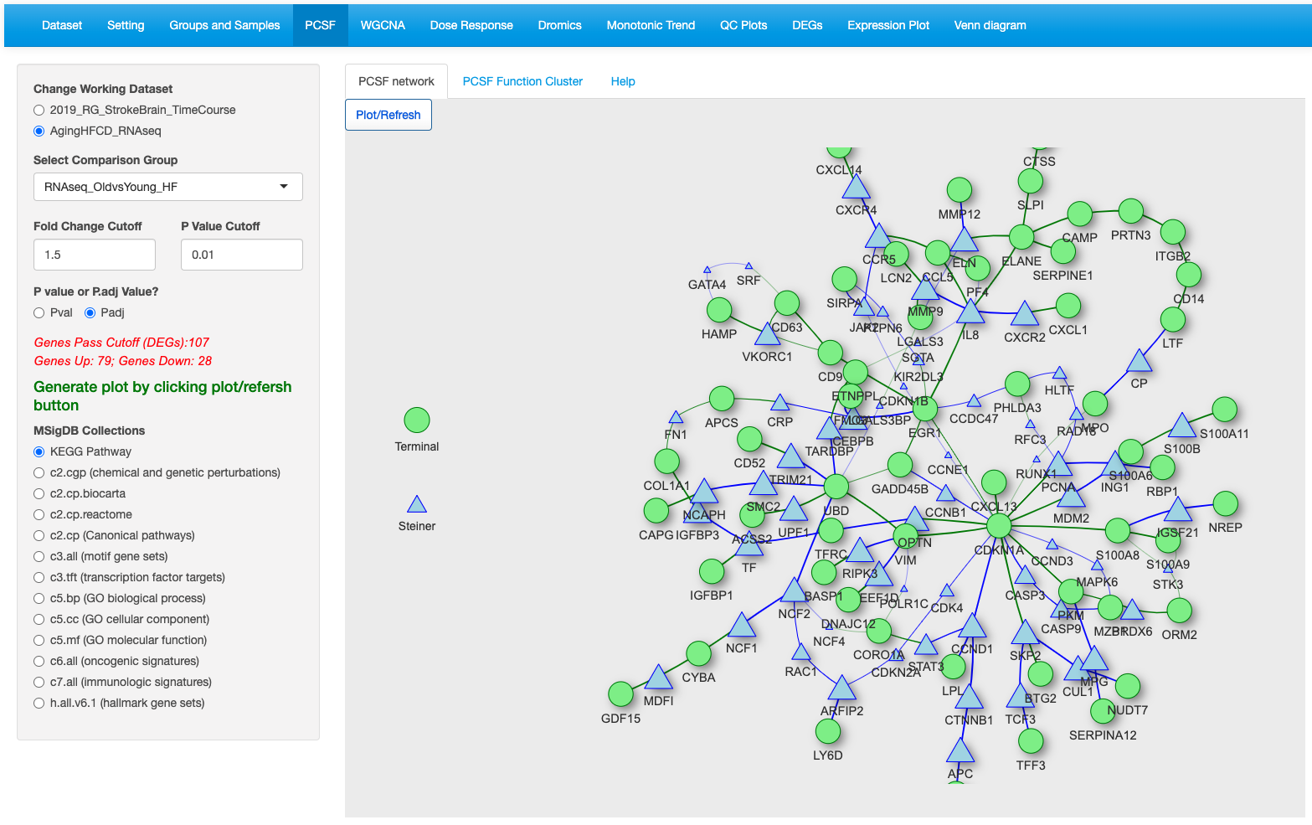

4.Click Plot/Refresh.

3.Select a gene set or pathway database.

2.Set cutoffs to get the total # of genes between 5 to 500.

1.Select data set and comparison.

* 1. 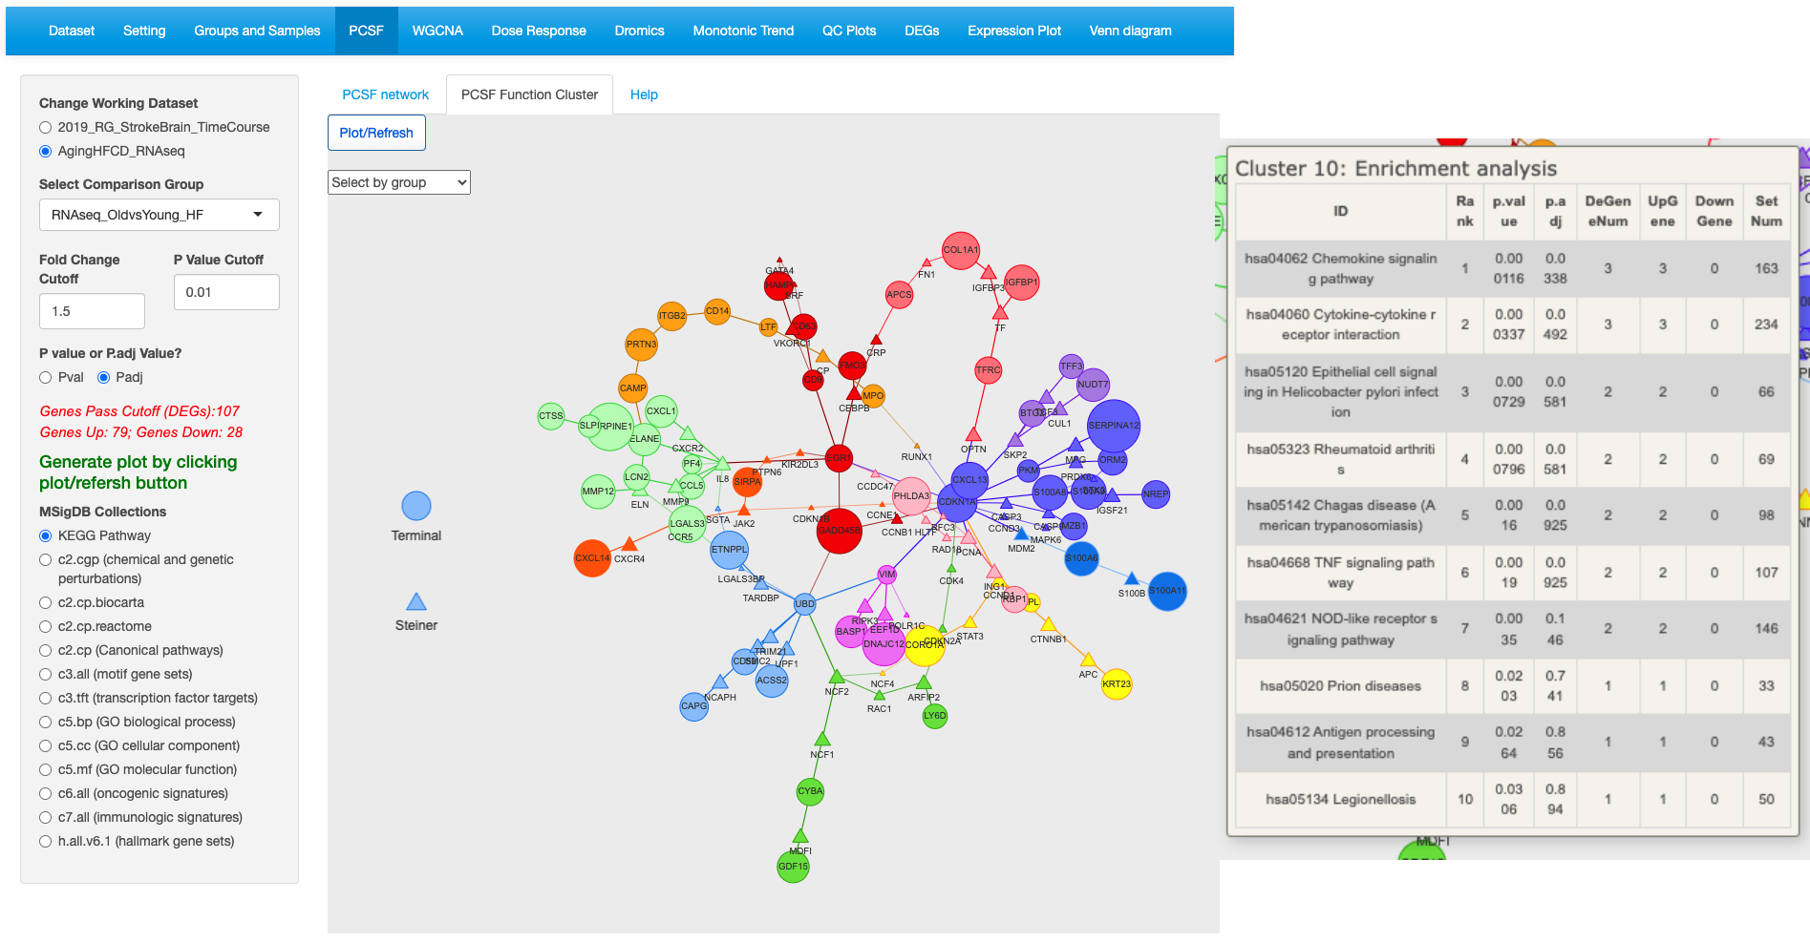

Click on a gene will show the ORA results of the top 15 enriched pathways.

Larger size indicates more times appear during computation.

Different clusters are in different colors.

Select a number to view a specific cluster.

1. Dose Response  
   1. 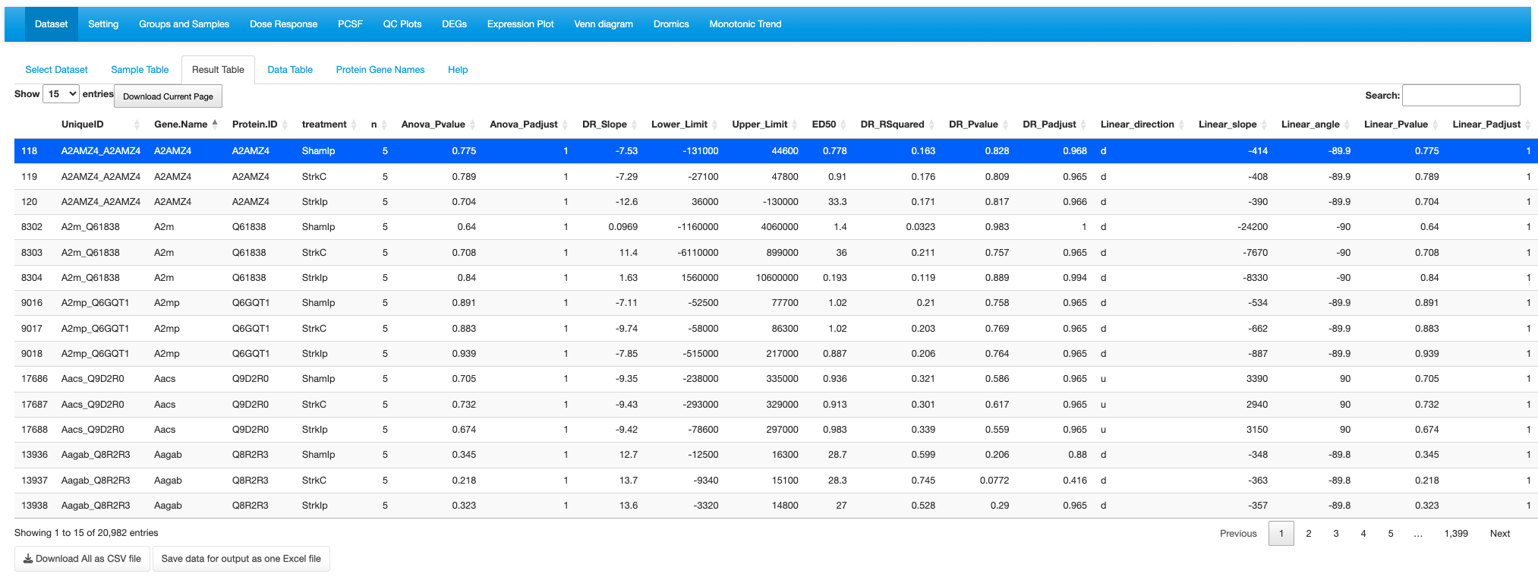
   2. 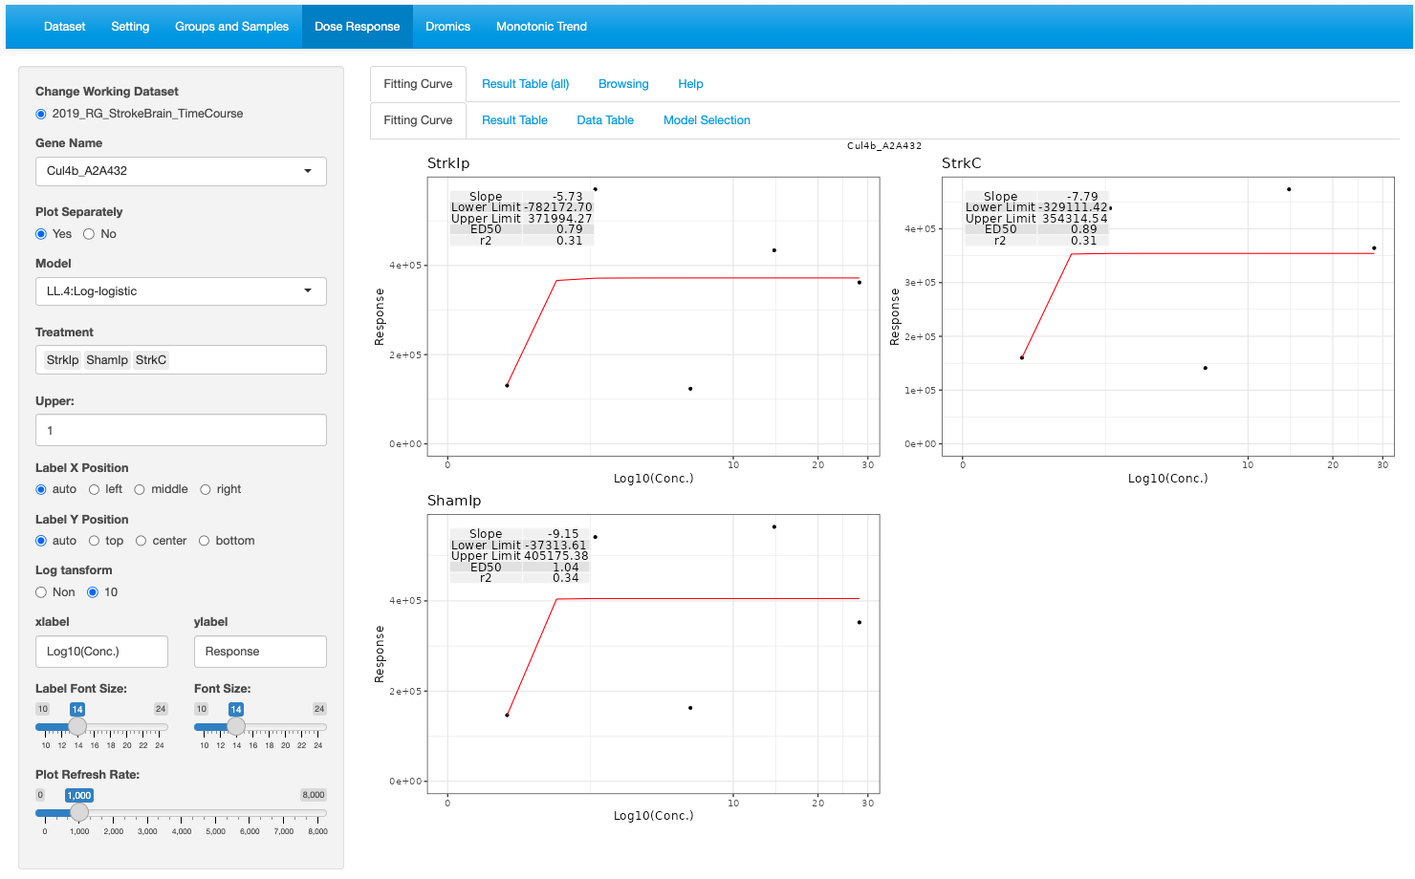

6. Layout preference

5. Set upper limit.

4. Select treatment to check

3. Select a model type to fit.

2. Plot separately or together.

1.Select a gene.

* 1. 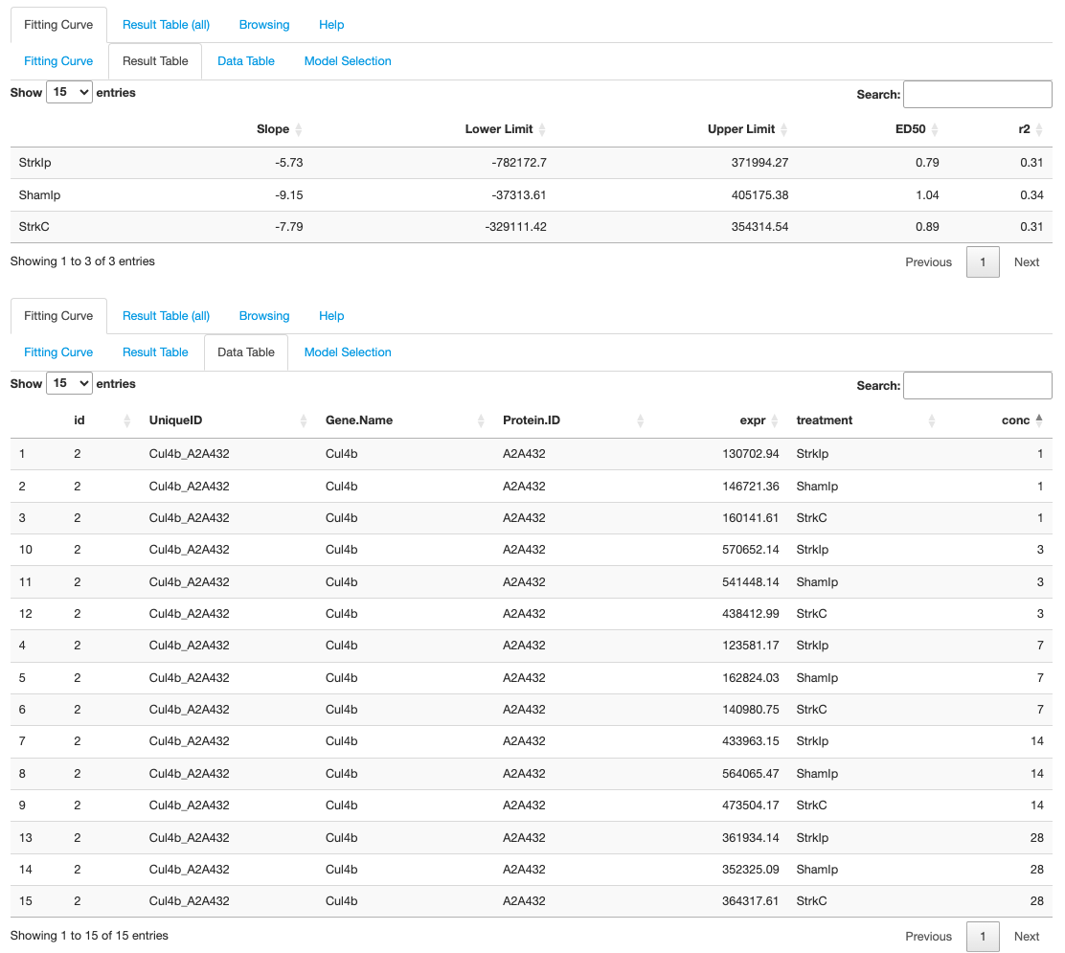
  2. 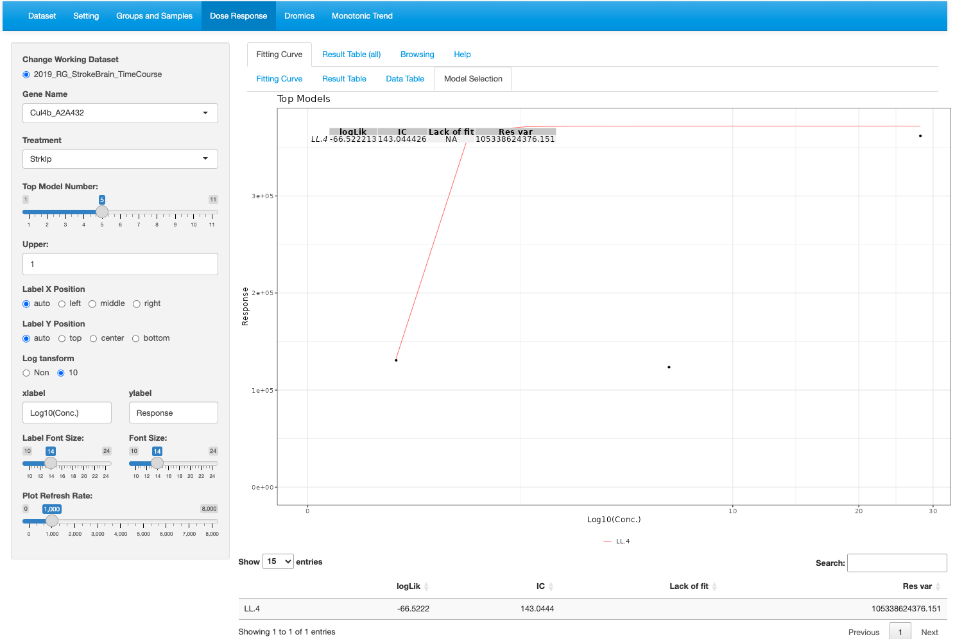

Table listing the top model results.

Fitted plot of the top models

3. Set upper limit.

4. Layout preference

2. Set # of top models.

1.Select a gene and a treatment

* 1. 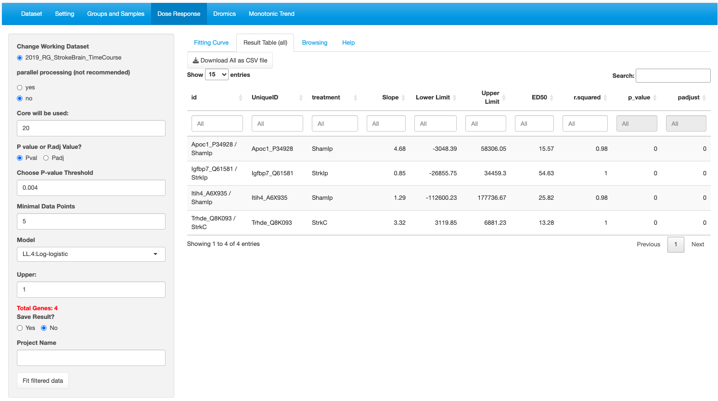

4. Fit model to the filtered genes.

Table shows the fitted results for all selected genes.

1.Select filter cutoffs

2. Select model type.

3. Result can be saved.

* 1. 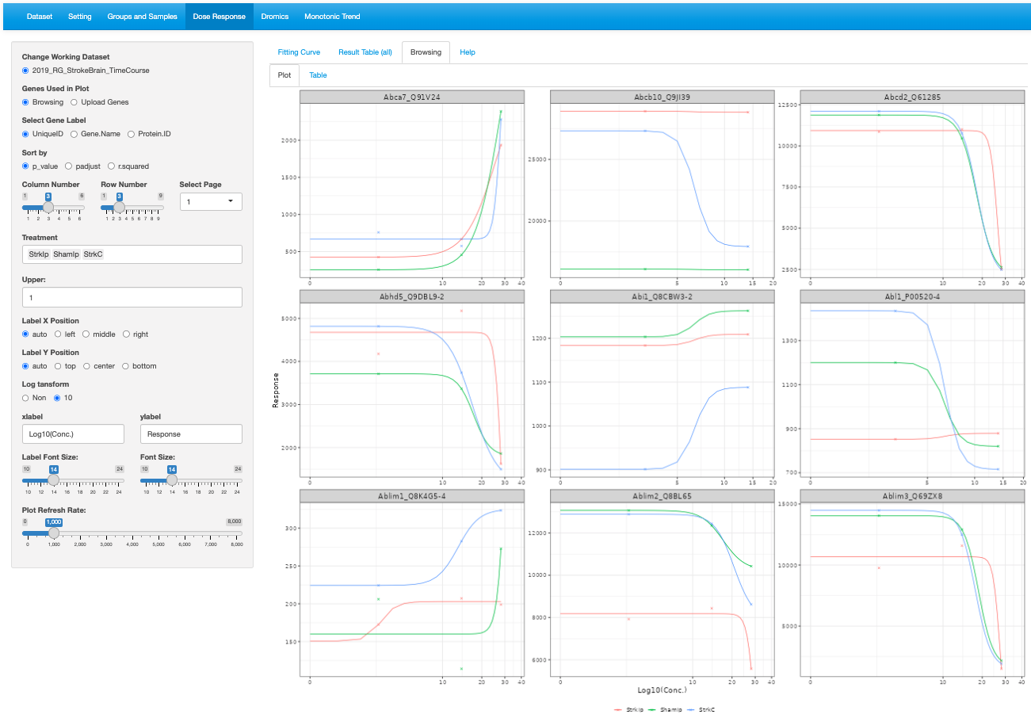

2. Determine the number and arrangement of plots by column and row numbers. Select Page number to view the plots of specific block subset of the filtered genes.

1.Sort the result table of the filtered table by the selected variable.

* 1. 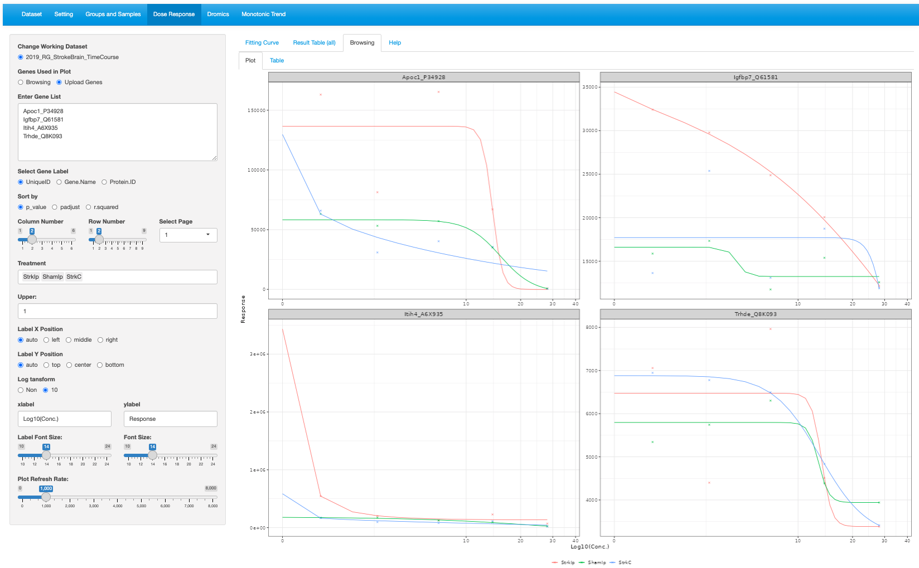
  2. 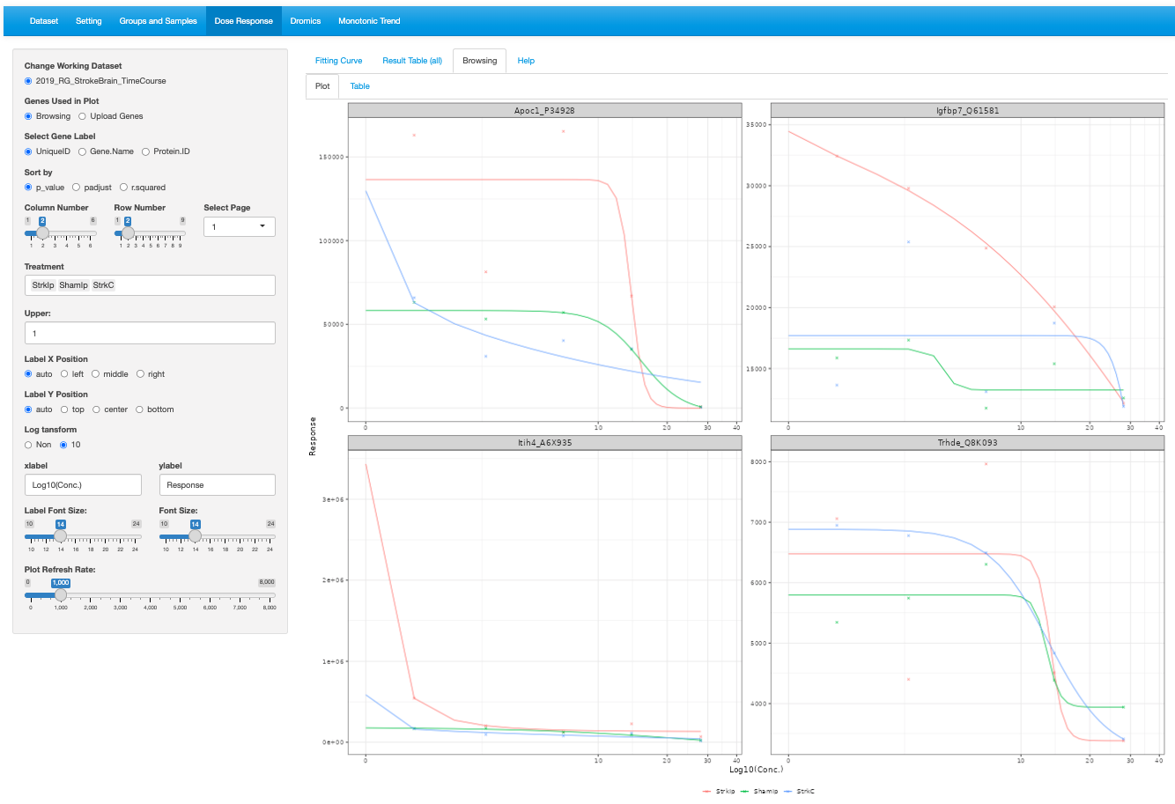

1. Time course module
   1. 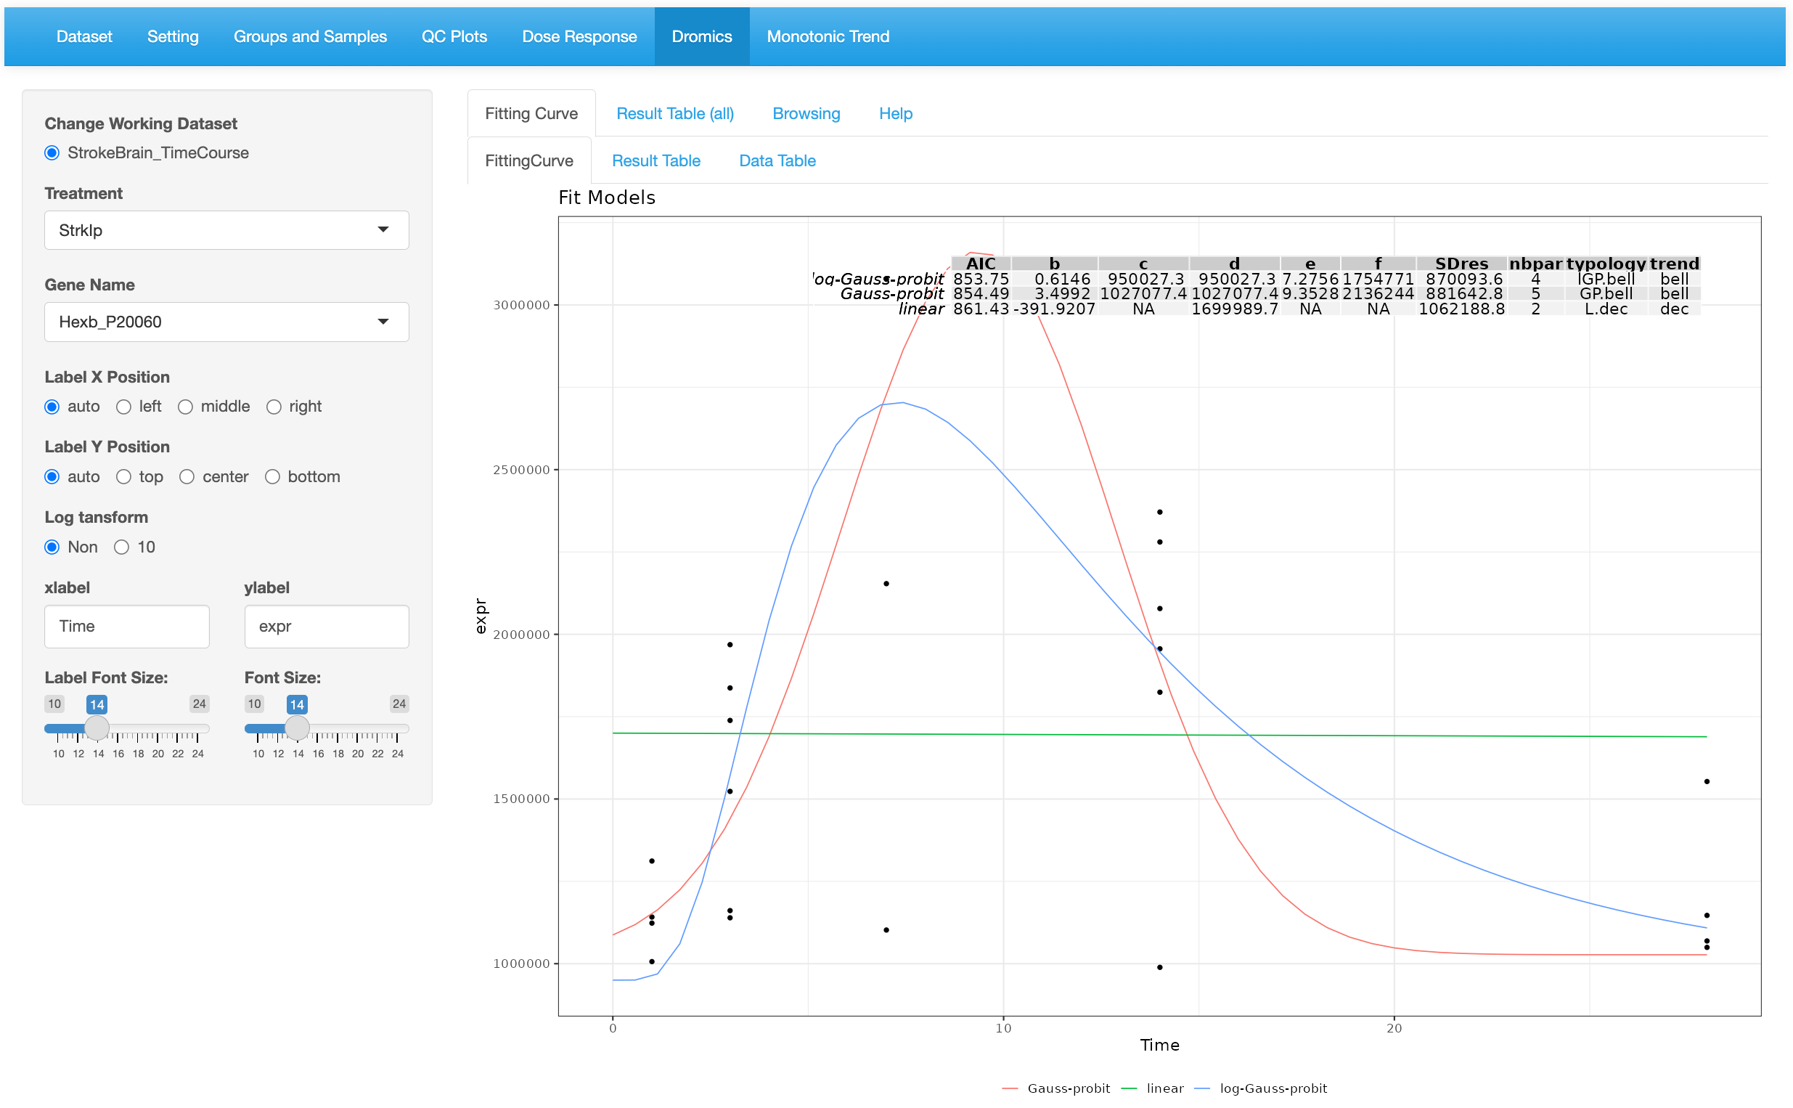

2. Set # of top models.

3. Layout preference

1.Select a gene and a treatment

* 1. 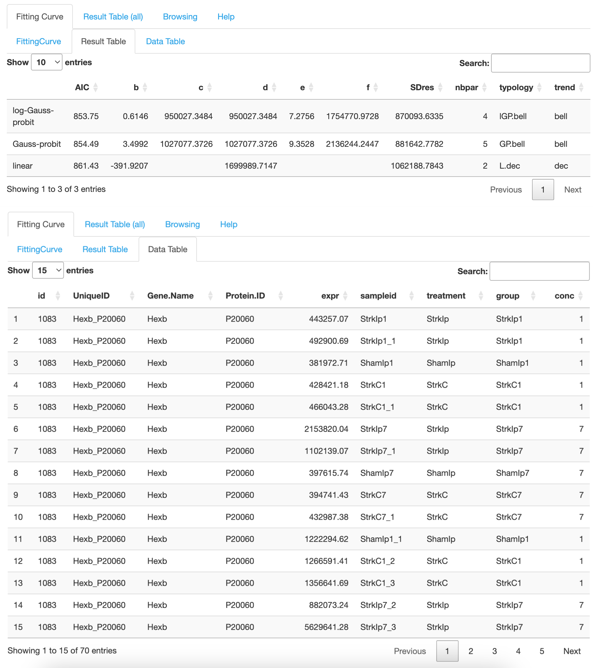
  2. 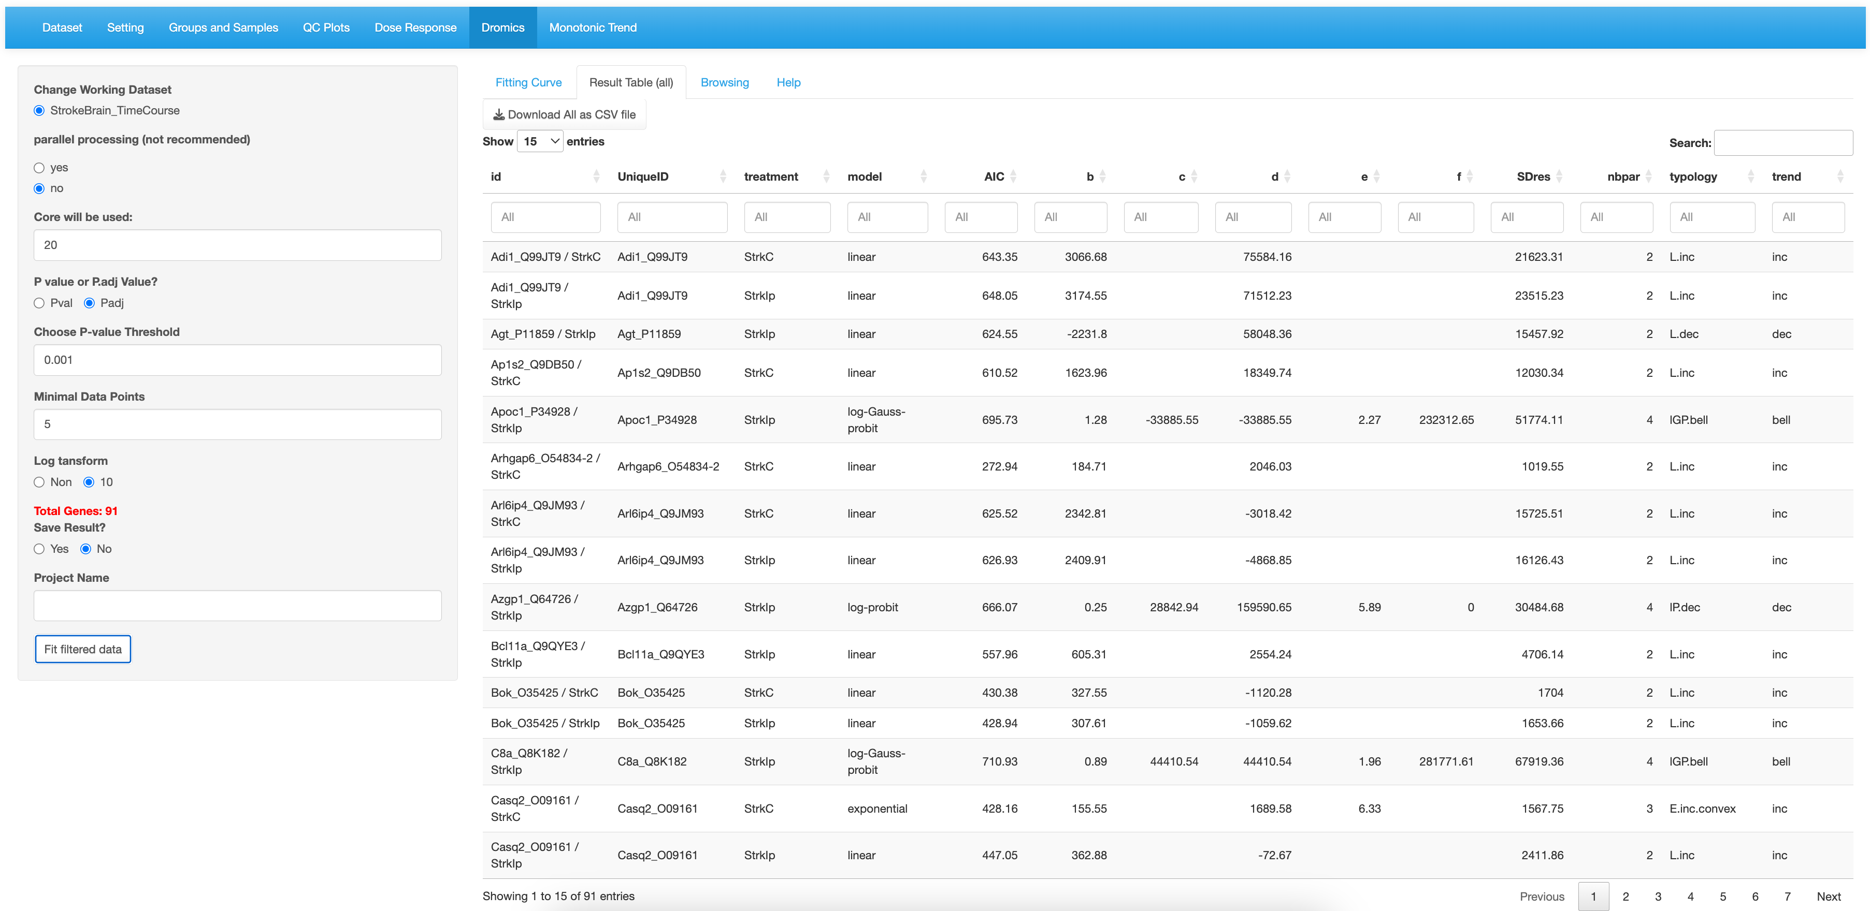

Table shows the fitted results for all selected genes.

3. Fit model to the filtered genes.

2. Result can be saved.

1.Select filter cutoffs

* 1. 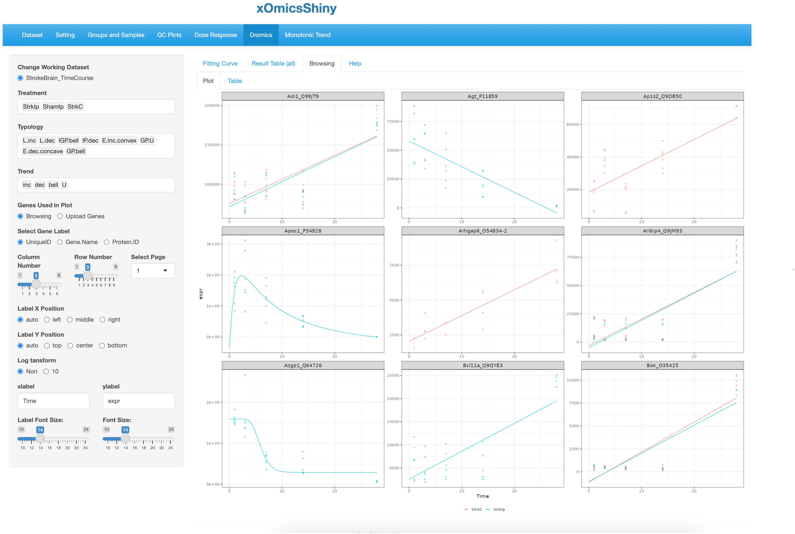

Display preference.

Select “Browsing”

User can select subset of the data set by excluding unwanted groups.

* 1. 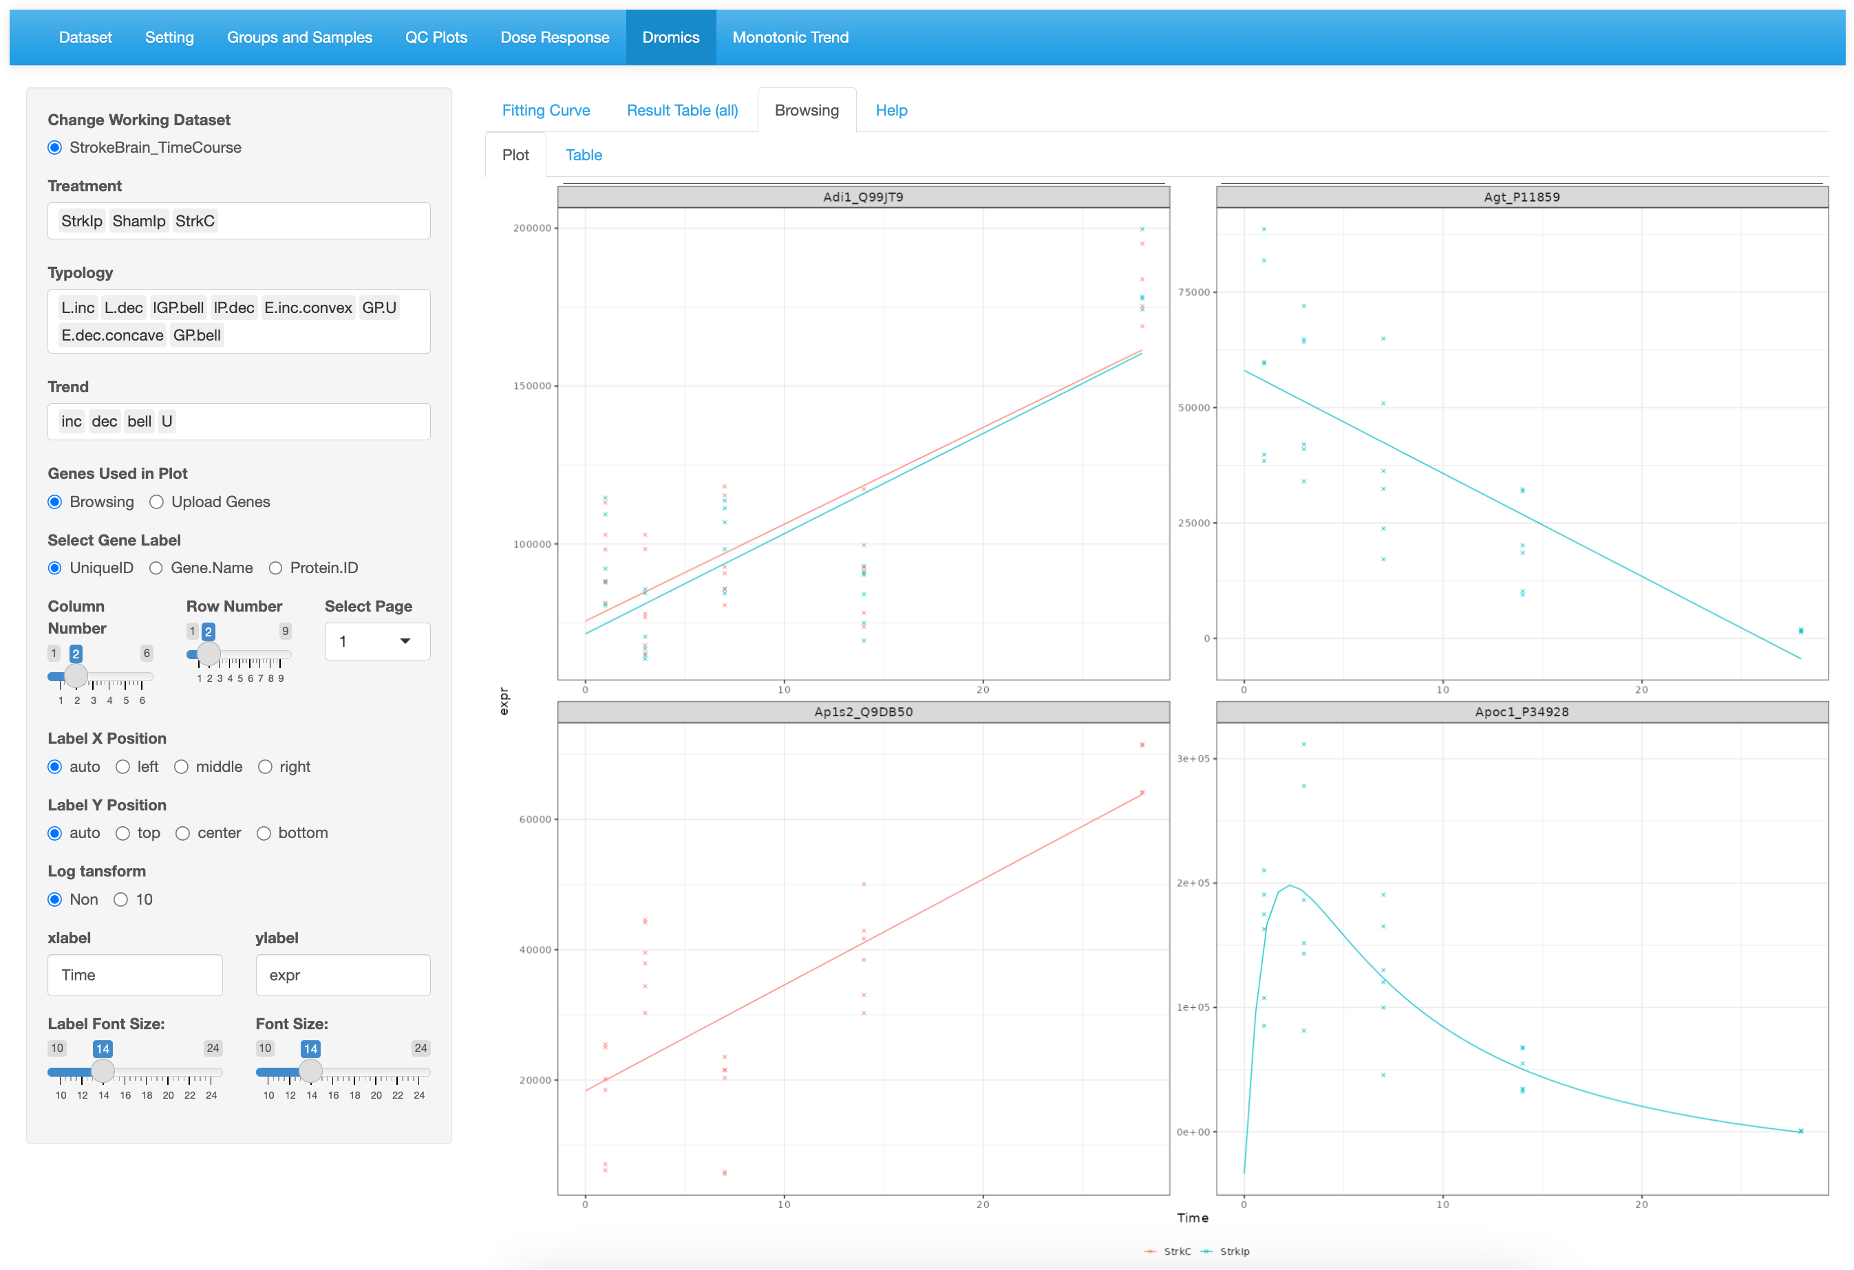

The plots are separated into multiple pages.

* 1. 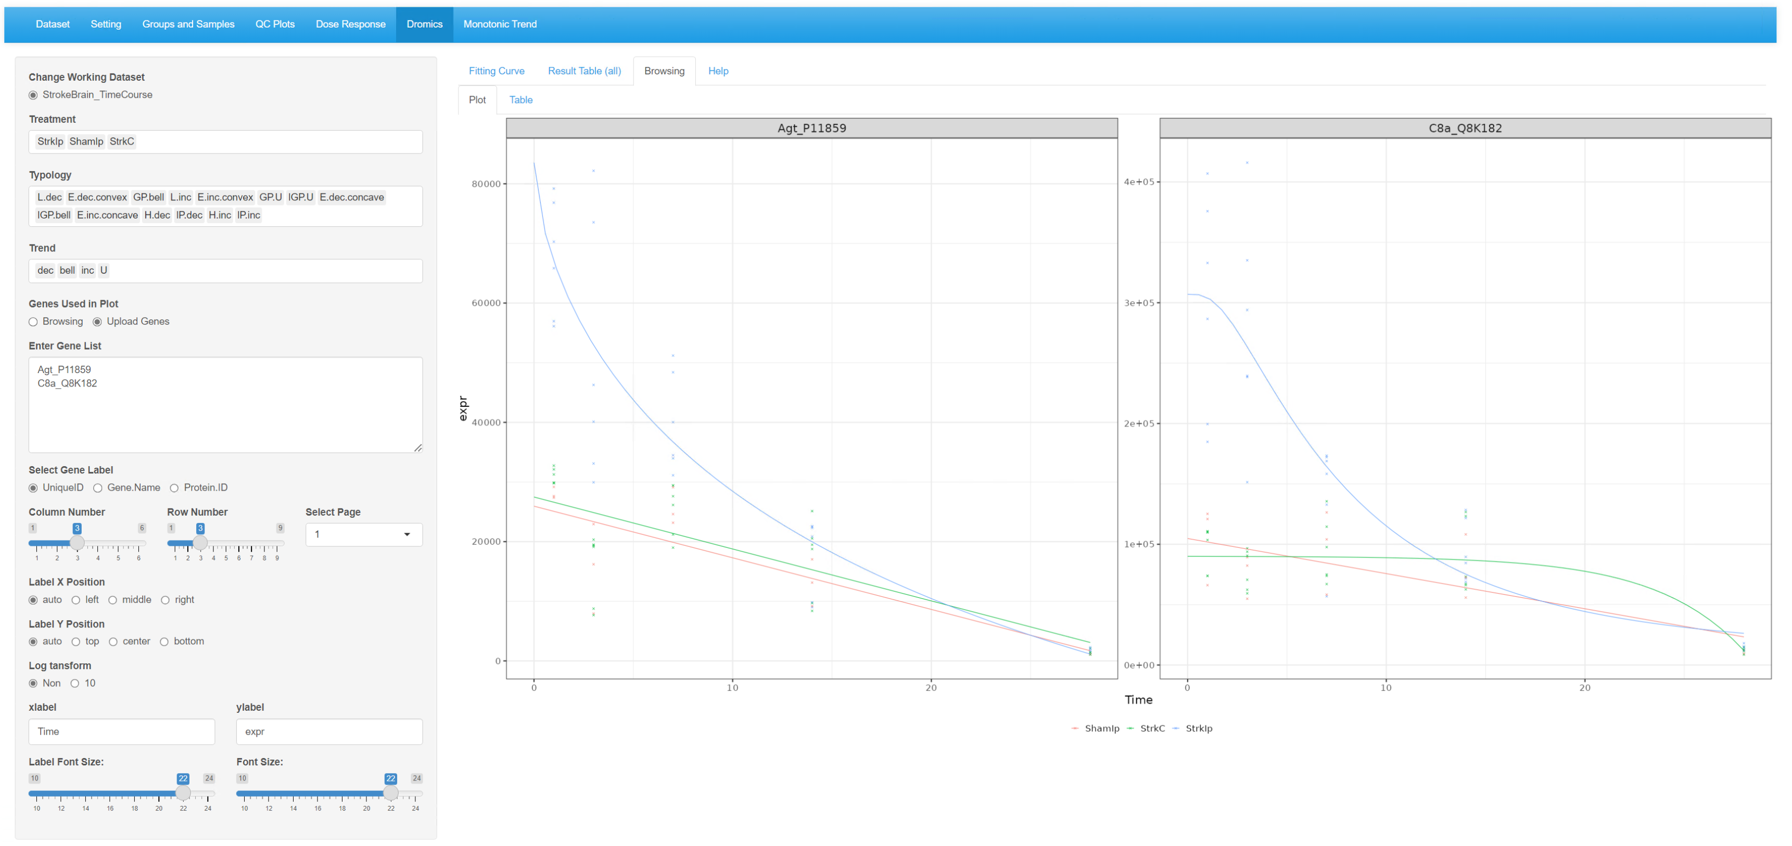

1. Monotonic Trend
   1. 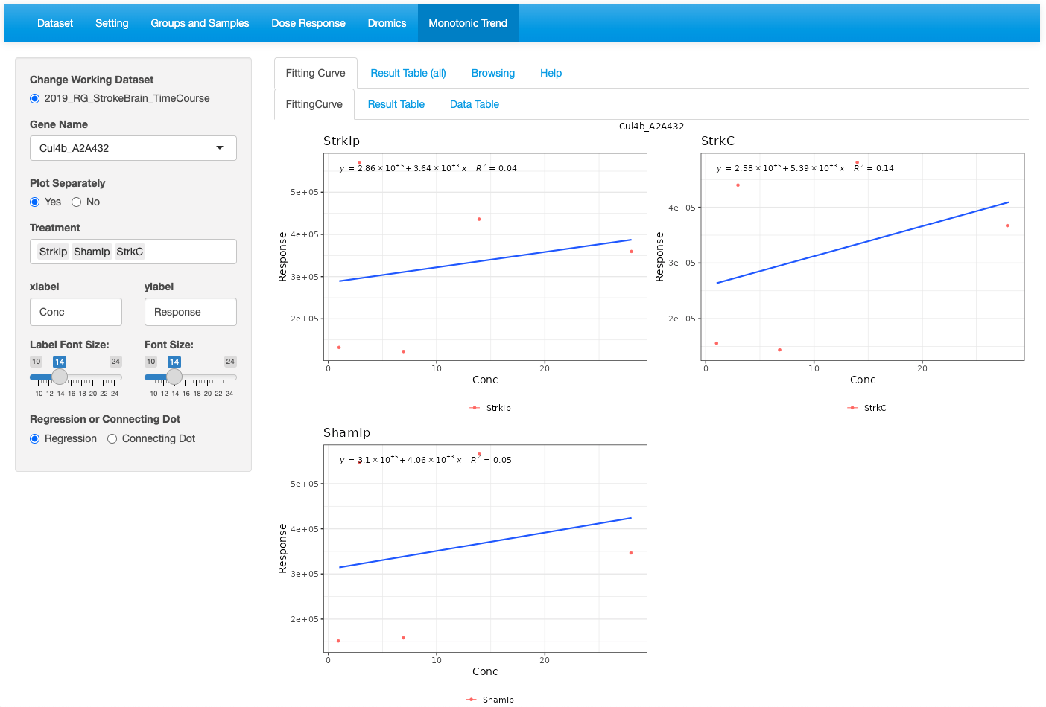
   2. 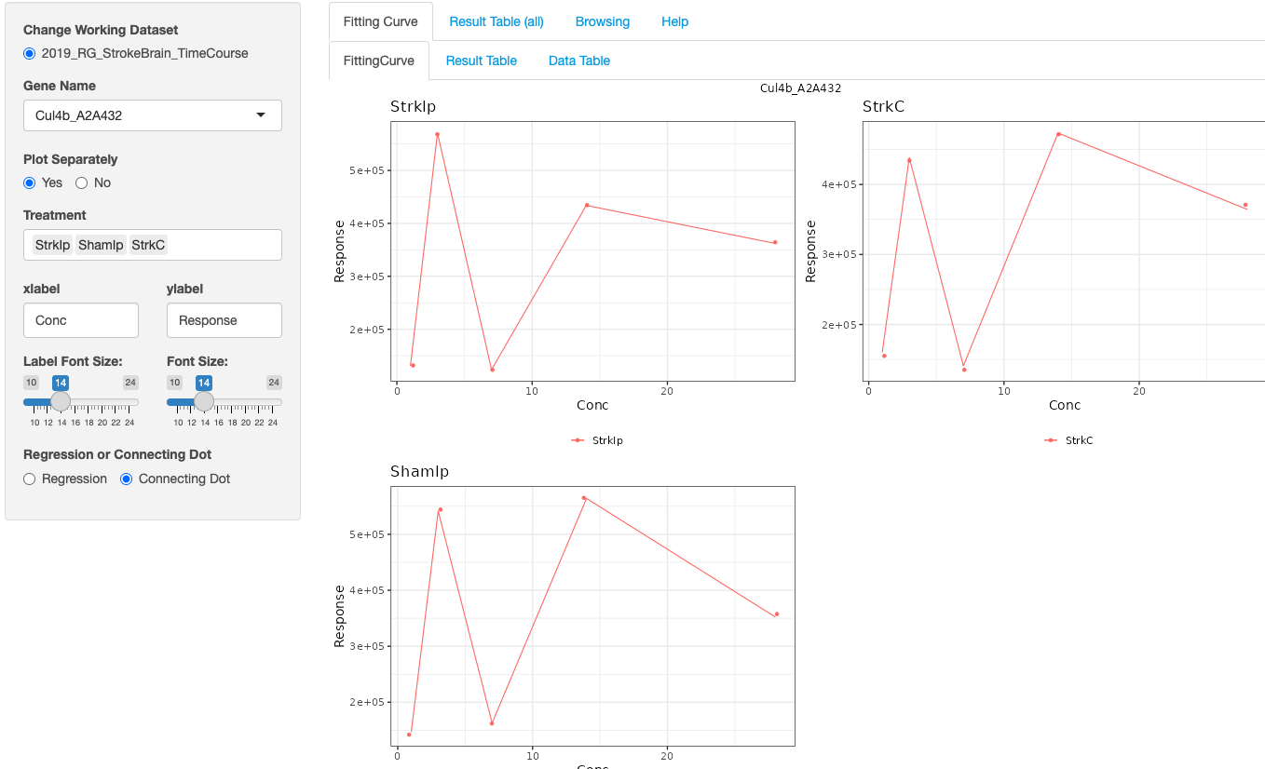
   3. 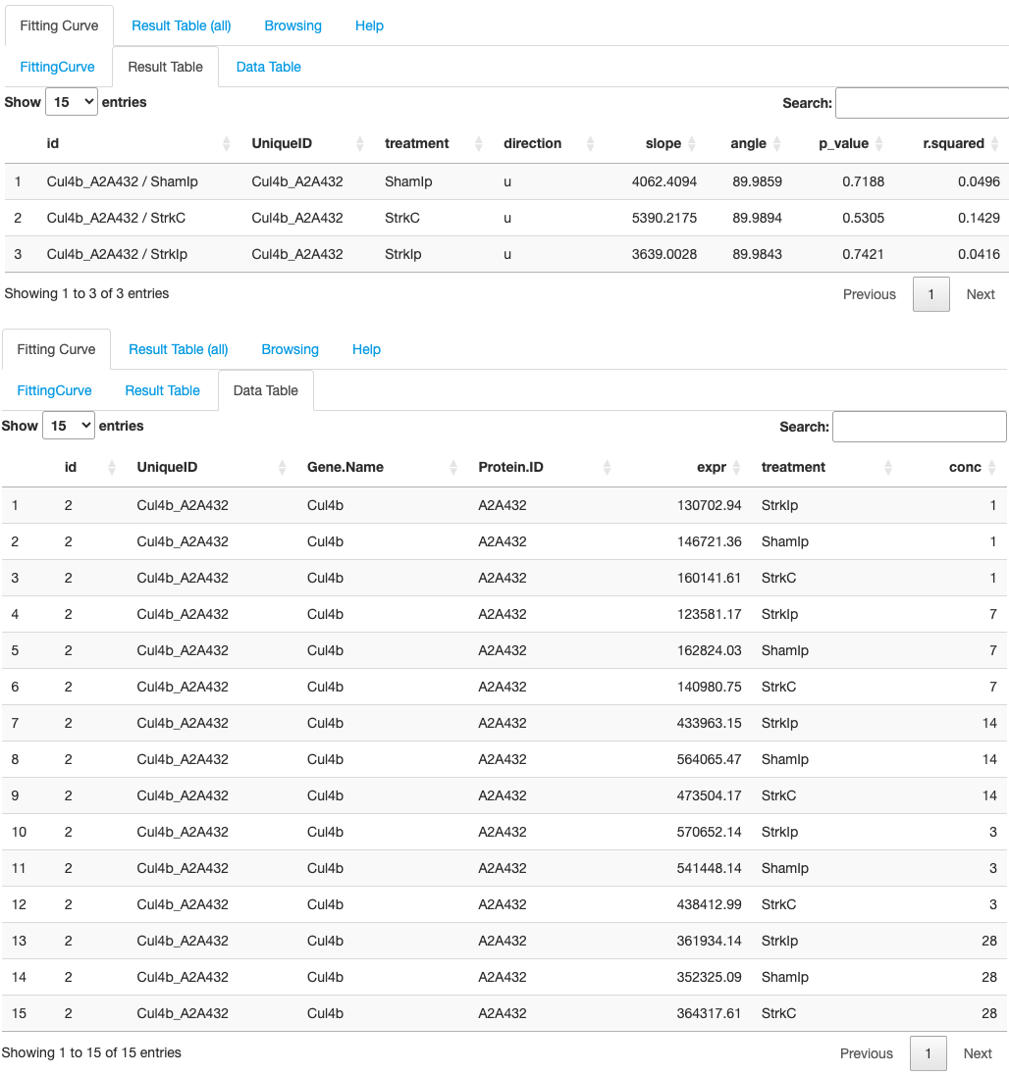
   4. 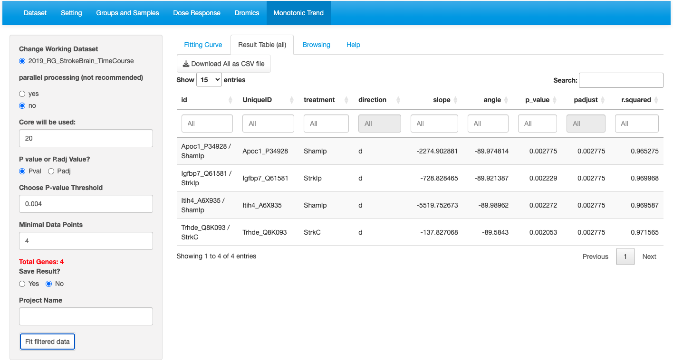

Table shows the fitted results for all selected genes.

3. Fit model to the filtered genes.

2. Result can be saved.

1.Select filter cutoffs

* 1. 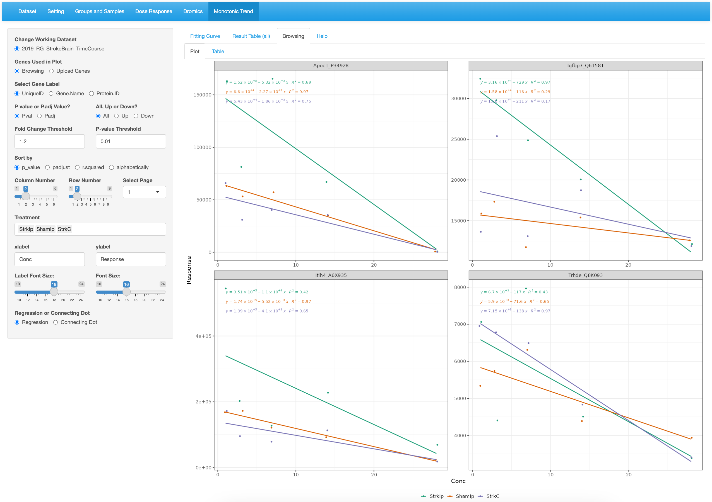

1. Comparison Results Merging
   1. 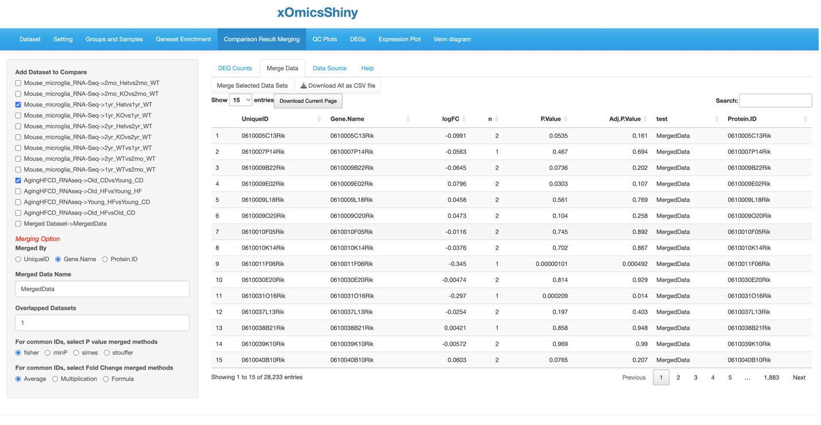

2. Select the method of merging

1. Select comparisons and merging option.

Comparisons are merged using Gene.Name. Only genes that present in all 3 comparisons are selected. The logFC are the average value of the logFC of the original comparisons. The p-values were calculated by fisher method.

* 1. 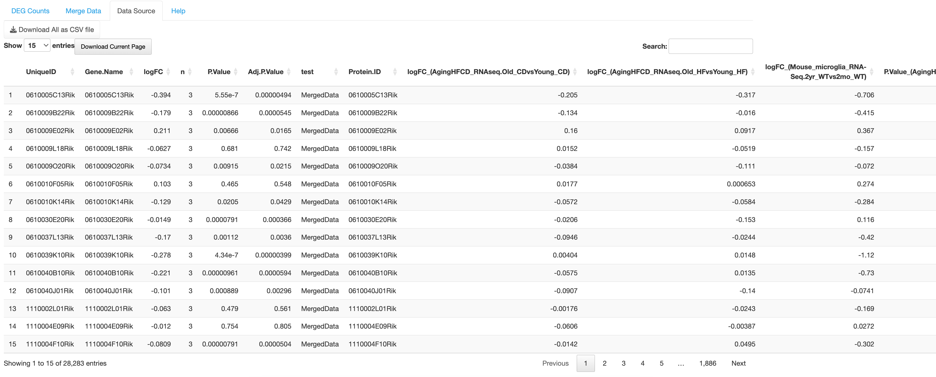

Source data are attached to the merged data.

* 1. 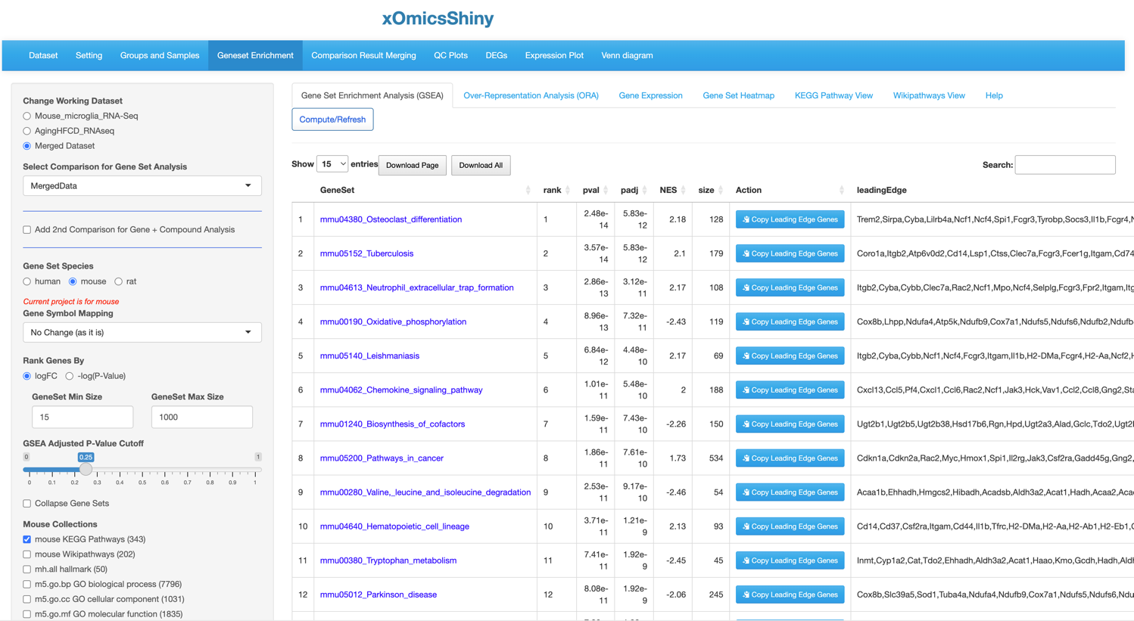

1. Output
   1. 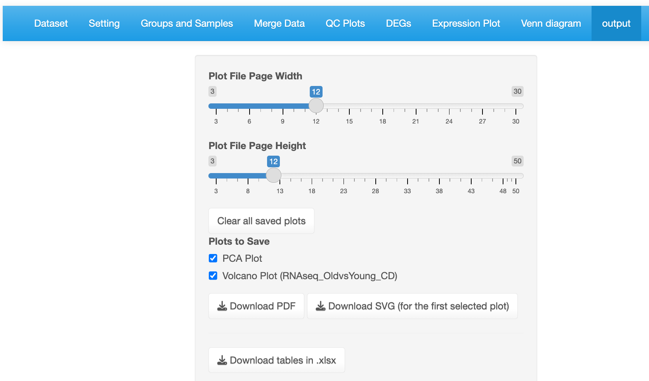

Plots can be downloaded as PDF or SVG

Set up page size.

Select plots to save.